INTERPRETATION OF PRIMARY RELIGIOUS EDUCATION EXPECTATIONS
SPRING SECOND HALF TERM
YEAR 2
UNIT | EXPECTATION | OUR UNDERSTANDING | PROMPT QUESTIONS
2.4 The Mass | Recognise links between the Mass and why it is important to Catholics | This expectation is asking pupils to be able to recognise basic links between Catholics going to Church and Mass and why they go. Pupils do not need to give reasons only recognise some of the reasons why Mass is important.  The old (p.48) and new (pp. 52-53) PBs are not a helpful source for getting children to think about the importance of Sunday or going to Church and Mass on Sunday. Therefore, teachers will probably focus first on the expectation Talk, ask and answer questions about their experiences of celebrations, saying sorry and the Mass and some of the activities described before engaging with this expectation. However, this expectation is linked to the Talk one and can come after it.  Teachers ought to think of having a few artefact/religious objects lessons and perhaps devoting a place in the classroom for continuous provision.  This expectation can be met by  - looking at the inside of the church and from this a further focus can be put on  - things inside the church that are needed to celebrate a Mass.  If teachers have a ready stock of photographs of the inside of the school’s parish church this is best. If not there are some images provided in the resources.  Using the first set of images about the objects that make up a church (Church 1)  Set up the activity in small groups where the pupils are asked to look carefully at the images and respond to them: allow pupils to express any ideas, thoughts or feelings that arise because of the images. (An aside or extended task could be to ask pupils to ‘Build a Church’ listing/drawing things that would be seen in a Catholic church). Encourage pupils to use their imagination: to work out what the images are of, how an image can show what happens in a church, and most importantly, how an image can show what is important to the people who go to Church.  Record together the responses to this last question.  Recapping the recorded responses, teachers can then use the second set of images to bring out several new or supporting reasons why Catholics go to Mass in church.  Using the second set of images about objects needed for a Mass (Church 2) again encourage pupils to use their imagination: to work out what the images are of, how an image can show what happens in a church, and most importantly, how an image can show what is important to the people who go to Church. If pupils or some pupils have enough knowledge, ask them to try putting the images in order having placed them randomly on desks. Teachers could also ask pupils to reflect and think about what might be missing that would need adding, you could talk about ‘building a Mass’). Use a diamond 5 or 9 and ask pupils to think what is the most important image or images and can they say why? In order to do this pupils may pick up two images and choose the more important of the two and do this again until they have the most important images.  To record the learning pupils complete the worksheet on Draw some ways that show why Catholics go to Mass: | What is this a photo of?  What is it about?  Why is it in a church?  Can you say what it tells you about the church?  Can you say what it tells you about what happens in the Church?  Taking an object: What does it tell you about is important to the people who go to Church?  What might be special about this object?  How do you know?  If you were building a church – what other objects would you put inside?  What’s that object used for?  Is colour important? Why?  If you had to choose the most important object(s) what would you pick?  Why did you pick this one? Can you give me another reason?  Can you think of another reason why Catholics go to Mass?
 | Recognise the link between the Last Supper and the Mass | This expectation is covered in the old PB at the beginning of the unit on pp. 49-50 and is the fifth learning objective in the new PB on pp. 60-61. The PBs want pupils to learn that the Consecration at Mass repeats the words of Jesus about the bread and wine at the Last Supper. It may therefore be more appropriate, as you go through the order of the Mass with pupils, to do as the new PB does and cover this when looking at the Consecration in the old PB on pp. 60-61.  The Consecration is central to the Mass and so it will be beneficial and relevant at this time of year to have a focus on the Last Supper, principally through an exploration of art.  Give pupils two or three images of the Last Supper and give time for pupils to look at the images you have chosen:  What do they notice? What’s the same in your pictures? What is different? What is your favourite? Why do you like it best?  Next ask some knowledge-based questions you want them to answer  - Who is in the picture?  - What is happening?  - When did this happen?  - What are they all sat around?  Watch the first 1.20 minute of a clip of the Last Supper from The Miracle Maker film:  https://www.youtube.com/watch?v=EIrN9RJhbi0  Give pupils the text of PB pp. 60-61 or read the bible text of the Last Supper as below:  ‘Jesus took his place at the table with his disciples. He said to them, “I have wanted so much to eat this meal with you, before I suffer…” Then he took a piece of bread, gave thanks to God, broke it, and gave it to them, saying, “This is my body which is given up for you. Do this is memory of me.” In the same way, he gave them the cup of wine saying, This is my blood which is poured out for many.”  Pupils will need to understand that this was Jesus’ last supper because the next day he would die on the cross (Good Friday). But he promised us that he would still be with us. So he gave us a parting gift: the gift of Holy Communion. The old PB p. 50 makes the point that the gift Jesus gives us is the gift of himself, of the bread he says ‘This is my body’ and of wine he says ‘This is my blood’ i.e. ‘This is me’.  At Mass, we do what Jesus asked at the Last Supper. He asked us to ‘Do this in memory of me’, so the priest repeat his words over the bread and wine. Use the photo of the priest at the table (altar) with the bread and the cup (chalice) of wine clearly visible at this point to show this in conjunction with the PB pp. 60-61.  A good follow up activity would be to use the wording on p. 62 of the new PB with the bible text  ‘Jesus said, “Let the children come to me” (Matthew 19:14)  Did you know that no matter what happens, Jesus will always keep his promise to us? Even if we forget him, he will never forget us. He will always be with us.  - Jesus is with us when we are happy  - He is with us when we are sad  - He is with us when we feel lonely  - He is with us when we need him  - No matter where we are, we can always talk to Jesus  And convert it into an activity where pupils complete sentence starters like  - ‘When I’m happy (think of an activity to write and/or draw) Jesus is with me.:  - When I’m sad (because?) Jesus is with me etc. | What was the Last Supper?  What did Jesus say about the bread/wine?  What did he do with it?  What did he say we should do?  What’s the same in your pictures? Is there anything that is in both pictures? Why is it there?  What is different?  What’s your favourite?  Why do you like this one best?  Who is in the picture?  What is happening?  When did this happen?  What are they all sat around?  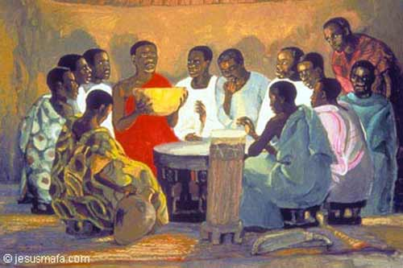  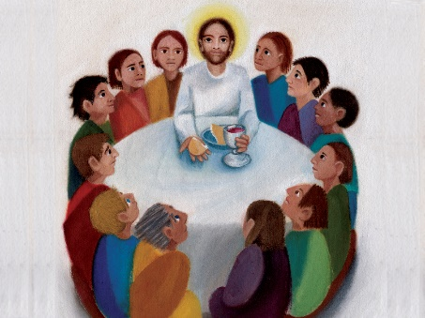  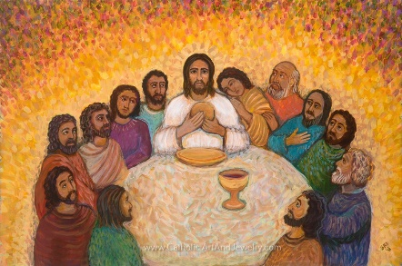  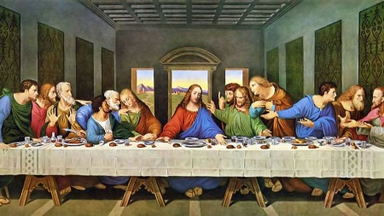  What gift did Jesus give us at the Last Supper?  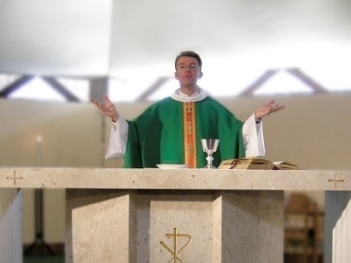
 | Give clear, simple descriptions of parts of the Mass | Pupils are expected to be able to give simple descriptions of some parts of the Mass as an individual task. Pupils do not have to complete the whole order of the Mass (though some no doubt will do), the whole order can be a done in partners or trios with the order of the Mass divided amongst them or as a group activity for the whole class (see activity 1 p. 65 new PB). These ‘Guide(s) to the Mass’ can be displayed.  Alongside the PBs, the teacher can use the power points on the order of the Mass (see resources) to help with this task.  - We Gather Together  We come inside the Church and sit at a bench [genuflect to the Tabernacle because Jesus is present inside it]  - We say Sorry: we think of when we said unkind words and hurt others. We ask Jesus to forgive us. We say ‘Lord have mercy, Christ have mercy, Lord have mercy’ (Make sure pupils do complete the activities on p. 55 of the new PB and p.53 of the old PB).  This part of the Mass is focused on the Lectern – the stand where we hear the readings from the Bible  - We Listen to God’s Word: we listen to readings from the Bible, [these are read from the lectern] the most important being the Gospel where we listen to Jesus words and what Jesus did. We listen so that we can think how we follow Jesus example and live like Jesus.  (There are activities on the readings in the Teacher Book (old TB pp. 74-75 and new TB pp. 60-61) to extend the learning. Teachers could also do a guided meditation on a gospel reading or a basic Lectio Divina to bring out what we can learn from a gospel reading.  There is scope here for teachers to recap the work – or to do some of the activities from Unit 2.3 The Good News. The expectation Answer questions like, ‘Are our actions more important than our words?’ ‘Why?’ (GD) began with an activity which tries to bring out the importance of words because they can guide us.  There is also scope for pupils to sort (if cut up by the teacher) some of the Responses at Mass by matching what the Priest says to what we reply, see new TB p. 62.  The next part of the Mass is focused on the Altar (table)  [For the teacher: after the gifts of bread and wine are brought to the altar and blessed, the priest says a long prayer called the Eucharistic Prayer recounting how wonderful God is and thanking God for all of creation and for His Son, Jesus. In this prayer, we listen as the priest retells the moment in the Last Supper when Jesus did something new – gave us a new gift, the gift of himself, his body and blood in the form of bread and wine.]  - We Offer Gifts to God – the Offertory: the simple description is the bread and wine are taken to the altar (table). Jesus used bread and wine at the Last Supper so we do the same.  It is important that pupils are taught, not only that the bread and wine are brought to the priest who takes them to the altar, but that the Offertory is a special time we are given to think about what we can offer Jesus. This is the point of the PB talking about invisible gifts. So while using the word ‘invisible’ isn’t that helpful, it is important for pupils to know that they are helping Jesus when they help others. So do allow pupils to complete the activities on p. 59 of the old (p. 76 old TB) and new PB (p. 63 of new TB) or do something similar.  - The Consecration: the simple description is that the priest repeats the words of Jesus about the bread ‘Take this, all of you, and eat of it. This is my body which will be given up for you.” And the wine, “Take this, all of you, and drink from it. This is the chalice of my blood, the blood of the new and eternal Covenant...”  It is at this point that the expectation Recognise the link between the Last Supper and the Mass can be explored through the art work.  - Holy Communion those who have made their first Holy Communion can come up to the front and receive Jesus. The priest says, ‘Body of Christ’ and ‘Blood of Christ’ and the people say ‘Amen’. If you have not made your first Holy Communion, you can come up for a blessing. It is a special time between just me and Jesus: we can tell him we love him.  - The End of Mass we go out of Church thanking Jesus [for his gift to us] by giving joy and love to others: how can we do this in class, in the playground and at home? | What are the different parts of the Mass?  What can you tell me about the photograph?  What happens at this part of the Mass?  Why do we say sorry?  What do we listen to?  Why is this important?  What is the Lectern?  What is a gospel?  Can you match what we say to what the priest says?  What do we bring up at the Offertory?  What can you offer Jesus?  What is it called when the priest repeats Jesus’ words ‘This is my body’, ‘This is my blood’?  [Consecration means made holy. What does ‘made holy’ mean? Not just special but ‘given to God’]  What happens at Holy Communion?  What can you have if you haven’t made your first Holy Communion?  Why is Holy Communion a special time?  What are we to do after we leave church at the end of Mass?
 | Give simple descriptions of some special signs and actions performed in Church and at Mass | Using photographs, pupils can give simple descriptions of some special objects from the church and some that are used at Mass:  - Crucifix: seen inside (on the outside of the church in the photograph) the church. We remember that Jesus died this way.[We make the Sign of the Cross]  - Candles: show that Jesus is the Light of the World  - Lectern: a stand for the bible. The readings are read from the lectern  - Altar: It reminds us of the table Jesus sat at during the Last Supper. It’s the table where the bread and wine become the body and blood of Jesus.  - Tabernacle: a box where the Body of Christ is kept safe.  - Sanctuary Lamp: it shows that the Body of Christ is in the Tabernacle  - Genuflect: kneel down on one knee to show we know that the Body of Christ is in the tabernacle.
 | Talk, ask and answer questions about their experiences of celebrations, saying sorry and the Mass | Pupils will focus on celebrations in general and those in Church as well as times they have fallen out and said sorry. The coronavirus restrictions may mean pupils have little memory of going to Church or celebrating Mass – though they may have celebrated a class Mass this academic year.  Suggested ideas could be to use images of celebrations (see resources for examples) using personal photographs, internet images, and from Church’s Story and its CD, photographs of celebrations in Church and some images from the Welcome to the Mass resource.  Celebrations: Teachers could begin with a sorting activity using pictures:  9a). Collect a number of pictures of celebrations, birthdays, weddings, anniversaries, seasonal celebrations like Christmas, Easter etc. Some need to be related to parish celebrations e.g. from Church’s Story books and CD and Welcome to the Mass; some related to family/school celebrations  As an individual, small group or class activity, ask pupils to:  Choose something to talk about relating it to their own experience. They could also do a sorting activity by identifying and naming those pictures that show religious or church celebrations and those that are not.  Activity – Picture labelling.  Using some of the pictures from Church’s Story 2 p.6-25 ask the children to talk about/label/write/scribe what they see and what is happening, using religious words and phrases.  Set up a Circle Time session focusing on ‘I remember when I celebrated………’  Draw a picture of a family celebration with faces annotated to show feelings of themselves and others and talk about it or bring in pictures from home of celebrations and talk about them.  In pairs, discuss Church’s Story 1 p. 30-31: ‘What do you think the children are celebrating?’ ‘How do they feel?’ How would you feel if you were at this celebration?  Alternatively, use a picture of a celebration. Invite children to say what they wonder about the picture (in groups or class circle time). Record using ‘thought bubble’ post-its.  From this initial exploration of celebrations, some church based some not, the teacher will lead pupils into a focus on what happens on a Sunday in church. Using a selection of images from Church Story 2/Welcome to the Mass (see resources) describe how the parish family celebrates a Sunday Mass.  This could begin with the teacher using a class doll with a box and tell the story of the doll – give them a name – who they live with etc. and put selected items in the box that you take out one-by-one, to tell the story of what the doll does on a Sunday. Your doll should go to church as well as do all the other things children may do on a Sunday.  Pupils are then invited to complete a piece of work that shows what they normally do on a Sunday. This could be taken further and made into a Sunday box like the dolls.  Saying Sorry: ask pupils to think about times when people need to say sorry. Use the picture on p. 51 of the old PB and the pictures on p. 55 of the new PB as a stimulus. The key is: saying sorry shows that we want to put things right again. We know we need to be kind and helpful, but sometimes we are not so at Mass we always ask for God’s forgiveness.  The Mass: rather than talking about their experience of Mass – which for many children will be far off because of the restrictions due to the coronavirus – pupils may wonder about and be curious about and ask questions of the Mass and the objects in the photographs. | What is happening in the (this) picture?  How are the people in the picture feeling?  What question can you ask about this picture?  What happens when you have a birthday?  Do you do anything together?  Where is this happening?  What is the thing the people are stood around?  What is happening?  How do you know?  What other celebrations happen in church? Can you name one?  If you haven’t used Church’s Story 1 or 2 they look like this and come with CD’s to display the images:  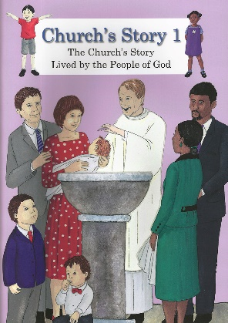  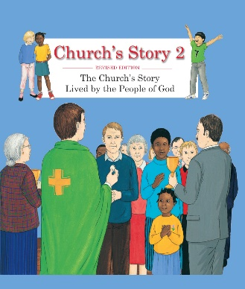  Do you do anything special on a Sunday you don’t do on the other days of the week?  Sunday is a very special day for Catholics and other Christians. Do you know what Christians or Catholics do on a Sunday?
 | Describe some ways in which they can live out the (mission of the) Mass | The expectation ‘Give clear, simple descriptions of parts of the Mass’ particularly the End of Mass goes some way to meet this expectation e.g. ‘we go out of Church thanking Jesus [for his gift to us] by giving joy and love to others: how can we do this in class, in the playground and at home?’  It is also important to bring to this expectation that when we Listen to the Readings we think about their meaning for us and try and put the message of the readings into practice.  The two readings given in the TB (old TB pp. 74-75 and new TB pp. 60-61) or bible passages or stories of the teacher’s choice should not only ask for the message of the reading, but also how the pupil will put that message into practice after the Mass has ended? | How can you bring joy to other people?  How can you show you love others?  What is the message of that reading, what does it mean to you?  How would you act on that message, what would you do?

