INTERPRETATION OF PRIMARY RELIGIOUS EDUCATION EXPECTATIONS
SPRING SECOND HALF TERM
YEAR 6
UNIT | EXPECTATION | OUR UNDERSTANDING | PROMPT QUESTIONS
6.4 Jesus, Son of God / Messiah | Show understanding of the title Son of God by making links with Bible texts (old book). | The old PB pp. 50-54 uses the miracles of Jesus as a way of showing that Jesus is the Son of God. The learning objective is ‘Know that Jesus’ miracles led many to believe he was the Son of God’.  Firstly however, it is important for pupils to recognise that the title ‘Son of God’ for Jesus expresses the Christian belief in the Incarnation – that God became man in Jesus. Pupils should therefore look for evidence in bible texts that Jesus is both truly man and truly God.  Working in pairs or a trio pupils look up the following references:  Luke 2:5-7; 2:51-52; 8:23; 24:42-43  Luke 1:26-37; 2: 41-50; 3:21-22; 4:31-37  And answer the question: ‘How do we know Jesus is truly God and truly man?’ Pupils could design a poster, diagram to show their understanding.  Remind pupils of the earlier work on the Kingdom of God pp. 15-16 of the old PB. That God has power over nature and that Jesus’ miracles are signs that the Kingdom of God had arrived. Ask pupils to read Luke 4:16-21. Ask pupils to answer the question: ‘How does this story show that Jesus is the Son of God?’  The learning now needs to bring in the different reactions to Jesus because this will enable the pupils to begin to grasp why it was that Jesus was killed on Good Friday.  Take the question at the top of page 52 ‘Did everyone believe him to be the Son of God when they saw his miracles?’  Introduce the pupils to the Pharisees, a group of Jews at the time of Jesus who were the ultimate rule keepers  Ask pupils in pairs or trios to think about and list classroom rules and school rules. Ask them to choose two different rules and give a reason why it is a good rule and should be kept. The teaching point for this is that rules are useful and express a good intention or desire to keep people happy or safe etc.  However, the teacher should now take this further and explore with the pupils that sometimes a rule can get in the way of doing good.  Give pupils the PDF sheet entitled ‘Jesus’ enemies’. Focus on the Pharisees and tell the pupils that the commandment about the Sabbath meant that on the Sabbath Jews should rest and do no work and instead they should worship God. Ask pupils to read the full account of Matthew 12:9-14 ‘The Man with a Paralysed Hand’.  The Pharisees were an influential Jewish group at the time of Jesus. Their name means ‘separated ones’ and comes from two things:  1. They thought of themselves as the best Jews because they kept the Law of Moses more strictly than anyone else. They thought everyone else was inferior to them. They didn’t associate or mix with others they thought were less good, particularly sinners and foreigners.  2. The Pharisees prided themselves on their knowledge of the Law of Moses. They had a great desire to protect the Commandments from being broken so they set up extra rules around them like fences (separated them off) to limit the very possibility that the actual law could be broken. For example, the Commandment ‘Keep the Sabbath day holy’ is usually interpreted to mean worship God and do not work. However, the Pharisees added extra rules which defined work minutely. Some examples of prohibited work included ‘carrying’ ‘writing’, ‘untying’, ‘cooking’, ‘washing’, ‘tearing’ and ‘marking’ – there were many more. Only work that was vital (work in the Temple or Synagogue on the Sabbath) or in response to an emergency was allowed on the Sabbath.  Jesus made an enemy of the Pharisees by criticising their use of extra rules particularly about the Sabbath.  Jesus criticised the Pharisees’ extra rules because they prevented people responding to opportunities to show their love for God and their neighbour by doing good. Jesus did not break the Sabbath law, he worshipped God his Father (see Luke 4:16 “Then Jesus went to Nazareth, where he had been brought up, and on the Sabbath he went as usual to the synagogue”).  But the extra rules of the Pharisees got in the way of the real meaning of keeping the Sabbath Day holy. The Pharisees were policing the rules so minutely (see the PDF of the Concentric Circle Sabbath) that they got lost in the detail and forgot about the true meaning of the Sabbath. For Jesus, keeping the Sabbath holy did not mean doing no work at all, but doing God’s work by going about doing good by responding to human need with love and compassion (the Parable of the Good Samaritan makes the same point in a different context because the rules about a body lying at the road side – which would be ritually unclean – meant that the priest and Levite would not help the man who had been left for dead for fear of becoming unclean themselves).  For example, “No Carrying” does not just mean do not carry a bag, but also means not doing anything that shows your power over the natural world. So making something out of wood is prohibited, so is collecting wood for a fire, but so is performing miracles because miracles show power over nature. So Jesus should not, according to the Pharisees, perform healing on the Sabbath because it is against the Pharisees’ rules; but for Jesus, this very rule prevents good from being done – it makes the rule more important than performing good deeds out of compassion and love. This is why Jesus says at Mark 2:27-28 “The Sabbath was made for the good of human beings; they were not made for the Sabbath. So the Son of Man is Lord even of the Sabbath.”  For the Pharisees, healing a paralysed hand (see Matthew 12:9-14) was not an emergency, the hand could be healed before or after the Sabbath because the life of the person with the paralysed hand was not in danger. Jesus could have waited and healed the hand after the Sabbath day. In the eyes of the Pharisees, Jesus’ action was a form of work that broke their Sabbath rule.  Perhaps setting up a debate on who has the best case or whose side of the debate is strongest is something the teacher could set up with pupils. Alternatively, this lends itself to the Conscience Alley or Pros and Cons Tunnel.  Jesus also criticised the Pharisees for thinking they were really good people at the same time as despising other people. Jesus spoke out against the Pharisees and this made them hate Jesus even more. Use the Parable of the Pharisee and the Tax Collector, Luke 18:9-14 at this point.  Encourage the children to become familiar with the story through role play. Write prayers anonymously: one the Pharisee might say and one the tax collector might say. Ask the children to read prayers for others to guess which character might say the prayers.  Give pupils the text of Luke 18:9-13 and then ask them to complete the table on the PDF sheet ‘The story of the Pharisee and the Tax Collector’.  Finally, to answer ‘Did everyone believe him to be the Son of God when they saw his miracles?’ The pupils will know that the people at the time of Jesus believed he performed miracles. Those people who disliked Jesus, either criticised Jesus for performing miracles on the Sabbath day e.g. the Pharisees, or said he must be performing them through the power of Satan – the devil. Mark 3:22-27 gives Jesus’ answer to the teachers of the Law who say he is performing miracles by the power of the devil. Ask pupils to write down in their own words what Jesus’ answer means. | What have the words Son of God and Incarnation got to do with Jesus?  Can you find examples in the gospel of Luke that show Jesus is a human being?  Can you find examples in the gospel of Luke that show Jesus is truly God?  What sorts of things show Jesus is human?  What sorts of things show Jesus is divine (truly God)?  In what ways does this miracle of Jesus show that he is the Son of God?  Did everyone accept that Jesus was the Son of God?  Why did some people not believe in him?  Who were the Pharisees?  Explain what the Sabbath day was about.  What did Jesus think about the Pharisee’s Sabbath rules? Why?  Were the Pharisees right to say Jesus should not heal on the Sabbath day?  There were two reasons why the Pharisees thought that healing the man with the paralysed hand on the Sabbath day was wrong, what were they? (the man’s life was not in danger; healing is work because it shows power over nature)  If you were Jesus what would you do?  Rules are really helpful: can you give two examples how they are helpful?  Sometimes a rule is not helpful because it stops you from doing something good: can you give an example?  The Concentric Circle Sabbath shows the Commandment “Keep the Sabbath Holy” in the centre, but on each circle going out from the centre is a NO YOU CAN’T – work, carry etc. The point is that it focuses on the minute rules rather than what the Sabbath is really about!  Conscience Alley/Pros and Cons Tunnel  The aim of this activity is to create a balanced argument, considering how and when, not just what, we say. It develops a range of perspectives, encouraging decision-making and challenging attitudes.  Pupils are split into 2 groups. Each half will explore one side of an issue.  Eg: In the story of the Man with the Paralysed Hand, should Jesus heal the man on the Sabbath? One side gives reasons to say yes, the other side agree with the Pharisees and give reasons not to heal the man.  - Each individual should have a separate point to make  - Each half agrees the order in which the individuals are going to present their argument and lines up  - The 2 lines face each other, forming a tunnel and a volunteer walks down, listening to the points which alternate between each side of the argument  - It is important to consider how each point is delivered and where in the line it will come  - At the end the volunteer decides which way he/she has been swayed and why  - This leads to a discussion of the strength and influence of certain points  Ask: What might Jesus be trying to say to people in this story? Why did he tell the story?  Which virtues did the Pharisee in the story need to develop?
 | Recognise difference comparing and contrasting different reactions to Jesus | Pupils following the old PB will have completed the work above and got to page 54 ‘Reactions to Jesus’. Using their knowledge about Jesus on the Sabbath and their knowledge about the enemies of Jesus (see PDF ‘Jesus’ enemies’) pupils answer Activity 4. The miracle of the healing of a man born blind is in John 9:1-34 and it is worth getting the pupils to read it in the Good News bible version. Pupils may debate whether miracles happen or not as part of responding to A ‘I don’t think the man was really blind from birth’. To show they can compare contrasting reactions to Jesus pupils will need to say which reaction, in their view, is the weakest and strongest. | What were the different views about Jesus and his miracles?  What is the weakest reaction to Jesus?  Is there a view you agree with? Why do you agree with it?
 | Show understanding of the title Messiah by making links with scripture (new book) | Use RE Ideas Jesus ‘Why do Christians call Jesus the “Messiah”? pp. 26-31 in conjunction with the text on pp. 67-69 of the new PB for this expectation.  It is important for pupils to know what the word Messiah means (anointed one) and the practice of anointing shows that someone is chosen by God (could relate this to Baptism)  It is important for pupils to know why the Jews at the time of Jesus longed for a Messiah.  It is important for pupils to know the similarities and differences between the Jewish ideas about the Messiah and what sort of Messiah Jesus actually was.  Compare two works of art on the Transfiguration as a companion to activity 3 on p.29 of “Why do Christians call Jesus the Messiah?” Using Raphael and Bellini:  Discuss with the pupils whether they can see the shining light, Moses and Elijah, the mountain.  What do they think each of these might mean?  Ask pupils to write the description to be put next to the art when it’s displayed in an art gallery.  The description must include: connections to the text / the meaning of this story for Christians / the clues that show Jesus is more than the expected Messiah (i.e. the Son of God).  Transfiguration means ‘transformation’. Teachers could extend the learning at this point and link to ways Christians or pupils themselves are inspired by Jesus to transform their own lives or the lives of others by supporting work by their Lenten charities (e.g. CAFOD) or work in school by the Mini-Vinnies or through Faith in Action. | What does the word ‘Messiah’ mean?  What does being ‘anointed’ mean?  Why did the Jewish people living at the time of Jesus long for a Messiah to come?  What was the Messiah expected to be like?  What sort of Messiah was Jesus? How do you know?  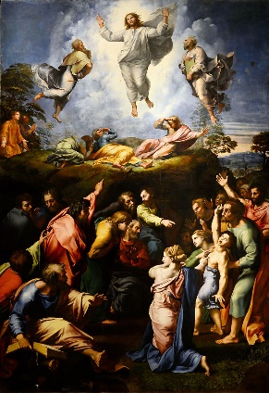  Raphael  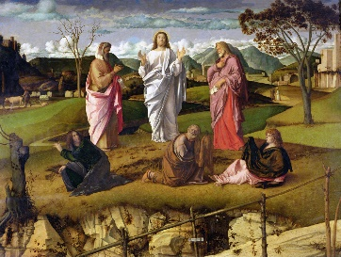  Bellini
 | Recognise difference comparing and contrasting the Jewish and Christian understanding of the Messiah | Pupils can meet this expectation by using all the activities from RE Ideas Jesus pp. 26-31. Pupils should also focus on the story of the Transfiguration and how it changes the view of the Messiah in Christian eyes principally through use of the titles Son of God and Son of Man and the idea that Jesus will suffer, die and rise again.  Pupils should be taught that the story of the Transfiguration transforms – changes - the Jewish understanding of Messiah because Jesus is not only a human person, but the Son of God and he will be a suffering servant of the people (not a warrior king) who will suffer and die but be raised from the dead. In the last verse of the story in Matthew 17 v. 9 Jesus speaks of himself as the Son of Man saying “Don’t tell anyone about what you have seen until the Son of Man has been raised from the dead.” This title is the title Jesus prefers to use for himself in the gospels. It comes from the Book of Daniel and refers to one who has authority and will rule over all other kings. The title Son of Man is also linked in the gospels to the suffering and death of Jesus as in “the Son of Man came to serve not to be served, and to give his life as a ransom for many.” (Mark 10:45). Three times in Mark’s gospel Jesus talks to his disciples about his coming rejection, suffering, death and resurrection using the title Son of Man see Mark 8:31-32; 9:30-32; 10:32-34. So the implication of Matthew 17 v9 is that Jesus will be rejected, suffer and die before being raised from the dead. The reference to Jesus rejection, suffering and death and being named Son of God are the distinctive features that differentiate the Christian understanding of the Messiah from the Jewish expectation at the time of Jesus. | What is similar in the Jewish and Christian view of the Messiah?  What parts of the story of the Transfiguration show that Jesus is more than the expected Messiah?  Can you name other actions or sayings of Jesus that show he is more than the expected Messiah? (At his Baptism; the sayings “Love your enemies” or “Happy are the peacemakers”; Mark 10:45 or an example when he speaks of his suffering and death.)
 | Show understanding of the events of Holy Week | While the new PB pp. 70-71 has work on Jesus’ entry into Jerusalem there is no material in the old PB on Jesus Entry into Jerusalem today called ‘Passion’ (or Palm) Sunday’. To show understanding of the events of Holy Week it is important to cover this event as it is the beginning of Holy Week and also expresses the hopes of many at the time of Jesus that Jesus is the Messiah though their understanding of Messiah was not always the same as Jesus’ view.  Pupils can read the story in parts, dramatise it and can watch the clip from The Miracle Maker film of the Entry into Jerusalem (https://vimeo.com/404287245 [47.10- 51.25]) It shows the hopes of the people and in the person of Judas gives the view of the warrior king. The clip begins with the rising of Jesus’ friend Lazarus from the dead to show the worries of the rulers in Jerusalem and the plan of Caiaphas, the high priest, to have Jesus killed.  [For the teacher: for those who wanted a warrior king Messiah the symbolism of the entry of Jesus into Jerusalem couldn’t have been stronger. It was the festival of Passover which remembers and celebrates the liberation of the Jews from slavery in Egypt where God vanquished the army of the Egyptians. There were Jews who believed in fighting to rid the land of the Romans (remember one of Jesus’ 12 disciples was ‘Simon the Patriot’ see Luke 6:14 and it may be that Judas was disillusioned as he begins to see that Jesus is a humble Messiah figure giving him a motive to betray Jesus (this is hinted in the Miracle Maker film). The Romans are an occupying force and the Jewish priests and leaders in Jerusalem are only ruling their own people because they are allowed to by the Romans. Any rebellion would risk their position because they would be seen as unable to control their own people. This explains their plans to kill Jesus by making Jesus a scapegoat whose death will keep the pact alive between the Romans and Jewish priests (this is the root of Caiaphas’ statement “Don't you realise that it is better for you to have one man die for the people, instead of having the whole nation destroyed?"” (John 11:50))  Jesus deliberately rides into Jerusalem on a donkey (colt) thereby fulfilling the prophecy of Zechariah 9:9-10 “Rejoice, rejoice, people of Zion!  Shout for joy, you people of Jerusalem!  Look, your king is coming to you!  He comes triumphant and victorious,  but humble and riding on a donkey—  on a colt, the foal of a donkey. The Lord says,  “I will remove the war chariots from Israel  and take the horses from Jerusalem;  the bows used in battle will be destroyed.  Your king will make peace among the nations;  he will rule from sea to sea,  from the Euphrates River to the ends of the earth.”  When he enters Jerusalem the people shouted “God bless the coming kingdom of King David, our Father! Praise God!” (Mark 11:10).  The riding on a donkey (rather than a horse) and the title King or Son of David are clear references that Jesus is being hailed as the Messiah. As we know from the stories of Jesus’ nativity, the Messiah was to be a descendent of King David see Matthew 2:3-6. ]  Teachers can extend the learning by discussing with pupils how they can follow the example of Jesus and be peacemakers like Jesus the Messiah. Pupil could look at the work of Pax Christi and design a draft of a Peace Garden https://paxchristi.org.uk/wp/wp-content/uploads/2013/10/Create-a-Peace-Garden.pdf  Both the old and new PBs next cover the events of Holy Thursday. However, teachers can supplement the learning about Holy Week by focusing on Jesus Goes to the Temple (Mark 11:15-19). Jesus goes to the Temple the day after Palm Sunday – it corresponds to the Monday of Holy Week. Watch a clip from The Greatest Story Ever Told www.youtube.com/watch?v=rUJVTdNSCTA  Using the painting of The Angry Christ by Lino Pontebon from The Christ we Share resource and the PDF Temple 1 complete the activities. In pairs or a trio pupils can complete PDF Temple 2 activity.  [For the teacher: Israel’s covenant with God was understood as a covenant that would apply to all the nations (Abraham’s name means ‘father of many nations’) of the earth eventually. It was the understanding at the time of Jesus that through the Jewish people all other people would be brought to God. The Temple in Jerusalem modelled this understanding because within it was a place for non-Jews, the Gentiles, to pray. It was just inside the Temple and called the ‘Court of Gentiles’. You could use a diagram of Herod’s Temple at the time of Jesus to show this. However, Jesus is angry because the Temple authorities are making it difficult for Gentiles to pray by converting it into a market for the buying of animals for sacrifice and money changing. Roman coins were not allowed in the Temple so to buy an animal people had to exchange them for Temple money. In this exchange people were ripped off. Ritual sacrifice of animals was an expensive business and so the poor were at a disadvantage and excluded from worship in this way. This is the background for Jesus’ anger and why he says the Temple has been made into a ‘hideout for thieves instead of a house of prayer’ and in the Calling of Matthew the tax collector, Jesus says to the Pharisees “Go and learn the meaning of the scripture I desire mercy not animal sacrifices” (Matthew 9:13)  Show understanding of the events of Holy Thursday. Both the old and new PB focus on the story of the Last Supper from John’s gospel so as not to repeat the emphasis on the Eucharist, which was central to the last unit of work, and instead focus on Jesus’ washing of his disciples feet, the betraying of Jesus by Judas and the disowning of Jesus by Peter.  Pupils read the story from John 13:1-15 and answer questions 1 (a) and (b) from p. 57 of the old PB and questions (a) to (c) on p. 73 of the new PB. The key for the focus on the foot washing at the Last Supper is to bring out again the nature of Jesus’ messiahship as a self-giving servant who always puts other people’s needs before his own. This is why the old PB uses a quotation from Philippians 2:6-7 on p. 56.  A useful exercise is to ask pupils to make links with specific virtues that Jesus displays: from the https://www.virtuestoliveby.org/ website pupils might pick courtesy, patience, simplicity, kindness and service. They might also pick humility and gentleness from https://www.dioceseofleeds.org.uk/education/wp-content/uploads/2019/05/CLASSIFICATION-OF-THE-VIRTUES.pdf  Pupils can say how they apply to Jesus and how they themselves can show these virtues.  The betrayal of Jesus by Judas and the Denial of Peter.  Questions 2-3 on p. 57 and questions 1-4 on pp. 60-61 of the old PB and questions a-i on p. 75 and 1-4 on p. 76 of the new PB are good questions and the learning will be enhanced if this is supplemented by the exploration of artwork through activities within the Picturing Jesus booklet.  Teachers could begin the story of Jesus in the Garden of Gethsemane using a guided visualisation before engaging with the text from the bible and the PB see PDF Guided visualisation.  Both the old and new PB have a good activity in asking pupils to weigh the evidence to decide if Jesus had a fair trial before the Sanhedrin. This can meet the expectation: Recognise difference comparing and contrasting differences: whether the Trial of Jesus was fair or not (GD)  Alongside the activities on Good Friday in the old and new PBs pupils could be asked to look at some art of the crucifixion. See PDF ‘Images of Crucifixion’ and PDF ‘Pieta’. Pupils could also engage in the thinking skills activity of Responsibility Pies answering the question: ‘Who was responsible for Jesus’ death?’ See activity sheet on this.  The Resurrection: the activities in the old PB pp. 62-63 and the new PB pp. 80-81 give an opportunity for pupils to show an understanding of the resurrection for Christians.  See RE Quest website link to view 3 short videos in which Christians talk about the importance of the resurrection for them:  https://request.org.uk/festivals/holy-week-and-easter/why-is-the-resurrection-so-important-to-christians/#  To supplement this work on the resurrection pupils can work through the activities from RE Today’s booklet Opening Up Easter entitled ‘What does Easter really mean? On pp. 26-29 | Describe Jesus’ entry into Jerusalem  What parts of the story show that Jesus is the Messiah?  Highlight the links between Mark 11:1-10 and Zechariah 9:9-10  What sort of Messiah is Jesus? What’s the evidence for this in this text and from what you know about other things Jesus said and did? (E.g. “Happy are those who work for peace; God will call them his children.” Matthew 5:9; “Love your enemies” Matthew 5:43)  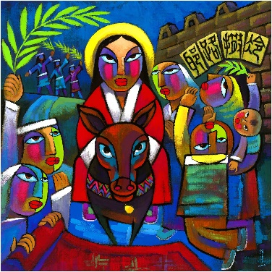  He Qi Christ’s Entry into Jerusalem  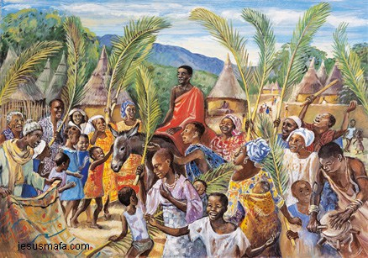  Mafa Christ’s Entry into Jerusalem  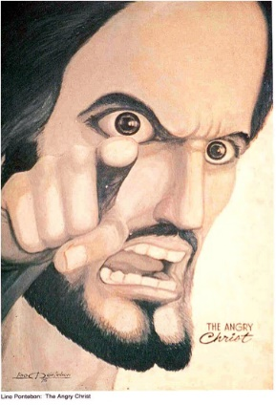  See Picture card 13 Edward Burra’s ‘The Expulsion of the Money Changers’ from Picturing Jesus, RE Today. There is a useful set of questions on the back for use in the classroom.  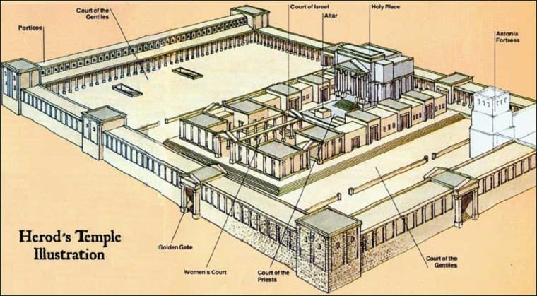  At the time of Jesus a servant would wash the feet of guests. Foot washing was a practical act but also a sign of hospitality.  How do you know that Jesus’ disciples were shocked by what Jesus was doing?  What message is Jesus wanting the disciples to learn from the foot washing?  Which virtues is Jesus showing in the foot washing?  Give some examples how you can put these virtues into practice?  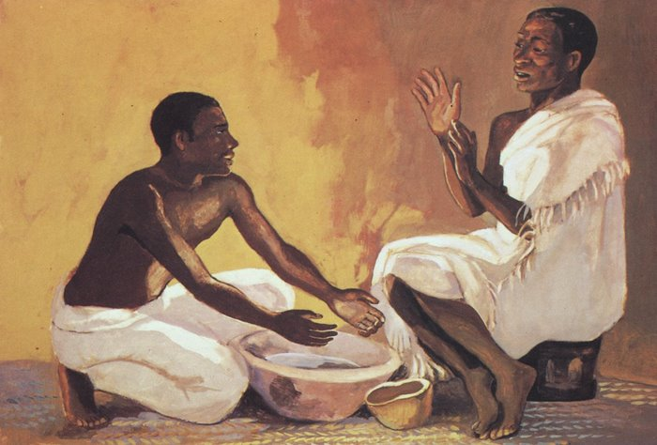  Mafa, Jesus washing Peter’s feet  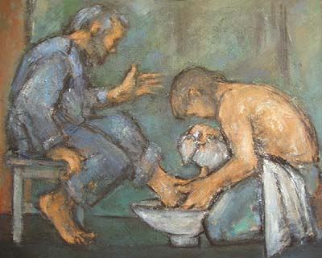  Ghislane Howard, Jesus Washing Peter’s Feet  Linda Roberts has some Stations that add different events to the traditional stations of the cross, the 2nd on the betrayal of Jesus by Judas and the 4th the denial of Jesus by Peter  https://lindaesroberts.com/?p=44  Peter’s Denial by Frank Wesley see http://www.frankwesleyart.com/Gallery1.htm and scroll down to ‘Peter’s Denial 2’  Dinah Roe-Kendall ‘The Courtyard’ portrays the denial of Peter see picture 16 in Picturing Jesus RE Today. (Peter is on the right with his hand on his head in anguish facing away.)  The Passion of St Matthew by J. S. Bach Part 2 track 39 an aria entitled “Erbarme dich, mein Gott” (“Have mercy, my God,  for the sake of my tears! See here, before you heart and eyes weep bitterly. Have mercy, my God.”) Peter’s lament after disowning Jesus:  https://www.youtube.com/watch?v=hQjN_pTjpXc  An instrumental version is here with the oboe playing the part of the voice:  https://www.youtube.com/watch?v=3tZ2wfxzOeQ  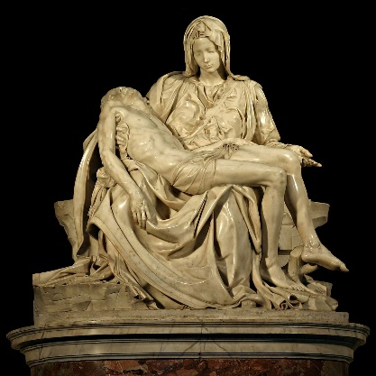  Michelangelo ‘Pieta’
 | Show knowledge and understanding of worship during Holy Week in Church by making links between beliefs and worship | In the new PB there is a section on pp. 82-85 that outlines what happens in Church during Holy Week. The following link shows the beginning of the Mass of Passion (Palm) Sunday. It shows the blessing of the palms, the reading of the gospel account of Jesus’ entry into Jerusalem and the procession with palms. Alongside the photographs and text in the new PB it will enable pupils to answer the questions on page 82.  https://www.youtube.com/watch?v=Sa6N74jhchI  Pupils will be expected to make a connection between what happens at the Palm (Passion) Sunday Mass and beliefs about Jesus.  - At Mass on Palm Sunday we reenact the procession of Jesus into Jerusalem: this expresses Christian belief that Jesus is the long awaited Messiah who comes on a donkey (Zechariah 9:9)  - The entry of Jesus is re-enacted with the holding and waving of palm tree branches. Palm branches are a sign of peace, expressing the belief that Jesus is a peaceful Messiah. The belief that Jesus is the king of peace is also shown in his entry into Jerusalem on a donkey not a war horse.  - The palms are often made into crosses and displayed at home or in the car to remind us that Jesus came as a humble servant who gave his life for us.  - The vestments worn by the priest and the cloth over the tabernacle and the lectern (if applicable) are red, expressing our belief that Jesus gave up his life to save us. We are also reminded of the sacrifice of Jesus – his suffering and death – because the main gospel that is read retells the story of his passion (suffering and death). This is why the Church calls Palm Sunday ‘Passion Sunday’.  Holy Thursday: clip from a church in the US of a foot washing https://www.youtube.com/watch?v=fxhArffcXZM  The Mass on Holy Thursday celebrates the Last Supper of Jesus with his disciples when he gave the gift of himself in the Eucharist (‘This is my body’, ‘This is my blood’) and re-enacts the foot washing which teaches us that we should be like Jesus and seek to serve others and meet their needs before our own.  At the end of Holy Thursday Mass the sanctuary and altar is made bare – this is called the ‘stripping of the altars’. This is to remind us that Jesus was stripped of his garments before he died (see Matthew 27:27-28):  https://www.youtube.com/watch?v=7M2nrq9ewYk  Good Friday:  The Stations of the Cross: are a spiritual reflection and journey through the events of Jesus last hours to his death – the Way of the Cross. They recall the pilgrimage of Christians from the 4th Century onwards to the Holy Land and the visiting of the sites central to Holy Week. They enable participants to reflect on what happened to Jesus and place ourselves within the story of Jesus’ suffering and death. [This link which gives 8 reasons from Pope Francis to undertake the journey of the Stations of the Cross will give some insight into their importance.] https://focusequip.org/why-pray-the-stations-of-the-cross-8-reasons-from-pope-francis/  The 14 Stations of the Cross are:  - Jesus is condemned to death ;  - Jesus receives his cross  - Jesus falls the first time  - Jesus meets his Mother  - Simon of Cyrene is made to carry the cross;  - Veronica wipes the face of Jesus  - Jesus falls a second time  - Jesus meets the women of Jerusalem  - Jesus falls a third time  - Jesus is stripped of his garments  - Jesus is crucified  - Jesus dies on the cross  - Jesus’ body is taken down from the cross  - Jesus is laid in the tomb  Good Friday Service at 3pm: The service is at 3pm – the time Jesus died. It is not a Mass – when bread and wine are made holy and become the Body and Blood of Christ - on Good Friday although Holy Communion is offered at the end of the service from bread consecrated the day before.  Good Friday, of all days in the Church’s year is the most sad and sombre and the celebration of the Mass is out of place. We instead fix our gaze upon the crucified Jesus and venerate the Cross by kissing the feet of Jesus. [For the teacher: in John 19:37 it says “People will look at him whom they pierced” which comes from Zechariah 12:10 “And I will pour out on the house of David and the inhabitants of Jerusalem a spirit of grace and supplication. They will look on me, the one they have pierced, and they will mourn for him as one mourns for an only child, and grieve bitterly for him as one grieves for a firstborn son.”] And reflect on his suffering and death and the sins of the world and my sins that were weighed upon him.  Easter Vigil  The new PB gives a useful summary of what happens at the Easter Vigil Service of Light and Mass. The long Exultet (Triumphantly happy) prayer begins with these words:  Exult, let them exult, the hosts of heaven,  exult, let Angel ministers of God exult,  let the trumpet of salvation  sound aloud our mighty King's triumph!  Be glad, let earth be glad, as glory floods her,  ablaze with light from her eternal King,  let all corners of the earth be glad,  knowing an end to gloom and darkness.  Rejoice, let Mother Church also rejoice,  arrayed with the lightning of his glory,  let this holy building shake with joy,  filled with the mighty voices of the peoples. | What happens during the Mass of Passion (Palm) Sunday?  What does it tell you about Catholic beliefs in Jesus?  What gift of Jesus does the Mass in the evening of Holy Thursday remember and celebrate?  What is re-enacted in church on the evening of Holy Thursday? Why do we (Catholics) do this?  What is the ‘stripping of the altars’ and why is it done?  Give 3 reasons why the Stations of the Cross are good thing to do on Good Friday?  Pick 2 of the 14 stations. Create your stations drawing ideas by looking at other versions and write a reflection for each.  See https://www.google.com/search?q=turvey+abbey+stations+of+the+cross&tbm=isch&chips=q:turvey+abbey+stations+of+the+cross,online_chips:painting&rlz=1C1GCEU_enGB866GB866&hl=en-US&sa=X&ved=2ahUKEwj2xvbzs6_uAhVRXxoKHQlNDDAQ4lYoC3oECAEQJA&biw=1349&bih=625#imgrc=5Je6Qobmecmg-M  Here is a good summary video of the Easter Vigil – the first half being the most important  https://stswithuns.org.uk/easter-vigil-mass/  What has Jesus triumphed over?  How did Jesus triumph over this?  Why are Christians triumphantly happy at Easter?  What does darkness represent?  What does light represent?  Why is the Paschal (Easter) Candle the most important candle in a Catholic Church?  What so the symbols on the Paschal Candle represent?  Paschal Candle  https://diocesan.com/product/easter_sunday_14/  There’s a Paschal Candle template on Twinkl see:  https://www.twinkl.co.in/resource/t-t-27220-design-a-paschal-candle-activity-resource-creation
 | Express a point of view and give reasons for it | Pupils will have lots of opportunities to express a point of view during this unit. When learning about the Pharisees and the Sabbath, the miracles of Jesus, the evidence for the human and divine nature of Jesus, the Messiah and the events of Holy Week. Whatever their point of view pupils will need to say why they think what they do.

