INTERPRETATION OF PRIMARY RELIGIOUS EDUCATION EXPECTATIONS
SPRING SECOND HALF TERM
YEAR 1
UNIT | EXPECTATION | OUR UNDERSTANDING | PROMPT QUESTIONS
1.4 Following Jesus | Talk about their friends and friendship  Ask and respond to questions about Jesus’ friends | Pupils will need to spend some time reflecting on and talking about friendship and the friends. How much time pupils need to spend reflecting on friendship depends on the teacher. The teacher could focus on how friends can help us using some of the lyrics of the Beatles’ song ‘A Little Help from my Friends’. This could generate some ideas from the pupils about how their own friends help them and these ideas could be displayed.  This could then link to Jesus’ call of the first disciples in Luke 5:1-11.The Call of the Disciples (Luke 5:1-11) The key idea is that Jesus needed friends to help him tell everyone the good news that God loves everyone.  The Miracle Maker film clip (4.00) could be used at this point as well as the story in the Teacher book. There is a clip of the Call of the First Disciples (4.00) in the Miracle Maker film: https://www.youtube.com/watch?v=poNuGusSX5c  What do you think you would need to a person who catches fish in the sea? What would you need to be good at? Responses are written into the Teacher Book, old TB, p. 54 and new TB p. 74.  The pupils could think of one quality they have that would be a way they could help Jesus too. This could be displayed in a scene of a boat with a net and each idea written on a fish template.  The focus in the story on Peter and how he was curious about Jesus can be picked up and applied to the worksheet on Simon Peter (see resources). Teachers could read the story up to ‘Jesus is no ordinary person.’ The question about Simon being renamed Peter also focuses on what Peter will be like in the future as well as what he was like when he met Jesus. | What is a friend?  Why might you choose someone as your friend?  Why is it good to have a friend?  How does your friend help you?  What is the best thing about your friend?  Jesus needed friends too, what did he want his friends to help him do?  Can you name one of Jesus’ friends?  What job were some of Jesus’ friends doing when Jesus met them?  What do you think you would need to a person who catches fish in the sea? What would you need to be good at?
 | Talk about their feelings and experience of prayer (new book)  Recognise some religious signs of prayer (new book) | Have a collection of things associated with prayer: rosary beads, a small children’s bible, prayer cards, written out prayers, candle, holding cross, music cd etc. If you use the Big Book there is a picture of Jesus teaching his friends the “Our Father”. These can be used as an introductory session detailed on p. 76 of the new TB.  In a circle time activity with a small group pupils can be encouraged to choose an object and say why it could help them pray.  The Lord’s Prayer: “Our Father”  Focus on our FATHER – perhaps explore the word ‘Father’ what it (the best FATHER ever) tells us about what God is like. There are some useful ideas in Opening Up Christianity (RE Today) in What do Christians say God is like? Pages 12-13 are particularly relevant for this activity.  The questions in the new TB are a good exercise to bring out the learning. Teachers who want to take it a little further could use jelly babies. Choose 4 jelly babies and make each stand for a type of prayer: praise, ask, sorry and thanks.  Your able pupils could be asked to match at least three types of prayer to parts of the “Our Father”. Praise: “Our Father, who art in heaven, hallowed be thy name.” Ask: “Give us this day our daily bread”. Sorry: “And forgive us our trespasses” They could then be asked to choose two types of prayer and compose a prayer for each using the word bank (see resources).  The teacher could ask pupils to choose a (jelly baby) type of prayer and compose a prayer using the word bank (see resources).  Another extension: use the song ‘How we need you’ from Fischy Music which is available from their online Collective Worship. It is also available through the booklet Big, Big Questions from RE Today. It can be used as a theme for why we pray! | Why do you think Jesus prayed to God his Father?  What do you think he friends thought when they saw Jesus praying?  What do you think you need to able to pray?  What do you think Jesus’ friends thought when he said call God ‘Father’ like him?  What is a good Father like?  Is God like this? How?
 | Begin to retell, in simple form, the story of the miraculous catch of fish, Good Samaritan, Palm Sunday and Good Friday | Pupils do not need to begin to retell, in simple form, all these stories. Teachers can expect pupils to be able to begin to retell at least two. The expectation is about pupils beginning to sequence the story so that their retell has some things in the correct order. This simple form could be oral, and mix of oral and pictures and it could use different media to create the story – this could be individually or in pairs to bring together a sequence.  It is good to ask pupils to look at pictures of the events: below are 3 images of the Call of the First Disciples (Luke 5) and the Parable of the Good Samaritan (also see resources).  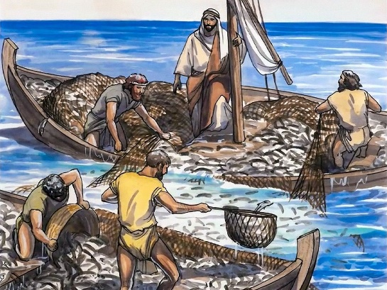  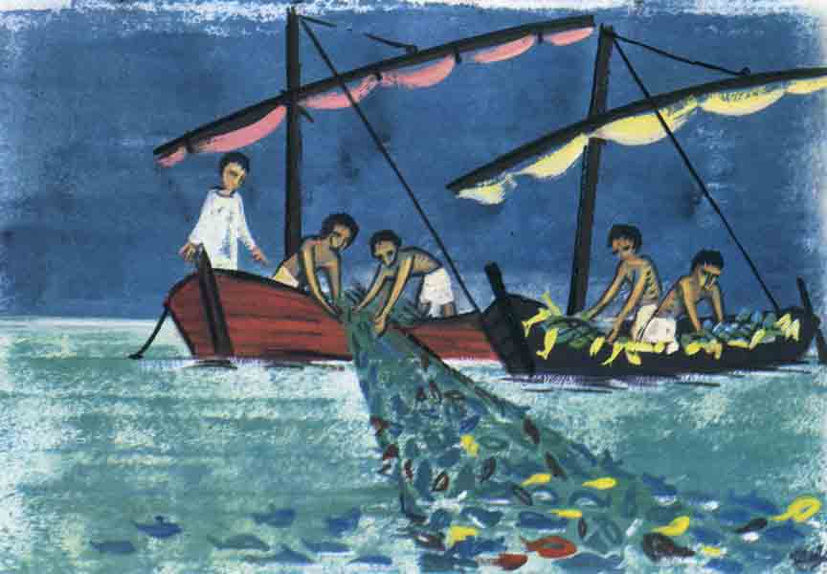  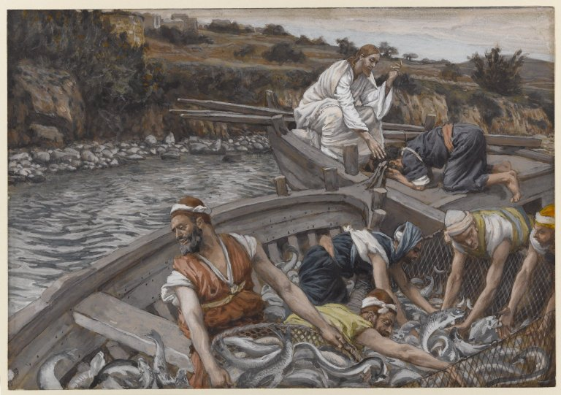  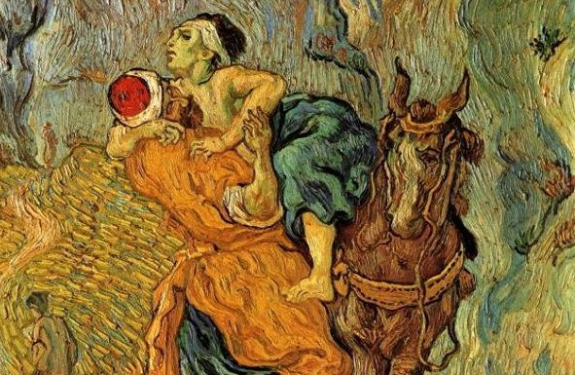  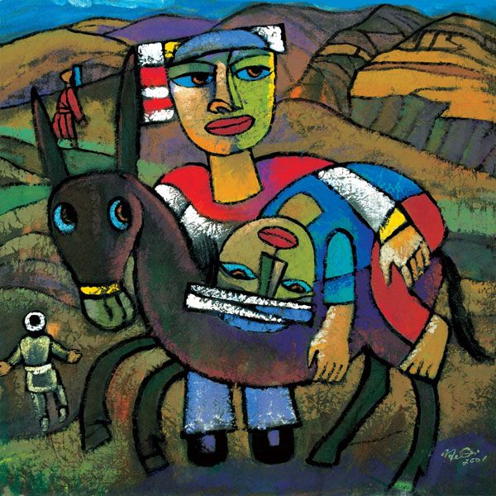  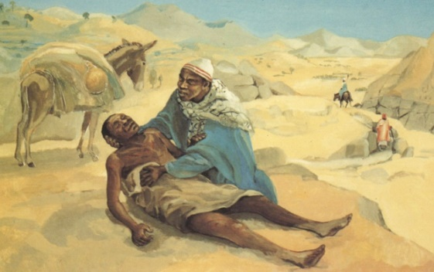 | What is this a picture of?  What comes before this (picture / text)?  What comes after this (picture / text)?  Can you tell me what happens?  What happens next?
 | Say what the story of the Good Samaritan tells them about how they should live | There are plenty of opportunities to dramatise this parable, role play it and retell it using Godly Play or story sack or finger puppets (see resources)  The TB has ample activities to provide familiarity with the story and the main teaching point is that we should be thoughtful, kind and helpful when we see anyone in need! If you haven’t already got one, devise a ‘Good Samaritan’ award for the duration of the unit of work. Pupils can help the teacher spot people being a good Samaritan (lots of praise given) and these can be recorded and collected and then the teacher or class who can get the award that week.  There is a good retelling of the story with teacher activities at:  https://www.bbc.co.uk/programmes/articles/1pYRg2f202rqWHrp3ywhTyX/religions-of-the-world | How do you think the man felt as he walked along the road?  Suddenly, something happened – what was it?  Why do you think the other people didn’t stop and help the man?  How did the Samaritan feel about what he saw?  How did the man who was beaten up feel?  Why did Jesus tell this story?  What can you do to be kind and helpful?
 | Give an answer to questions like ‘Why are my friends important?’ or ‘Who is my neighbour?’ | At the beginning of the unit, pupils will be reflecting on friendship and the importance of friends. Any reasonable response to a question of this type will be sufficient.  ‘Who is my neighbour?’ This question is not meant to be answered in a concrete fashion i.e. ‘So and so next door!’ The question is only a suggestion and is really more like ‘Who should we help?’ the answer being ‘anyone who is in need.
 | Recognise the stories of Palm Sunday and Good Friday and know they are from the Bible | Recognition of stories can be visual – from being shown a picture – but is principally from hearing stories read and working with a story. In order to recognise the story of Palm Sunday and Good Friday pupils will have heard the story during the lessons and be able to identify it. Pupils are not required to retell the story, but because lots happen in both stories, pupils should be able to go beyond knowing that it is ‘Palm Sunday’ or ‘Good Friday’ and are able to give a detail from the story. This can be from questions to pupils about what a character did in the story etc.  Pupils could be given individual emotion cards and asked to hold them up as the story is told and retold. Teachers could give pupils a set of different emojis they are asked to select the ones that fit the story of the characters in the story of Palm Sunday.  Teachers can follow up the idea that people are welcoming Jesus by asking pupils to think about how they can welcome Jesus.  If pupils are able to explore a bible and told that the stories about Jesus are found in the Bible and the teacher points out the story of Palm Sunday (Mark 11:1-11) in a bible this should help pupils know the stories come from the Bible.  There is a good retelling of the story of Easter with teacher activities at:  https://www.bbc.co.uk/programmes/articles/1pYRg2f202rqWHrp3ywhTyX/religions-of-the-world  See resources for ideas to supplement the material in the TB | Where was Jesus going?  What is he riding?  What are people doing?  What are they shouting?  Why are there so many people?  Is everyone happy? Why?  https://www.youtube.com/watch?v=98-wkKPpxbo&list=RD8p6i1z3cGAc&index=9  Palm Sunday song
 | Say what these stories (Palm Sunday and Good Friday) from Holy Week tell us about Jesus | Palm Sunday: the TB asks two key questions about the story: ‘Why do you think the people were giving Jesus a big welcome?’ And ‘Do you think everyone would have been happy to see Jesus? Why? Why not?’  Jesus was a king, but a king of peace because he comes on a donkey (not a warhorse) and his friends are not an army of soldiers, they wave palms not swords. Teachers could ask pupils how they can be peacemakers using the image of Jesus on Palm Sunday and Jesus teaching “Happy are the peacemakers, they shall be called children of God” (Matthew 5:9)  Good Friday: while the focus of the retelling of the story of Good Friday will focus on the emotions of Jesus’ friends enabling the teacher to repeat the work with emotion cards and emojis, what we learn about Jesus – particularly if pupils watch the clip about Easter from Religions of the World – is that Jesus wasn’t angry with the people when he was dying on the cross – he prayed to his Father that they would be forgiven (Luke 23:34 “Forgive them, Father…”). He was also full of courage: he didn’t run away like his friends.

