INTERPRETATION OF PRIMARY RELIGIOUS EDUCATION EXPECTATIONS
AUTUMN FIRST HALF TERM
YEAR 3
UNIT | EXPECTATION | OUR UNDERSTANDING | PROMPT QUESTIONS
3.1  The Christian Family | Ask and respond to questions about their own and others’ experience of family life  Links to learning objective: ‘To reflect upon what it means to be part of a family’ (TB p. 12). ‘Know that we all belong to a family. Think about how we can help our family.’ (new PB p. 4)  Suggest an answer to questions like ‘What things show you belong to your family?’  Links to learning objective: ‘To reflect upon what it means to be part of a family’ (TB p. 12). ‘Know that we all belong to a family. Think about how we can help our family.’ (new PB p. 4) | Both the old and new PB begin the unit with Jesus, Mary and Joseph – the Holy Family. The new PB adds the story of the Discovery of Jesus in the Temple alongside the story of Jesus’ Presentation in the Temple in the TB and both stories are a good way to bring in two ideas: a) how families share special occasions and b) how we have to learn to both give and take and get along together.  a). After talking with pupils about the sorts of things that Jesus would have done with his family (see TB p. 12 first bullet point) move on to talk about one special occasion when Mary and Joseph first took baby Jesus to the Temple (most important religious place of worship) in Jerusalem (capital city) to thank God for their baby son and to dedicate him to God. The story is in Luke 2:22-40 though only Lk. 2:22-23 is necessary. A Lumo video of the event is on You Tube at https://www.youtube.com/watch?v=4FpiR-lcc9o&list=PLcJVIuhI8isJOKcvkIMhwj7Gv5769FqEJ&index=6  Ask pupils to think about what ‘dedicate’ means, look up its meaning and come to understand that Jesus now belonged to God, or by dedicating him to God, Mary and Joseph were promising to bring Jesus up so that Jesus would give his time and energy to learning about God the Father and living as God the Father wanted.  Complete activities 1 and 2 from the PB p. 5  Ensure pupils are given an opportunity to ‘think-pair-share’ ‘Signs of Belonging’ – what places, things, words, special objects show that you belong to your family? Pupils can record this discussion in a poster or a badge with annotation.  b). When he was 12, Mary and Joseph took Jesus to Jerusalem to celebrate the Passover. It was a real treat to go to the capital city for Passover – the most important Jewish celebration. It was a journey of about 80 miles (groups of people travelling together usually covered about 20 miles a day at the time of Jesus) but took about 4 days to get to Jerusalem. It was – and still is - a very special occasion that celebrates the time when God rescued the Jewish people from slavery in Egypt. On the way back home Jesus stayed in Jerusalem but Mary and Joseph didn’t know this and thought he was travelling back home among their larger group. After a day they began to get worried and started to look for him but they couldn’t find him. After not finding him, they had no choice but to go back to Jerusalem to see if he was there. Eventually, Mary and Joseph found Jesus in the Temple. There is a clip of the Discovery in the Temple in The Miracle Maker (5.40-6.53 minutes) see https://vimeo.com/404287245  The text of the story is found at Luke 2:41-50 and is in the new TB at p. 21. There is also an excellent retelling of the story in the Lion Storyteller Bible by Bob Hartman entitled ‘The Boy in the Temple’.  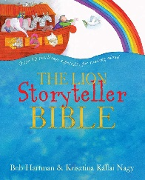  Using the latter text, there are good opportunities to dramatise the story, to bring out the feelings that Mary and Joseph went through: calm to worry, to panic, to amazement, to indignation (anger and annoyance at Jesus’ seeming lack of consideration for his parents) and back to calm again. These words could be placed on cards and pupils could use them to help with a dramatization or a retelling.  Teachers can use the painting of Simone Martini (1342) to reflect on what the painting shows about the feelings and reactions of each character following their meeting up again. The use of hands pointing, Joseph’s head tilted and Jesus’ arms folded speak of the various feelings expressed, see https://www.liverpoolmuseums.org.uk/artifact/christ-discovered-temple  Ensure the happy ending in Luke 2:51 is referred to as the Storyteller Bible story does in its last line “Mary and Joseph looked at each other. Jesus took their hands. And together they started off home.”  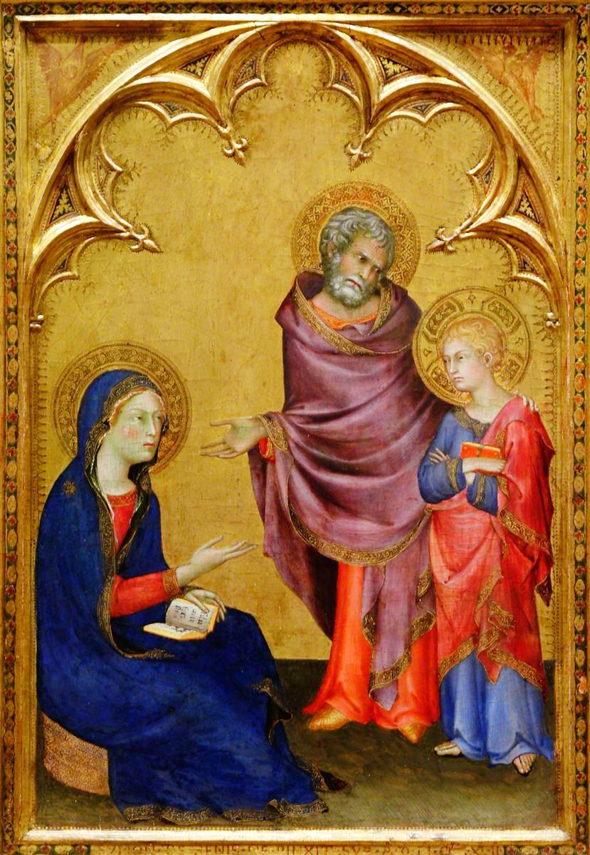  Complete activity 3 and 4 on p. 5 of the old PB or activity 3 a-c on p. 6 of the new PB. | What things would Jesus have done with his family?  Can you remember any stories from the Bible about Jesus and his family?  Who is part of your family?  What do you enjoy doing with your family?  What things show you belong to your family?
 | Suggest an answer to questions like ‘What do people who belong to the Church do?’  Links to learning objective: ‘Think about what it means to be part of the Christian family’ (old PB p. 6). ‘Know what it means to belong to the family of the Church. Reflect on how the family of the Church helps us (new PB p. 7)  Make a simple link between a bible story and living like Jesus  Links to learning objective: ‘Think about what it means to be part of the Christian family’ (old PB p. 6). ‘Know what it means to belong to the family of the Church. Reflect on how the family of the Church helps us (new PB p. 7) | The PBs expand the focus on the family to the family of the Church – the Christian family. Church here means the people who follow Jesus and want to live in the way Jesus taught us. So ‘Church’ has a double meaning, the worldwide people who follow Jesus as well as the building where groups of Christians go to worship. The PBs explain that because there are so many Christians all over the world they cannot all meet together, so they meet in smaller groups. These smaller groups are called parishes, and the Parish is made up of all the people in our Church (Catholic) family who live near each other.  Those following the old PB can access a song to make a reflection on Isaiah’s words ‘I have written your name on the palms of my hand’ (Is. 49:16) using Fischy Music’s CD Down to Earth. A 45 second excerpt is on You Tube at https://www.youtube.com/watch?v=yUhbCNMUljY  The expectation question ‘What do people who belong to the Church do?’ is aimed firstly at the discussion that the TB (old TB p. 13, new TB pp. 14-15) encourages about what happens when the Parish meet at church together – this is what happens at Mass (the sequence of what we do – say sorry, listen to God’s Word, receive communion or a blessing, try and live like Jesus) and other celebrations during the year (Advent, Christmas, Easter) or special family occasions like Reconciliation, Baptisms, First Holy Communion, Weddings.  This expectation can also be met by thinking about the role of the parish priest and asking pupils to think of some questions in a ‘think-pair-share’ to ask the priest and emailing them to him – expecting him to send a reply to the questions - if he isn’t able to come into class to answer them.  Introduce the pupils to the healing of the paralysed man – Mark 2:1-12 (the man who couldn’t move) see old PB p. 9 and in your retelling of the story highlight the kindness of Jesus. Ask pupils to think-pair-share about how Jesus shows his kindness using activities 3 and 4 in the old PB p. 9 (see resources). There is a very good retelling of this miracle in The Lion Storyteller Bible by Bob Hartman entitled ‘Down through the Roof’. The Miracle Maker film also has a good retelling of the miracle see https://www.youtube.com/watch?v=7l5yFH64QhQ  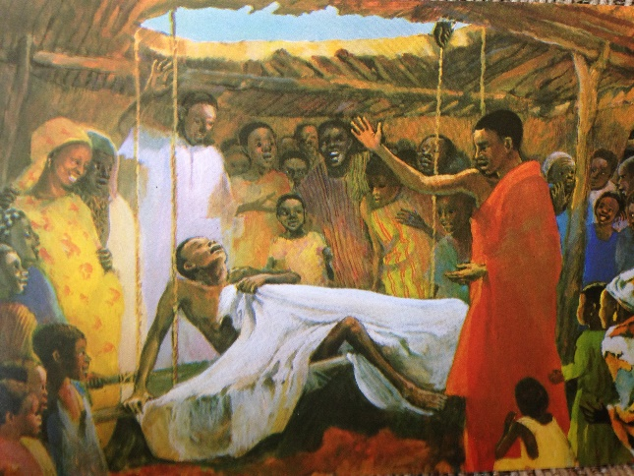  MafaJesus ‘The Cure of the Paralysed Man’  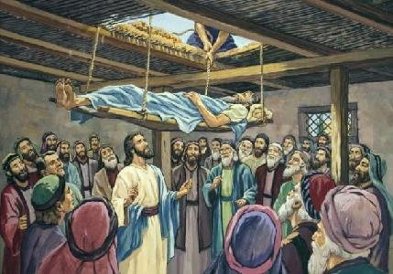  After retelling the story through various medium, pupils will have enough understanding to provide both questions and answers that the paralysed man could give when completing activity 2 a, b and c on p. 9 of the old PB.  Finally, in conjunction with activities 1, 2 and 3 in the new PB (p. 11) and activities 3 and 4 in the old PB (p. 9) and to link with how Jesus showed by the miracle how he wants us to live – forgiving one another; showing kindness and compassion - pupils could be asked to explore a Parish bulletin or newsletter (could also use the Parish webpage if accessible to the pupils) to note down the different groups that the Parish has – include child-related groups like Beavers, Cubs, Brownies, Scouts – and ask pupils in talk partners to note down what some of these groups do and be able to answer how some of these groups helps the people of the parish live like Jesus. | What is a parish? Which parish is the school part of?  Where does the parish family meet together?  What is a diocese?
 | Describe how each sign is used in Baptism, (sign of the cross, water, chrism oil, white garment, candle)  Links to learning objective: ‘Know what happens when we are baptised’ (old PB p. 10). ‘Understand what happens when we receive the Sacrament of Baptism. Reflect on the meaning of the Sacrament of Baptism’ (new PB p. 12). | A sacrament is an important gift from Jesus that gives us God’s grace – His help – and special gifts (E.g. Baptism gives us membership of the Church and the gift of the Holy Spirit). In order to show what a sacrament is, the WTL (new book pp. 14-15) distinguishes between ‘sign’ and ‘symbol’. The WTL uses this distinction to teach that symbols are really powerful signs with more than one meaning, and unlike ordinary signs (e.g. road signs), symbols really do make things happen – they produce the desired effect e.g. water is powerful because it really does make clean and give new life. However, in the first place, the new PB is a bit confusing because it uses symbol and sign for what is used in baptism and secondly, the Church does not use the word symbol to describe sacraments it understands sacraments as efficacious signs – signs that effect a change. So you could teach Baptism by distinguishing between simple (road signs) and powerful signs (signs used in Baptism and other sacraments). However you could also follow the WTL new PB and use ‘sign’ and ‘symbol’ if preferred.  Baptism is the sacrament that makes the child a member of the Church – the Christian family. It marks the start of new life as a Christian.  To describe how each sign is used pupils will offer a description that will name the sign – e.g.  ‘Sign of the Cross’ and give a description of how it is used. In the Rite of Baptism for one child at the beginning of the sacrament it says, ‘I now trace the cross on your forehead, and invite your parents and godparents to do the same.’  The next sign used is the ‘Oil of Catechumen’. This is not taught to Year 3 because it is the sign that signifies the removal of original sin, but you could mention this oil if you want to stress its other meaning – it is a sign giving the baby strength to live as a Christian by avoiding giving in to temptations to do the wrong thing. As the priest anoints the baby he says: ‘We anoint you with the oil of salvation in the name of Christ our Saviour; may he strengthen you with his power, who lives and reigns for ever and ever.’  The next sign used is (holy – water that has been blessed) ‘Water’. Water is named and a description of how water is used e.g. all are gathered at the font and the priest pours holy water over the baby’s forehead three times [once for each person of the Trinity], ‘I baptise you [the name of the child] in the name of the Father and of the Son and of the Holy Spirit.  The next sign used is ‘Chrism Oil’. The priest anoints the crown of the baby’s head with the oil of chrism. Chrism is a mixture of olive oil and the perfume balsam.  The next sign used is the ‘White Garment’. After the anointing of the baby with chrism oil, the priest clothes the baby in a white garment.  The last sign used is the ‘Baptismal Candle’. The baby’s baptismal candle is given by the priest to a parent or god parent and says ‘Receive the Light of Christ’. The parent or godparent lights the baptismal candle from the Easter or Paschal Candle in the church.  For the Rite of Baptism for one child outside of the Mass see: https://parish.rcdow.org.uk/hitchin/wp-content/uploads/sites/60/2014/06/Baptism-book.pdf  It is a good idea to re-enact a baby’s baptism in church or class if the church isn’t possible and photograph the different stages. The photographs can then be used to talk about the different signs used and as a sequencing aid.  What the signs of baptism signify (their meaning) is not required for this description.  See ‘Signs used in Baptism’ in resources
 | Give a reason why, at least, three signs are used in Baptism  Links to learning objective ‘Know about some of the signs used in baptism’ (old PB p. 12). ‘Know about some of the signs and symbols used in the Sacrament of Baptism. Reflect on why they are used’ (new PB p. 14). | Pupils will say why at least three signs are used. In other words, pupils will say what effect (what does it do for the child, what changes) each of the signs has on the baptised person?  The WTL PBs (old PB pp. 12-13 and new PB pp. 15-16) give the meaning and the Rite of Baptism also gives the meaning of each sign used. | Why is …. used in Baptism?  When the water is poured over the baby’s forehead, what change is taking place?  How is putting on a white garment the same as putting on Christ?
 | Make a link in your work between Baptism and what it tells Christians about living a Christian life (welcoming others, making promises, being a ‘light’ to others,)  Links to learning objective ‘Know about the promises made at Baptism’ (old PB p. 14-15). ‘Know about the promises made at Baptism by parents and godparents. Think about the importance of keeping promises’ (new PB pp. 17-19). | Alongside the work on describing the signs used in Baptism and saying why, at least, 3 are used pupils can be asked to make a link in their work when discussing that Baptism welcomes a baby (or person) into the Church to how the pupil can welcome others.  When discussing the parents and god-parents making promises at a Baptism and in conjunction with Activities 1 and 2 in the old PB p. 15 and Activities a-e and 1-4 in the new PB pp. 17-19, encourage pupils to make a link to important promises they have made.  When discussing lighting the baptismal candle from the Paschal or Easter candle pupils can make a link with Jesus as the light of the world and how the pupil can be a ‘light’ to others.  This work can be made into mobiles or posters with the theme of Baptism: living like Jesus.
 | Suggest an answer to questions like ‘What helps you on the journey of life?’  Links to learning objective ‘Know that Baptism is a Sacrament’ (old PB p. 16). ‘Know that we join the Church when we receive the sacrament of Baptism’ (new PB p. 10) | This expectation is provided as an opportunity for pupils to think what, alongside some of the sacraments like Baptism, Reconciliation and Eucharist, helps them in their journey through life. There is a song to help with this theme from Fischy Music called ‘We’re on this road’ see  https://www.youtube.com/watch?v=Yh3ODIg8elI (the song begins at 3.48 minutes and ends at 7.35 minutes). The theme is picked up in the old TB first bullet point p. 14 and new TB p. 15-16.  There are suggestions to support life as a journey or a road in Big, Big Questions, an RE Today publication the uses 12 songs from Fischy Music and provides examples of activities to go alongside.  Pupils can be asked to name other sacraments that help on the Journey of Life and give simple reason why they help  Pupils can be asked how the bible which is full of wise sayings is like a Guidebook for Life. Pupils pick 2 or 3 sayings or passages and say why they are great guides for life (see resources)  Pupils are asked to pick 2 sayings or events from the life of Jesus to say how they are helpful for life because they help them live like Jesus. These could be stories with a meaning like a parable or other event or sayings like ‘The Golden Rule’ Do to others as you would have them do to you, Matthew 7:12 the Greatest Commandments “‘Love the Lord your God with all your heart and with all your soul and with all your mind.’ This is the first and greatest commandment. And the second is like it: ‘Love your neighbour as yourself.’ Matthew 22:37-39.  There is an opportunity to use a journey line or road map idea to present the pupils responses.

