INTERPRETATION OF PRIMARY RELIGIOUS EDUCATION EXPECTATIONS
AUTUMN FIRST HALF TERM
YEAR 2
UNIT | EXPECTATION | OUR UNDERSTANDING | PROMPT QUESTIONS
2.1  The Chosen People | Talk about and answer questions about being chosen and what it feels like.  Links to learning objective:  ‘Know that we are chosen by God and [think of ways] we thank God by helping others’  (old TB p. 10, new TB p. 14) | Pupils will be able to talk to each other or the teacher and answer questions about what they have been chosen for or to do and talk about what it feels like to be chosen.  Using task 2 (PB p. 6) as a stimulus use emojis or a feelings word mat to help pupils describe how they felt or how they feel when they were or are chosen to do something. Use the selected emojis or feeling words to create a poster to show what it feels like.  To make a connection with the belief that ‘God has chosen each one of us, He has even said, “I have called you by your name, you are mine” (Isaiah 43:1), ask pupils if they have a pet at home and talk about how they gave it a name, how they show they love it/how they show it is precious to them.  Link this to how God loves us by linking it to the story of the Lost Sheep. The shepherd showed he loved the sheep so much that he went after it, carried it home on his shoulders and celebrated that he had found it. How is God like a shepherd? How are you like a shepherd with your pet?  Use the BBC video of the parable of the Lost Sheep (3.05 minutes to 4.00 minutes)  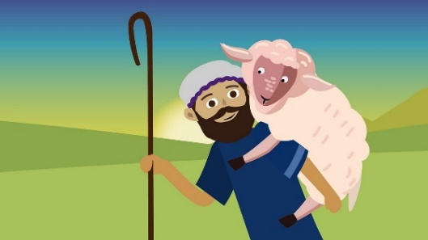  https://www.bbc.co.uk/teach/class-clips-video/religious-studies-ks1-the-christian-story-of-the-good-samaritan-and-the-lost-sheep/zr7wxyc  For lesson notes on this story and others in the BBC Religions series see:  https://www.natre.org.uk/uploads/Member%20Resources/Religions%20of%20the%20World%20-%20Teachers%20notes%20UPDATED-converted%20280519.pdf  We can thank God for choosing and loving us by loving God too:  Teachers could use the book Kind by Alison Green as a stimulus for thinking through ways to show love and as a link to the virtues we can display. This links well with task 3 and 4 on p.7 of the PB or task 4 and 5 on p. 6 of the new PB.  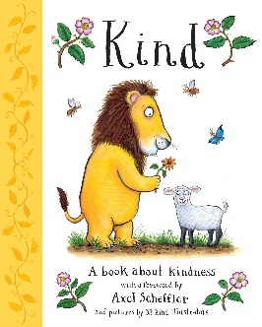  As an alternative or additional activity, ask pupils to think of ways we can show we love God, make sure these ideas include how we can love and help others. Collate responses and ask pupils to choose the best six to draw. Number each response selected 1-6 and pupils take turns to throw a die and act out the example (1-6) it lands on.  There are additional activities in the TB p. 11 which extend the learning to include the idea of building a happy school. | What does it feel like to be chosen?  If you are chosen to help, which virtues could you use and how? (See PB examples on p.5 and task 3 PB p. 7 and task 4 new PB p. 6.)
 | Retell simply, in any form, the story of God’s call of Abraham  Links to learning objective:  ‘Know why God chose Abraham and Abraham trusted God to guide him’ (TB p. 12) and ‘Know that God chose Abraham. Think about how Abraham trusted God to guide him’ (new PB p. 8). | To retell does not mean learning to write down the story exactly as it appears in the Bible, but means to retell the story in their own words. To retell simply means to have some details from the actual story in their own account: sequence, characters, but not everything. However, the words ‘in any form’ means that a pupil’s retelling does not need to be a written account, but could be an oral retelling based on an account of the story presented in different media or from memory. Or a pupil could write a sentence for each part of a sequence created in different media.  In addition to the sequencing grid on p. 10 of the old PB (and the pictures in the new TB p. 18) teachers could ask pupils to complete Activity 1 from RE Ideas: spiritual development p. 7 from RE Today. There are six pictures to enlarge and cut up for pupils to remember and sequence the story. This version of the story includes how God told Abraham to look up at the stars promising that he would be the ‘father of many nations’. This part of the story is not mentioned in the PB version but makes sense of Genesis 17:5 ‘I will make you father of many nations.’ (old PB p. 10. The new PB p. 10 uses Genesis 17:2 but it has the same meaning.) | Tell me the story of God’s call of Abraham.  What happened in the story of Abraham?  Who are the characters in the story?  What do they do?  What did God do? What did Abraham do? What did Sarah do?  Can you sequence this story and tell me what happened?  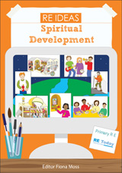
 | Ask and answer questions about the feelings of Abraham and Sarah and their own feelings  Links to learning objective:  ‘Know why God chose Abraham and Abraham trusted God to guide him’ (TB p. 12) and ‘Know that God chose Abraham. Think about how Abraham trusted God to guide him’ (new PB p. 8). | In addition to the ‘Pause to talk’ questions (p. 8 and 9 in the new PB) and tasks 1, 2 and 4 in the new PB (p. 11) – see resources – pupils could complete Activity 2 from RE Ideas: spiritual development p. 10 from RE Today. This activity that highlights the importance of the starry sky in the story also uses Can’t You Sleep Little Bear as a companion to the story of Abraham. It uses 12 emotion cards to explore the feelings of pupils and characters in the stories. | How would Abraham/Sarah have felt about having to …?  How would you feel? Why?  What would it be like to have to leave your home?  Why did Abraham set out on a long journey?  Why was the journey difficult?  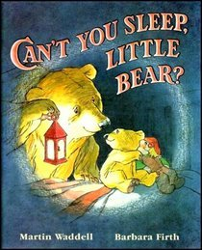
 | Describe how Abraham showed his faith in God  Links to learning objective:  ‘Know why God chose Abraham and Abraham trusted God to guide him’ (TB p. 12) and ‘Know that God chose Abraham. Think about how Abraham trusted God to guide him’ (new PB p. 8). | This unit expectation is related to the end of Year Two expectation: ‘describe what religious stories tell us about God, Jesus or key figures.’ Pupils cannot meet this expectation by retelling the story of Abraham (a key figure). The expectation is focused on the specific behaviour and reaction of Abraham which show that he had faith in God.  To describe means to offer a description – usually written, but not always – of the specific behaviours of Abraham rather than simply being able to recognise them i.e. point them out in the text. Pupils could examine the text highlighting the parts that show Abraham’s faith as a basis for their description.  The pupils will need to know that in some contexts faith and trust are synonymous. | How does Abraham show his faith in God?  Can you give examples from the story that show Abraham trusted in God?  - Listened to God  - He did as God asked and left his home in Haran  - Abraham didn’t even know where he was going  - He knew that God always keeps his promises  - Abraham knew that God was always with him looking after him and his family
 | What does the story of Abraham tell you about God, give two examples?  Links to learning objective:  ‘Know why God chose Abraham and Abraham trusted God to guide him’ (TB p. 12) and ‘Know that God chose Abraham. Think about how Abraham trusted God to guide him’ (new PB p. 8). | About God (two of the following):  - God is faithful  - God makes promises and keeps his promises  - God wants people to become his friends  - He looks after Abraham and his family  The promises made by God:  - I will give you many descendants, and they will become a great nation (Gen. 12:2)  - I will bless you and make your name famous  - I will give you a land (Gen. 12:7)  - Abraham will have a Son with his wife Sarah (Gen.18:9-10) | What does this story tell us about God?  Why did God choose Abraham?  What does God want Abraham to do?  What promises does God make?  Is Abraham famous? How do you know?  What name did Abraham give to his son? Why?
 | Retell simply, in any form, the story of baby Moses  Links to learning objective: ‘Know that God chose Moses to help His people and we are also chosen to help others’ (TB p. 13). Know that God chose Moses to help His people. Reflect on how He looked after him’ (new PB p. 12) | To retell does not mean learning to write down the story exactly as it appears in the Bible, but means to retell the story in their own words. To retell simply means to have some details from the actual story in their own account: sequence, characters, but not everything. However, the words ‘in any form’ means that a pupil’s retelling does not need to be a written account, but could be an oral retelling based on an account of the story presented in different media or from memory. Or a pupil could write a sentence for each part of a sequence created in different media.  https://www.bbc.co.uk/teach/class-clips-video/religious-studies-ks1-the-jewish-story-of-moses/zmfp382  watch up to 1minute 23 seconds  For those following the new PB, pupils can watch a little more of the video because the new PB includes a short summary of what happened when Moses grew up. However, the focus of the learning is baby Moses.  For lesson notes on this story and others in the BBC Religions series see:  https://www.natre.org.uk/uploads/Member%20Resources/Religions%20of%20the%20World%20-%20Teachers%20notes%20UPDATED-converted%20280519.pdf | Tell me the story of baby Moses.  What happened in the story of baby Moses?  Who are the characters in the story?  What do they do?  What did Miriam do? What did Pharaoh’s daughter do?  Can you sequence this story and tell me what happened?  What can you tell me about Moses?
 | Wonder and ask questions about the stories of Abraham, Moses and Daniel  Links to learning objectives on Abraham, Moses and Daniel | Pupils will draw attention to something that they are wondering about and ask questions about it. It may be about the descendants of Abraham numbering as many as the stars, about the land promised, about the age of Abraham and Sarah. It may be prompted by the teacher who asks them to wonder what it would be like to move away to an unknown land. Pupils may wonder how Moses (‘drawn out of the water’) got his name – just as the names Abraham (‘father of many’) and Isaac (‘laughter’) have meaning. Names are sometimes given because they show how we feel: Isaac = laughter, because Sarah and Abraham were so happy to have a child of their own at last. Pupils could wonder about the lions in the story of Daniel and about the bravery of Daniel and whether they could be that brave.  Introduce the big question mark activity – displaying or using a suitably large question mark. In small groups pupils think and write a big question they have about each story in turn or focus only on one story in total. Pupils could think and write a big question about a character in the story or a big question for God related to the story. Ask pupils to classify the questions: the best? The hardest? The funniest? The most important? Create a Class 2 Why? Book or ‘Wonder Wall’ using the questions. Pupils can add their answers to the questions during the unit or later in the year.
 | Ask and answer questions about the feelings of Moses’ parents and sister Miriam and Daniel | Teachers will read the story of baby Moses from a suitable bible story book like The Storyteller Bible by Bob Hartman  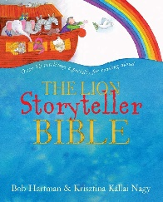  https://www.bbc.co.uk/teach/class-clips-video/religious-studies-ks1-the-jewish-story-of-moses/zmfp382  watch up to 1minute 23 seconds  In addition to using the questions and completing activities from the old TB p. 13 pupils could complete Activity 1, 2 and 3 from RE Ideas: God pp. 8-9, 12 from RE Today. | https://www.dltk-kids.com/bible/exodus/story_of_baby_moses_cv.htm  Daniel video from the Beginners Bible  https://www.youtube.com/watch?v=MqJl0dzYYuA

