INTERPRETATION OF PRIMARY RELIGIOUS EDUCATION EXPECTATIONS
SUMMER SECOND HALF TERM
YEAR 2
UNIT | EXPECTATION | OUR UNDERSTANDING
2.6 The Church is Born / The First Christians | Describe how the Holy Spirit helped the apostles  Give examples how the Holy Spirit can help them in their own lives (remember, understand, courage) | This unit begins with Pentecost, but because this was looked at in detail in unit 2.5 before half term it is best to focus on how the Holy Spirit helped the friends (apostles) of Jesus after Pentecost using the three key words: remember, understand, courage. The old PB pp. 76-79 has activities, but pupils could also be asked in pairs to think about what Jesus’ friends might remember about what Jesus taught them. Pupils could be asked to do this from memory or be given passages or stories from the life of Jesus to choose from (if using the PB, pupils could look back in the PB for suitable stories or passages or sayings). Pairs of pupils could then choose a story or parable of Jesus and think up the message of the parable to show their understanding of it. (Teachers could use previous resources for this task or see resources given for this unit.) Finally, pupils in pairs could think about when the friends of Jesus may need courage. The new PB has the three key words on p. 85 and then it has an extended task that puts the three key words into action in a class project on the life of Jesus, see pp. 86-87.  Ask pupils how what they have chosen for remember, understand, courage could also apply to them in their own lives. Teachers can use the typical WTL structure of at home, school, in the community.
 | Recognise the link between Pentecost and the beginning of Christianity (birthday of the Church) | This expectation provides an opportunity to explain to pupils that Pentecost was the birthday of the Church. It is covered in the old PB on pp. 80-82 and in the new PB on pp. 88-89. It will enable pupils to see the connection between the coming of the Holy Spirit and Peter and his friends telling people about Jesus and many wanted to become followers of Jesus (and they did this by being baptised). They were called Christians after the title Jesus was given (Christ).  A different way of covering the material would be to focus on the birthday of the Church. Bring in a cake to celebrate the birthday of the Church.  Ask pupils to say or list or make a ‘recipe for a birthday’ or ‘build a birthday’ - what makes up a birthday – cake, candles, invitations, family and friends, birthday cards, gifts (presents) etc.  Develop the idea of the Church’s birthday by focusing on two ideas: invitations and gifts. Using the text on p. 88 of the new PB how Peter and his friends told people about Jesus and invited them to follow Jesus by joining the Church.  Ask pupils using the information on p. 81 of the old PB and p. 88 of the new PB, how people who accepted the invite to join the church showed they belonged to the Church.  Pupils can complete the activities on p. 82 of the old PB and p. 89 of the new PB.  Next develop the idea of gifts by focusing on the gifts the Holy Spirit gives us when we join (belong to) the Church, see p. 95 of the new PB: the gifts of Peace, Gentleness, Self-control, Love, Patience, Faith, Joy. Pupils could complete the activity on p. 95.  Teachers can link this to the gift that Peter gave the man who could not walk and particular gifts the pupils have that they use to help others.  Teachers could take it further by focusing on the gift of peace: teachers could link this to the symbol of the dove for the Holy Spirit or the symbol of the heart linked to a piece of scripture like John 14:27 ‘My peace I leave you, my peace I give you. Do not let your hearts be troubled and do not be afraid.’  Belonging to the Church or following Jesus can give you peace. Give pupils 4 heart shapes (these could be inset in dove shapes if linked to the Holy Spirit). Ask pupils to record in any form on 3 of them a heart that is afraid. Ask them to talk about what they have shown. Give pupils the scripture from John 14:27. Following Jesus is sometimes hard and his first followers went through many troubles, but they had peace in their hearts. Talking with the pupils about the many troubles of the first followers of Jesus (arrested, put in prison, stoned, beaten, faced death, shipwrecked etc. Read 2 Corinthians 11:23-33 for Paul’s recount of his suffering because he follows Jesus) is ripe for dramatic expression.  Ask pupils to think about 4 kinds of peace: peace in my own life, peace with other people, peace in the world and peace with God. Can the pupils express one or more of these kinds of peace in a media of their choice? Use the 4th heart for this creative expression (adapted from Understanding Christianity).
 | Ask and respond to questions about Peter’s cure of the man who could not walk | This story is ripe for dramatic presentation and the ‘pause to talk’ questions in the new PB p. 93 are a good basis for freeze-framing the drama to ask a particular question. Encourage pupils to ask questions when the drama is stopped. There are plenty of questions that pupils can respond to on p. 85-86 of the old PB and p. 92-93 of the new PB.  Teachers can take this a little further by asking them in pairs to reflect on the importance of money, but then reflect on the fact that money is important, but more important than money is…. This links to the activities in the PBs and also how pupils can use the gifts of the Holy Spirit listed in the new PB p. 95.
 | Retell the story of Peter’s escape from prison  Ask and respond to questions about Peter’s escape from prison | To retell does not mean learning to write down the story exactly as it appears in the Bible, but means to retell the story in their own words. To retell means to have correct details from the actual story in their own account: the correct sequence, characters and setting.  There are some good activities in the PBs like ‘hot-seating’. There is a retelling on You Tube at https://www.youtube.com/watch?v=Rr7Udj8lEUU  There is a good sequence of images (sample below) that retell the story at http://funbiblestuff.com/coppermine/displayimage.php?pid=2246  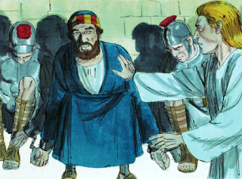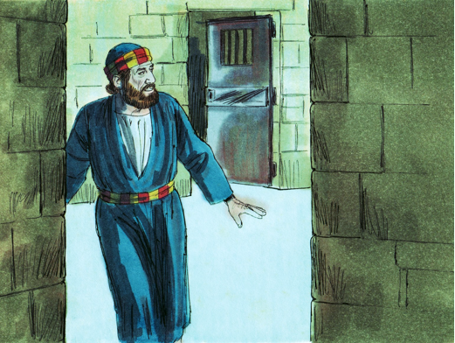  During the ‘hot-seating’ and some of the activities in the PBs give opportunities for pupils to ask and respond to questions.

