INTERPRETATION OF PRIMARY RELIGIOUS EDUCATION EXPECTATIONS
SUMMER SECOND HALF TERM
YEAR 1
UNIT | EXPECTATION | OUR UNDERSTANDING
1.6 Miracles | Recognise some miracle stories from the gospels | Recognition of stories can be visual – from being shown a picture – but is principally from hearing stories read and working with a story. In order to recognise the stories pupils will have heard the story during the lessons and be able to identify it. Pupils are not required to retell the story, but should be able to go beyond knowing the story title and are able to give a detail from the story. This can be from questions to pupils about what a character did in the story etc.  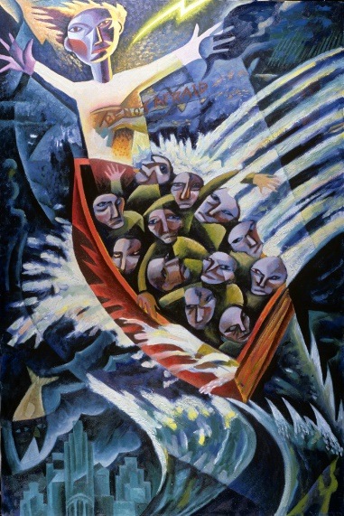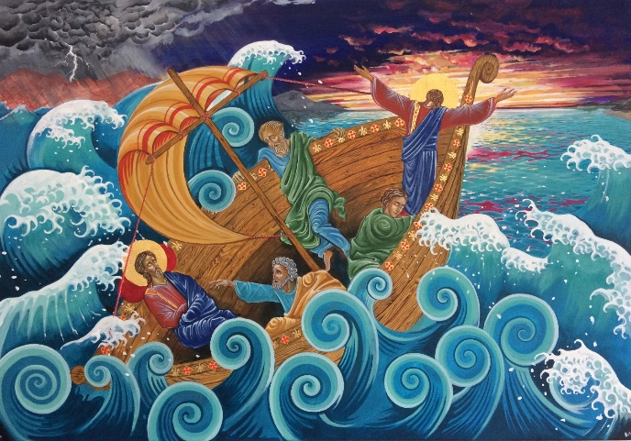  Calming the Storm, James B. Janknegt Calming of the Storm, Bernard Allen
 | Talk, ask questions and wonder about their own feelings and the feelings of characters in the miracle stories | There are a number of miracle stories within the unit and all provide opportunities for pupils to consider the feelings of characters in the stories as well as their own feelings, particularly in the sections entitled ‘Questions to ask about the story’.  After talking about the stories, pupils can be encouraged to record a feeling of a character or their own feelings about a story in words and pictures.  There are numerous images of the Cure of the Paralysed Man at https://www.google.com/search?q=cure+of+the+paralytic&rlz=1C1GCEU_enGB866GB866&source=lnms&tbm=isch&sa=X&ved=2ahUKEwjWmrDJoIXxAhWWgVwKHdwYBYwQ_AUoAXoECAEQAw&biw=1303&bih=665#imgrc=_0TaAb2flA0N1M  Images for the Cure of the blind man (Bartimaeus) at https://www.google.com/search?q=cure+of+blind+bartimaeus&tbm=isch&ved=2ahUKEwiu3prKoIXxAhUIXRoKHUikCwoQ2-cCegQIABAA&oq=cure+of+blind+bartimaeus&gs_lcp=CgNpbWcQAzoECAAQGDoCCAA6BggAEAgQHlCq-wlYxsAKYNrHCmgAcAB4AIABXIgB9Q-SAQIyOZgBAKABAaoBC2d3cy13aXotaW1nwAEB&sclient=img&ei=-uy9YK75M4i6acjIrlA&bih=665&biw=1303&rlz=1C1GCEU_enGB866GB866  The new Teacher Book also includes the miracle at the Wedding at Cana, pp. 126-128. There are numerous You Tube clips on the story at https://www.google.com/search?q=the+wedding+at+cana&source=lmns&tbm=vid&bih=665&biw=1303&rlz=1C1GCEU_enGB866GB866&hl=en-US&sa=X&ved=2ahUKEwjB8JbGooXxAhUKfBoKHQeDCGwQ_AUoAnoECAEQAg  The Kids Wise version is a good one.
 | Retell, in simple form, two miracle stories | Pupils will be able to retell any two stories in simple form. The structure provided in the old PB p. 27, 30 and 31 and in the new PB p. 27, 29, 30 and 31 gives a means for pupils to record a simple retell.
 | Say what a miracle story tells us about Jesus / God | Pupils will be able to say something about what a miracle tells them about Jesus or God. Teachers will find the various ‘Notes for Teacher’ boxes helpful. These link the miracle to a teaching point that stresses why Jesus performed the miracle, usually showing his power and his love, care and compassion for people. The motive for the miracle can be brought out when talking about the miracle and the feelings of the characters in the miracle story.
 | Give examples how a miracle of Jesus may encourage you to act | This expectation links to the learning objective ‘Explore the motives for actions and how compassion motivates many people to act for the good of others’ pp. 81-83 of the old Teacher Book and ‘Begin to understand how compassion motivates many people to act for the good of others. Reflect on how we help one another’ pp. 116-119 of the new Teacher Book. Pupils will be expected to say how they could help someone in need after engaging in the material and the miracle of the calming of the storm.
 | Give an answer to a question like, ‘If anything were possible, what would you do?’ ‘Why?’ | In light of learning about the motivation of Jesus to show his love, care and compassion to help people in need, what would pupils do if they had the power to help others? Can pupils say why they would choose to help in the way they said?

