INTERPRETATION OF PRIMARY RELIGIOUS EDUCATION EXPECTATIONS
SUMMER SECOND HALF TERM
YEAR 5
UNIT | EXPECTATION | OUR UNDERSTANDING | PROMPT QUESTIONS
5.6  Work of the Apostles / The Transforming Spirit | Make links between character strengths and weaknesses of the disciples and passages from scripture. What conclusions can you draw about discipleship? | The old PB 6 uses this unit of work to focus on the character of the disciples, the transformation that took place in them after Pentecost and their mission to teach the good news about Jesus despite opposition. The new PB 6 begins with the disciples but focuses on St. Peter and St. Paul after work on the Ascension and Pentecost. Irrespective of which PB (old PB pp. 66-69 and new PB p. 86) is followed all pupils can engage with this expectation.  This expectation links with the first 3 learning objectives from the old PB: ‘Know and reflect on our calling to be disciples of Jesus’; ‘Know that the disciples were ordinary people’; ‘Know that the Apostles were people with strengths and weaknesses just like we are’. This expectation links to the information at the beginning of the unit on p. 86 of the new PB.  The old PB focuses on the fact that the disciples of Jesus were ordinary men with their own strengths and weaknesses. Pupils should explore the question: ‘Why did Jesus choose the first 4 fishermen and Matthew the tax collector as his first disciples, what strengths of character (or virtues) did they have?’  Pupils look up (or give the pupils the texts) and explore the following texts: Mark 1:16-20; Luke 5:1-11 – two different stories about the calling of the first four disciples – and Matthew 9:9-13 (Jesus calls Matthew).  The Call of the 4 fishermen (Mk. 1:16-20) shows the commitment needed of a disciple e.g. ‘At once they left their nets and went with him.’ (v. 18 and see v.20). The pupils may also suggest the virtue of service, giving of oneself now to others and generosity, ‘’Don’t be afraid; from now on you will be catching people’ (Luke 5:10). The story also shows what Jesus saw in these fishermen: the qualities of hard work, patience and courage, qualities that will be needed in a follower of Jesus.  The Miracle Maker film could be used at this point. There is a clip of the Call of the First Disciples from Luke 5 in the Miracle Maker film (from 18mins to 22:44) see https://vimeo.com/404287245 It is useful because it also shows the hatred towards tax collectors (Matthew).  Luke 5:1-11. At verse 5 Simon shows he has trust in Jesus ‘if you say so, I will let down the nets.’ Also Simon recognises that he isn’t perfect ‘Go away from me, Lord! I am a sinful man!’ but he is open to change because he, like the rest, left everything to follow Jesus. (Here is the ‘Turn, Drop, Trust dynamic of p. 67 of the old PB.)  Matthew 9:9-13: the same dynamic is shown in Jesus’ choice of Matthew the tax collector – a person hated by ordinary people as a traitor (working for the occupying power, the Romans) and dishonest cheat, who demands more money from people than they need pay (because tax collectors kept the extra for themselves). Matthew turns to Jesus, drops his old life and trusts in Jesus. There is a very short clip of this event in The Miracle Maker film https://vimeo.com/404287245 (at 28:15-29:53)  Teachers should give opportunities for pupils to review their own strengths of character that would make them suitable followers of Jesus  What were some of their weaknesses of character?  Luke 5:1-11, shows that Peter was not leading a good life – he calls himself a ‘sinful man’. Matthew the tax collector is a traitor and a cheat, he is therefore not to be trusted. At Mark 14:50 during the arrest of Jesus ‘Then all the disciples left him and ran away.’ They all deserted their friend when he most needed them. Also use the texts given in the old PB p. 70, John 20:24-25; Matthew 26:69-75 and Mark 10:35-40 (see resources).  A question to focus on after this textual work is ‘Why did Jesus choose these people as his followers if they had such faults and weaknesses?’ When discussing this question, teachers could use the story of The Rich Young Man from Matthew 19:16-30 to help. The rich young man has done everything right all his life – he is what we would call a good person – but Jesus invites him to commit himself to following him by leaving everything – all his riches – behind. Unlike the disciples (the first disciples were not poor, Peter and Andrew had their own boat and James and John had people working for them), the rich man can’t do it. He loves his life with its riches too much so he is not open to change as the disciples are. Being open to change is more important than the life you lead.  [For the teacher: because the rich young man keeps all the commandments, he does not think he needs to change, he does not see his need for God’s help. The rich young man is trapped in his virtue! This is one way of reading verses 25-26 “When the disciples heard this, they were completely amazed. “Who, then, can be saved?” they asked. Jesus looked straight at them and answered, “This is impossible for human beings, but for God everything is possible.” Jesus invites people to follow him with their strengths and weaknesses and they become followers because they recognise their need for God, which is another way of saying they are not afraid of the new life on offer, they have faith enough to follow. (When Jesus invites people to the new way of life he offers he will often say “Do not be afraid” see Luke 5:10).]  Now focus on the question: ‘Why did they follow Jesus, what did they see in him?’ This question may help explain the pupils’ wonderings about why the first disciples just left everything at once and followed Jesus. People don’t normally do this, pupils might ask ‘Surely, they must have known Jesus beforehand!’, ‘Surely, they must have thought about it and talked it over with their loved ones first!’ Many Jews at the time of Jesus were looking forward to the arrival of the Messiah, the Jewish saviour who would lead the people. The first disciples saw that Jesus was the awaited Messiah and wanted to follow him.  [For the teacher: for further information about the title Messiah see Interpretation document 6.4 pages 6-8 in the spring term materials.]  Teachers could use the passage in John chapter 6:60-69 to show that following Jesus was challenging and many stopped following him and when Jesus asked whether the 12, his closest friends, will leave him as well, Peter spoke for the 12 saying “Lord to whom would we go? You have the words that give eternal life…” – this is why they followed Jesus!  There are some good activities entitled “Who was Jesus and why do people follow him?” in Exploring Leaders and Followers, pp. 14, 19-21 from RE Today.  Teachers could give pupils two of the “I am” sayings from John’s gospel. The point here is that these sayings show why the 12 would follow Jesus. The first saying is “I am the light of the world (John 8:12) and the second is “I am the way, the truth and the life” (John 14:6) – [for activities on these two “I am” sayings see resources].  Pupils could complete the activity on p. 88 of the new PB as a conclusion to this part of the unit (see ‘My Mission’ in resources).  Pupils following the new PB can engage with some art on the Ascension (see new PB p. 87 and resources). | From your reading of different passages from the Bible, what are the qualities of character/virtues required of a disciple?  What questions have you got about the calling of the first 5 disciples?  What did they see in Jesus?  What has Jesus calling himself the Light of the World or The Way the Truth and Life got to do with the first disciples’ decision?  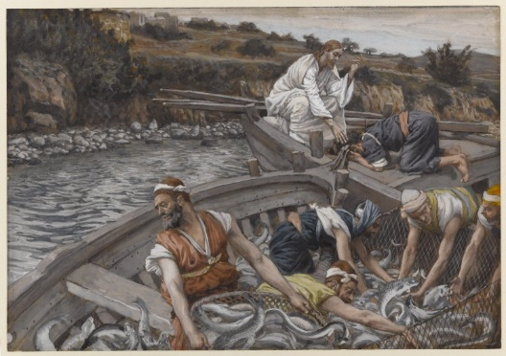  The Calling of the first 4 Fisherman (Luke 5:1-11) James Tissot  What do you find most challenging about what’s required of a disciple?  Caravaggio The Call of Matthew (1600)
 | Show some understanding of how the Holy Spirit changed the lives of the disciples by making links between beliefs and sources | This expectation links with the learning objective ‘Know how the Apostles changed when they received the Holy Spirit and reflect on how we can be changed’ in the old PB pp. 71-72 and ‘Understand what happened at Pentecost. Reflect on how the Spirit transformed the Apostles’ from the new PB pp. 89-91.  The change in language from ‘disciple’ to ‘apostle’ signifies the change in Jesus’ friends after Pentecost not only now followers of Jesus (disciples) who learn from him but people who put that learning into practice by going out on missions telling people about Jesus (apostle – means ‘one sent’).  There are some excellent activities in RE Ideas: Celebrations from RE Today entitled ‘Why is Pentecost an important festival for Christians?’ pp. 20-25.  Various paintings are included on the right so that pupils can make links between them, the text of Acts 2:1-4 (old PB p. 71, new PB p. 89) and the symbols of the Holy Spirit (wind, fire and dove, as well as other beliefs associated with the Holy Spirit like ‘providing energy and confidence’, giving understanding, instilling courage).  Place the different paintings of Pentecost Day on tables. Either place them in the centre of large sheets of paper or place large think bubbles, question bubbles, blank charts to add symbols with a box for its meaning. Ask groups of pupils to visit the tables in turn recording thoughts, writing questions, noting down symbols found and their meaning and beliefs expressed. Give some time for feedback to deepen understanding.  [For the beliefs that enabled the disciples to change, pupils will need to see that the Holy Spirit is our ‘Helper’ who gives us the gift of ‘Courage’ so that we can face our fears and tell everyone we meet about Jesus and who gives us the gift of ‘Understanding’.]  Give pupils the text (Good News version) of John 16: 5-7. Here the Holy Spirit is called the Helper. Ask pupils, ‘Why did Pentecost need to happen?’ ‘What if it hadn’t?’ Pupils can think about the state the disciples were in before Pentecost.  Prompt pupils to think about how the Holy Spirit helped the disciples: remind pupils of the change in the disciples and give them the text of Acts 2:14-24 (Peter’s Message) and John 16: 12-13.  [The Holy Spirit helps the disciples by giving them two gifts: 1. the gift of courage – to go out and tell the world about Jesus, and 2. the gift of understanding – to understand for the first time what God’s plan was – to give His only Son as saviour of the world. This plan is what Peter speaks about in Act 2:14-24]  Complete Activity 2 in the old PB p. 72 and Activity 1 and 2 in the new PB p. 91. | 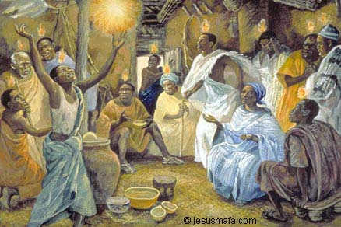  Jesus Mafa ‘Pentecost’  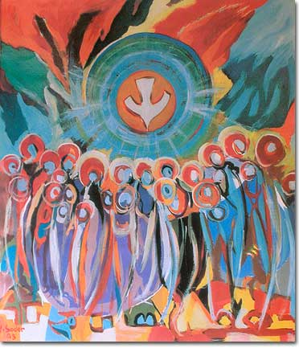  Jean Sader ‘Pentecost’  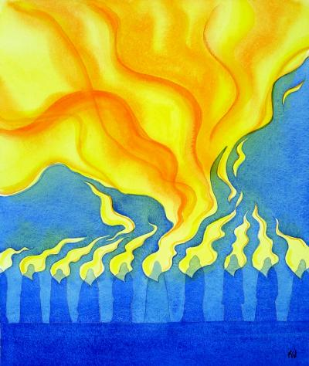  Elizabeth Wang ‘Pentecost’  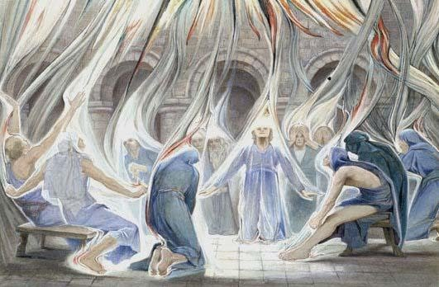  Estella Louisa M. Canziana, ‘Pentecost Day’  He Qi ‘Pentecost’  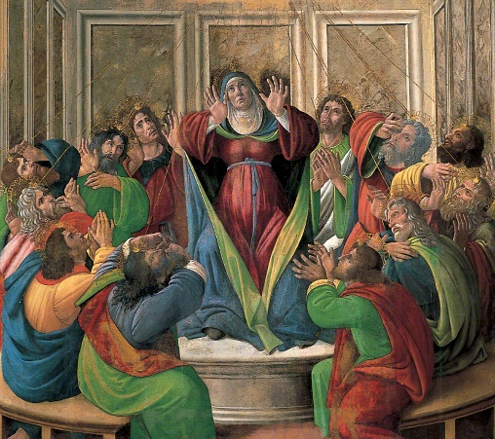  Botticelli, ‘The Descent of the Holy Ghost’
 | Show knowledge and some understanding of the transformation that took place in Peter or Paul, his mission and his teachings | There are aspects of the life of Peter after Pentecost in the old PB, see p. 74, the miraculous escape p. 75 and mission p. 77. However, teachers can ask pupils to use the resource sheet ‘Peter – Before and After Pentecost’ which gives opportunities for pupils to get a more rounded picture of the character of Peter and lots of opportunities for discussion to deepen understanding. Teachers can differentiate (give less references or give the texts rather than references) to suit different pupils and there is a teacher’s support sheet that gives suggested ideas. Pupils can use the ‘Peter Character Map’ (enlarge to A3 or make a similar map on a large sheet of paper) to note down particular aspects of Peter’s character but also how he was transformed by the coming of the Spirit at Pentecost (see resources). The new PB has a section on Peter see new PB pp. 92-93 and 101.  Paul: the new PB has a good section on the life and work of St. Paul. This can be supplemented by RE Ideas: Journey from RE Today that has some material on St. Paul, see pages 20-22 and 25.  On page 98 the new PB outlines the hardships that Paul endured because of his preaching of the good news about Jesus. This may be a good opportunity to focus on a song from Fischy Music entitled ‘Bad times won’t last’. It is found in Big Big Questions from RE Today song number 8. It is on You Tube but sanctioned for home use only. There are several suggested activities to engage the pupils. This will give pupils opportunities to focus on hardships of their own and those hardships that may come because of one’s faith.  [For the teacher: Paul was not one of the original 12 disciples; he did not know Jesus before his death and resurrection. He was known as Saul and was a very devout Jew and Pharisee. He became an apostle after the Resurrection and after persecuting the first Christians, believing their teaching was heretical (wrong belief) and dangerous, because they professed belief that Jesus was the Messiah and they did not follow the Jewish law strictly. Paul was present at the stoning to death of Stephen and approved of the killing. Once he converted, Paul had to fight for his status as an apostle. As is often the case in such a situation, he proves his love of Christ and fellow Christians by working ‘harder than all the other apostles’ (see 1 Corinthians 15:10). After his conversion experience on the road to Damascus, he was feared at first. However, he was accepted and it was agreed by the original disciples and Paul that he would preach the gospel to the gentiles – non Jews - which accounts for his missionary journeys. Where ever Paul founded a Christian community (a church) he kept in touch with them by writing letters – many of these letters are now part of the New Testament.  The name Saul (used for Paul in the first 13 chapters of Acts of the Apostles) is Hebrew, the language of his original faith. Paul is simply the Latin translation of Saul (Paulos in Greek). So it wasn’t that Paul was given or took a new name when he became a Christian – like Jesus named Simon ‘Peter’ - rather he went by his Latin (he was a Roman citizen) name when he went travelling around the Roman empire. This is understandable because he was the apostle to the gentiles – the non-Jews. Using his Roman name (a name similar in Greek) he would put people at ease (a good missionary tactic) and is one of the ways Paul became, as he says, “all things to all people” (see 1 Corinthians 9:19-23). Luke, who wrote Acts of the Apostles and who was a sometime companion of Saul, uses the name Saul until Acts 13 verse 9 where he says “Then Saul – also known as Paul…” showing that Paul isn’t a name taken after his conversion because his conversion happened back in Chapter 9 of Acts. After this verse, Luke then uses the Roman name Paul for Saul in Acts of the Apostles. Paul is also the name that Paul uses in his own letters to the Christian churches he founded.]  Simon Smith has a resource called ‘Raised in Leeds’ available for £5 from Proost, a hosting website. See https://proost.co.uk/downloads/stations-of-the-resurrection-by-si-smith  One of Smith’s 19 ‘stations of the resurrection’ is Paul’s Damascus Road conversion experience. It is situated under the A64 flyover in Leeds city centre. Pupils could situate their own artwork in their locality or in a favourite place.  The activities in RE Ideas: Journey pp. 20-22 and 25 from RE Today looks at the lives of 3 Christian figures, but only the material on Paul needs covering.

