INTERPRETATION OF PRIMARY RELIGIOUS EDUCATION EXPECTATIONS
SUMMER SECOND HALF TERM
YEAR 4
UNIT | EXPECTATION | OUR UNDERSTANDING
4.6 Belonging to the Church / The Church | Describe, in detail, at least four different roles in the parish community. | The old PB spends time exploring belonging to school and other groups or clubs before engaging in work about belonging to the Church. The old PB focuses briefly on the structure of the church and the parish then looks at Baptism, the Creed and the Church’s liturgical seasons.  The new PB omits reference to other communities and begins with the Church and a look at the parish. The new PB then has a brief focus on the sacraments, the liturgical year and then the mission of the church exploring the lives of Pope John Paul II and Mother Teresa. It ends with a section on Mary as Mother of the Church.  Irrespective of the different starting points in each PB it is important for pupils to be able to articulate the importance of community by providing them with opportunities to explore communities they belong to. The old PB provides opportunities to explore the pupils’ belonging on pp. 76-79. There is a useful set of bullet points on p. 85 of the old PB that pupils can use as a guide to completing information on different communities they belong to: ‘Remember that ‘community’ means that:’  To supplement the material at the beginning of the old PB, and for those pupils following the new PB there are activities in Opening Up Belonging by RE Today pp. 17-21. In place of, or alongside Activity 6 ‘Imran’s weekend’ pupils could be given ‘Meet Nathan’ from Exploring Religious Around Me by RE Today p. 20. Pupils could be asked to replicate the headings in Meet Nathan for themselves. There is also a good ‘talking circle’ activity on belonging in Opening Up Promises p. 24. Some of the 11 discussion ideas could be given to the pupils.  After work on the different communities the pupils belong to, cover belonging to the church by focusing on the Parish.  It is important – as shown in the new PB p. 91 – that the Parish (the local church) includes the school and it is good to describe the Parish as the Church family who live near each other go to school together and meet together at Church and at Mass and on other occasions.  The expectation requires pupils to describe at least four roles undertaken in the parish. This is an opportunity for the class to invite the parish or assistant priest in to school. Pupils can prepare questions in advance to ask the priest about his role in the parish. Pupils can also describe the role of the school in the parish – there are a series of helpful questions in the new PB on p. 92.  The parish newsletter (bulletin) is an important document that pupils can study to come to see what goes on in the parish. These are now found or obtained from the parish website. Alongside this, there are some good activities in Opening Up Christianity entitled ‘Why do Christians?’ pp. 14-19. If using ‘Why do Christians?’ it is important to add things from the parish newsletter to the notice board to ensure it is given a Catholic perspective (particularly Catholic charities and organisations).
 | Make links between Christian teachings and parish practice. | Using the ‘Christian Teaching and Behaviour’ worksheet ask pupils in pairs or trios to identify where on a parish newsletter or website the teaching is being followed. Pupils could also complete Activity 3 from ‘Why do Christians?’ to help them meet this expectation.
 | Make a link between the Creed and the ‘Communion of Saints’ and say what it means giving an example | This expectation requires that pupils use the Apostles’ Creed in their work. Pupils can identify the belief in ‘the communion of Saints’ (alongside other beliefs) and can say what it means by giving at least one example.  Apostles Creed  I believe in God,  the Father Almighty,  Creator of heaven and earth,  and in Jesus Christ, His only Son, our Lord,  who was conceived by the Holy Spirit,  born of the Virgin Mary,  suffered under Pontius Pilate,  was crucified, died and was buried;  He descended into hell;  on the third day He rose again from the dead;  He ascended into heaven,  and is seated at the right hand of God the Father Almighty;  from there He will come to judge the living and the dead.  I believe in the Holy Spirit,  the Holy Catholic Church,  the communion of Saints,  the forgiveness of sins,  the resurrection of the body,  and life everlasting. Amen  https://www.cdowcym.org/documents/resources/YOUCAT.pdf paragraph 25 onwards for information about the Creed.  There are many Orthodox icons depicting the descent into hell and Holy Saturday – the day between Good Friday and Easter Sunday - is an important feast that used to commemorate Christ’s descent into hell.]  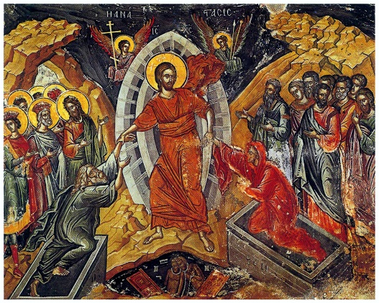  Before exploring the belief in the communion of saints in the Apostles’ Creed teachers can explore this creed more generally by asking pupils to identify the Trinitarian structure of Father, Son and Spirit and the beliefs about each person of the Trinity. Pupils in pairs or trios could be given one of the three parts of the Creed (statements beginning with the Father, Son, Holy Spirit) to discuss on a large sheet of paper and using the border note down their ideas and questions about what particular beliefs might mean. Pupils then feedback ideas.  [For the teacher: teachers and pupils may wonder about some of the beliefs in the Apostles’ Creed and in particular the statement ‘He descended into hell’. The belief is that when Jesus died on Good Friday he descended to hell or ‘to the dead’ traditionally called ‘the harrowing of hell’. This is an important root of the saying that through his death and resurrection Jesus ‘opened the gates of heaven’. The original sin of the first humans – called in Genesis Adam and Eve – closed heaven for all people, both good and bad. The good then await their redeemer, Christ, who descends and brings them to heaven. See https://catholicexchange.com/meaning-behind-descended-hell for a more complete explanation.  Pupils could explore art on the trinity like Jean Lamb’s abstract work and they could design their own panel for their person of the trinity. There is also work on the trinity from RE Today that teachers can revisit if done during the ‘Mysteries’ unit in Year 2. See RE Ideas: God ‘How do Christians portray God?’ pp. 13-18.  One of the features of belonging is that we often share things in common. This is seen in e.g. families whose members share physical and cultural characteristics (though obviously not always). Members of the Church share certain beliefs that are summarised in the Creed. The word creed comes from the Latin credo meaning ‘I believe’. The PB refers to the Apostles’ Creed, rather than the longer Nicene Creed which is recited at Sunday Mass, because the Apostles’ Creed states the Church’s belief in the ‘communion of saints’.  Teachers can, if applicable, make links here with the Sacrament of Baptism which makes the baptised a Christian – a member of the Church – by looking at the promises that the parents and god parents make in the section ‘Renunciation of Sin and Profession of Faith’ see: https://parish.rcdow.org.uk/hitchin/wp-content/uploads/sites/60/2014/06/Baptism-book.pdf (page 10) Teachers will note that the structure of the question and responses follows the structure of the creed which is why at the end the priest says: ‘This is our faith. This is the faith of the Church. We are proud to profess it, in Christ Jesus, our Lord.’  In the old PB the objective ‘know that the Creed states what we believe’ mentions the communion of saints and gives a brief definition = all the people who belong to the Church. The new PB expands on this using an image and 2 questions. All believers, living and dead are a part of the Communion of Saints. The Catechism says, "We believe in the communion of all the faithful of Christ, those who are pilgrims on earth, the dead who are being purified [the Holy Souls], and the blessed in heaven, all together forming one Church; and we believe that in this communion, the merciful love of God and his saints is always [attentive] to our prayers" (CCC 962).  [For the teacher: Basically, all those who believe in Christ and live accordingly are saints. St. Paul describes the Christians he writes to as saints e.g. ‘to the saints in Rome’ etc. Later in the Church’s history the word saint becomes a title for someone who has led an exemplary Christian life, that we now commonly call saints. However, those who have died and are not yet in heaven – the holy souls – are also saints. So all believers – what the Church calls ‘the faithful’ - are part of the communion of saints.]  Using the idea of belonging to a community, the new PB stressing that in a community we help each other so, in this way, the saints in heaven can help us because we often ask them to pray for us. Pupils can explore here how we ask for help from some saints because they are patrons of certain things see https://www.aboutcatholics.com/beliefs/alphabetical-list-of-patron-saints/  We can also pray for the saints – the holy souls – who have died but are not yet in heaven (November is the month we pray for the Holy Souls and 2nd November ‘All Souls Day’ is their feast day). And we also say many prayers asking for God to help each other.
 | Describe, with increasing detail and accuracy, some important signs and actions used in worship during the main liturgical seasons | This expectation requires that pupils name the main seasons of the Church’s year, describe what they are about (there are explanation boxes in the PBs) and to know the significance of different liturgical colours.  The focus of the PBs is on vestments worn by the priest but teachers can also show artefacts or images of artefacts that are associated with different liturgical seasons.  There are some good activities on how beliefs are expressed in a church in RE Today RE Ideas: Expressive Arts pp. 12-18. The images on page 16 are sourced from a Church of England church so two need modifying e.g. for pulpit Catholics use the word ‘lectern’ and for pew Catholics say ‘benches’ and Catholic churches usually have kneelers fixed to the benches not removable pew kneelers.  NOTE: while GREEN, PURPLE /VIOLET, WHITE/GOLD and RED are Liturgical colours, BLUE often used as the colour for Our Lady’s (St. Mary) clothes is not an official liturgical colour.  Artefacts:  Advent Christmas Lent  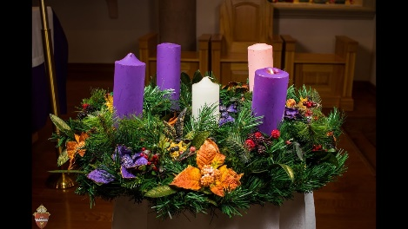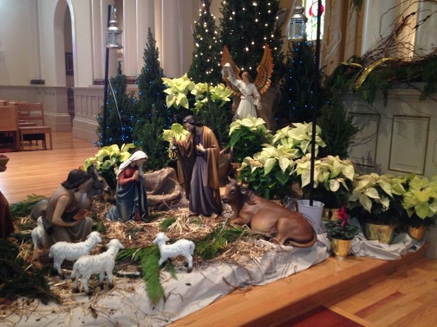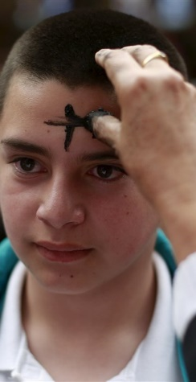  Advent Wreath Nativity scene in church Ashes  Easter  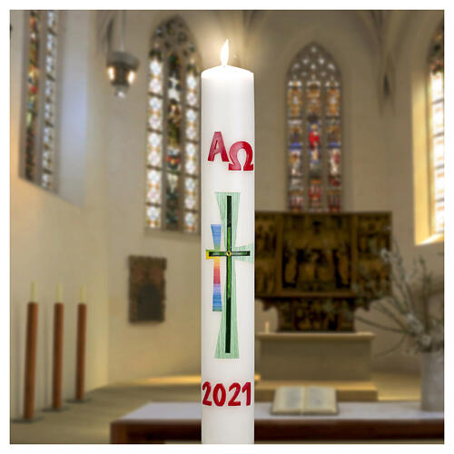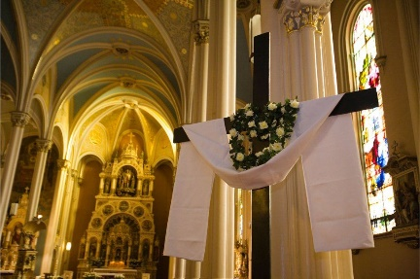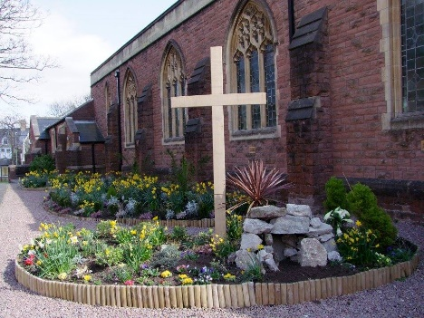  Paschal candle Cross draped with Jesus’ burial cloths Easter garden
 | Give reasons why important liturgical signs are used. | The focus of this expectation can be limited to the colours of the liturgical seasons. Pupils will be able to say why the colours green, purple, white and red are used, see old PB p. 87 and new PB p. 96. If teachers want to extend the learning for some pupils, these pupils can give the reason for use of other signs used in the main liturgical seasons, i.e. advent wreath, nativity scene, ashes, Paschal candle, cross draped with cloth, Easter garden. In the last unit, 3.5, pupils may have given the meaning of the Paschal candle and cross. If so, pupils should choose at least 2 other liturgical signs and say why they are used. It is open to teachers to include the signs used in church for Baptism (font) and the Eucharist (bread, wine, and tabernacle) if you want to extend the repertoire of signs used.
 | Describe the life and work of St. Teresa of Calcutta OR Pope St. John Paul II | The old PB does not cover the mission of the Church when exploring belonging to the Church – the mission was covered in unit 4.5, pp. 74-75. However, the new PB covers the mission of the Church because putting faith in action by making Christ known through their own lives is part of what belonging to the Church means for Christians.  Pupils following the new PB can use RE Ideas: literacy pp. 12-19 ‘Why do some people inspire others?’ which has an excellent set of activities on Mother Teresa (now St. Teresa of Calcutta). The activities in the RE Today publication will provide excellent additional materials to supplement what is provided in the new PB and teachers following the old PB will also be able to use the materials from RE Today.
 | Give reasons for actions and choices in the life St Teresa of Calcutta or Pope St. John Paul II | Mother Teresa: pupils will be able to say that Mother Teresa felt called to love the poorest of the poor. Love was the reason Mother Teresa made the choice to leave teaching and lead the life she did: she said “Not all of us can do great things. But we can do small things with great love” and “Spread love everywhere you go. Let no one ever come to you without leaving happier.”  She showed her love for Jesus, summed up in her poem:  “Jesus is my God,  Jesus is my Spouse,  Jesus is my only Love,  Jesus is my All in All;  Jesus is my Everything.”  by devoting her whole life to loving the poor. Mother Teresa was acting on Jesus’ words ‘I was hungry and you fed me, thirsty and you gave me a drink; I was a stranger and you received me in your homes, naked and you clothed me; I was sick and you took care of me, in prison and you visited me…. ‘I tell you, whenever you did this for one of the least important of these followers of mine, you did it for me!’ (Matthew 25:35-36, 40 Parable of the Final Judgement.)

