INTERPRETATION OF PRIMARY RELIGIOUS EDUCATION EXPECTATIONS
SUMMER SECOND HALF TERM
YEAR 3
UNIT | EXPECTATION | OUR UNDERSTANDING
3.6 Being a Christian | Ask and respond to questions about what being a Christian involves | Both the old and new PBs begin the unit with a summary of what being a Christian involves. In both PBs the parable of the Good Samaritan features (in more detail in the new PB) and then each go on to detail the life of St. Peter (only in the old PB) and the life of St Paul (mainly his conversion).  Ask pairs of pupils using the PB to note down, using pp. 76-77 (old PB) or pp. 90-91 (new PB) what being a Christian involves. They should provide a list of things Jesus was like and what Jesus said. Pupils feedback their lists and the teacher scribes so that pairs of pupils can note down other ideas that they didn’t get.  Using their lists pairs of pupils read through the list and highlight anything they think is most important and anything they don’t fully understand.  Feedback from some pairs of pupils what they think is most important in the list. Ask them why this is their most important thing. Feedback on anything they don’t fully understand while checking for any misconceptions. Make sure you ask those pairs who put love of God as their most important or in the PB (old PB top of p. 77 and new PB first bullet point in ‘Pause to reflect’ on p. 90) why is God put first?  Next ask pairs of pupils to ask each other two questions: firstly going down the list take turns to ask their partner to give one example how they can put each thing on their list into action. Secondly, of the things on their list, which is the most challenging or difficult thing Christians are asked to do? Can they say why?  Next, the teacher asks for some feedback on examples and what is most challenging and why.  To complete this activity pupils could choose three ideas from the list (one being the most challenging to them) and draw a picture of each idea in action. Then they write down which is the most challenging and say why.
 | Make simple links between the Parable of the Good Samaritan and loving your neighbour  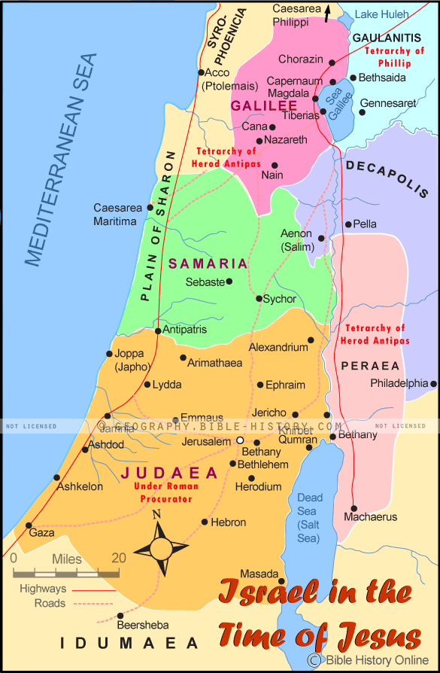 | Drawing on work on the parable of the Good Samaritan in old PB p. 77 and new PB pp. 93-94 pupils will be able make links between the things the Samaritan did for the man who was attacked and acting as a good neighbour or Christian. Pupils can link these actions with particular virtues or qualities the Samaritan showed.  In order to learn something of the context of the story the pupils will need time to unpack it both by dramatic retelling and other ways.  Remind pupils that parables are stories Jesus told that have a hidden meaning, a meaning that is sometimes hard to work out. Read Luke 10:25-29 and ask pupils in pairs or trios to talk about what they think the hidden meaning might be, particularly of the teacher of the Law’s question. Collect their ideas.  Ask pupils the question asked at the beginning of the story by the teacher of the Law (Luke 10:29) ‘Who is my neighbour?’ Pupils put themselves in the middle of a set of concentric circles and put the name of a neighbour in each one.  Show an image of someone being a good Samaritan (links to question 2 on p. 94 of new PB) – e.g. helping a homeless person. Talk with pupils about what is happening. Show more images and ask pupils to sort into ‘goodies’ and ‘baddies’. The images could include a police officer, burglar, nurse, someone in handcuffs, priest etc.  Read the parable to the pupils (Luke 10:30-37). Ask pupils what answer they think the teacher of the Law is expecting. Why? Ask why they think Jesus told this parable.  [For the teacher: Jews and Samaritans (from Samaria) at the time of Jesus hated each other. In fact, it was not uncommon for Jews from Galilee in the north to travel to Judaea (Jerusalem was in Judaea) in the south by avoiding as much of Samaria as possible, Samaria lay in the middle between both regions. They would instead journey through the Decapolis region to the east on the road that went through the borderlands away from inhabited places (see map). It would be like people in the north of England avoiding the midlands on a journey to London in the south by sailing from Hull into London! Jesus’ parable had a familiar 3 fold structure and his listeners would have expected that the hero of the story – the 3rd person to come across the man who had been attacked – would be an ordinary Jew rather than the priest and Levite. (Levites were people who had jobs in the Temple in Jerusalem, getting it ready for worship etc.) Jesus’ choice of a Samaritan would have been shocking, but one that would draw attention to his message. The difficulty the teacher of the Law had in coming to terms with Jesus’ choice of a Samaritan as the hero can be heard in his reply to Jesus’ question: ‘In your opinion, which one of these three acted like a neighbour towards the man attacked by the robbers?’ The teacher says, ‘The one who was kind to him.’ The teacher of the Law can’t even bring himself to utter the name ‘Samaritan!’]  Dramatise the story, by hot seating, seeing it from the point of view of different characters (including the Jewish man attacked by robbers). Explain to pupils that the people listening to Jesus’ parable did not like Samaritans at all so they would have been shocked that the Samaritan was the hero. Using the images of ‘goodies’ and ‘baddies’ again ask would it be shocking to have the burglar/robber being the Good Samaritan? Ask them why? (Adapted from Understanding Christianity, by RE Today.)  Ask pupils to complete ‘What is the message of the Parable of the Good Samaritan? Feedback responses and check for misconceptions.  Next ask pupils who they admire in the parable? What virtues or qualities did he show that make us admire the Samaritan? (This is related, but different from activity 1 on p. 94 of the new PB ‘List 5 things the Good Samaritan did to help the man who was attacked by robbers.) Relate some of the ideas of the hot-seating where the 3 people: priest, Levite, Samaritan, must have feared that the robbers were still about hiding and could have attacked them. The Samaritan showed courage – while he may have feared that the robbers were still about he still was brave and stopped to help the Jewish man who’d been attacked. The Samaritan helped a Jew – a person who hated Samaritans – the Samaritan showed either respect (you show respect when you treat other people as you would like to be treated. You treat people with courtesy and kindness not because of who they are or what they have done, but because, like you, they have a God-given dignity), or mercy (You are patient with people who may have hurt you and to you respond with gentleness, showing love and tenderness rather than treating them badly) or solidarity (If you see that someone or a group of people are in need, in solidarity with them you help them. You see other people’s needs and act to meet their needs before meeting your own). In helping the man in the ways he did the Samaritan was compassionate (You notice that a person is sad, in distress or in trouble, you care about how they are feeling and you want to help them) and kind (You decide to do something good to help someone else, because you know it is the right thing to do). And in paying for the care of the injured man the Samaritan was generous (You give what you have by sharing it with others or helping someone who is in need. You give and do not expect a gift in return or any attention, praise or reward for giving and you do it cheerfully).  Teachers could give each virtue and definition and ask pupils to match them up. Pupils could then be asked to match the virtue to a part of the story. This could be done while the story is told so that pupils hold up the virtue card when they think it is being shown by the Samaritan. Questions 2-4 on p. 94 of the new PB are worth using.  Paintings of the Parable of the Good Samaritan  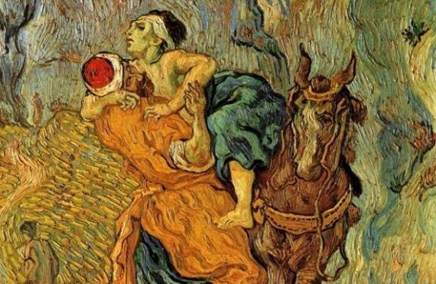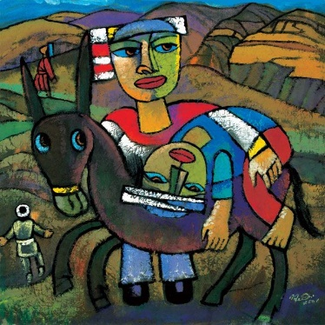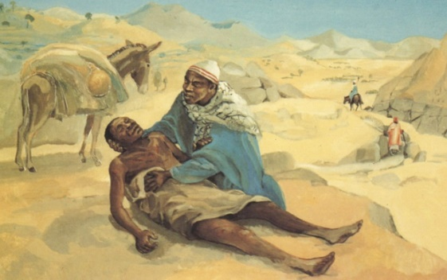  Van Gogh He Qi Mafa Jesus  These are useful images to use with pupils because they show all 3 characters within the painting.
 | Ask and respond to questions about the feelings and actions of St. Peter and/or St. Paul. | Pupils following the old PB will explore the life of Peter in three parts: Jesus calls Peter, Peter makes a promise and Peter breaks his promise. The new PB omits any reference to Peter and has a focus on Paul’s conversion to Christianity.  Exploring the life of Peter: Pupils are going to learn about some of the good and bad times in Peter’s life.  Jesus calls Peter: ask pupils to make a quick drawing of their three favourite possessions. Underneath, list in order the things they normally do during a normal weekday.  Read the start of the Calling of the first 4 Fishermen from Matthew 4:18-19 to the pupils:  ‘As Jesus walked along the shore of Lake Galilee, he saw two brothers who were fishermen, Simon (called Peter) and his brother Andrew, catching fish in the lake with a net. Jesus said to them, “Come with me, and I will teach you to catch people.”’  Ask pupils what Jesus asked Peter and Andrew to do. Tell pupils that by following Jesus Peter was giving up a lot. Go back to the drawings and lists the pupils made. Ask pupils how would they feel if asked to give up so much? Get pupils to give these things up by rubbing out the drawings and things on their list or dramatising leaving behind or giving up their favourite things and things on their lists.  Make some basic templates of a figure representing Peter and ask pupils to draw round it and ask them to write what Peter might have thought when he heard Jesus’ words – thought Jesus was ‘different’, ‘special’, ‘unique’, ‘an inspiration’, ‘good news’ etc.  Go back to the text of the story and verse 19 ‘Come with me, and I will teach you to catch people.’ What special job was Peter given? Ask pupils what catching people might mean? In pairs or small groups, create images of the different things a ‘fisher for, or catcher of, people’ might do. (Adapted from Understanding Christianity)  Link this to the earlier work on examples they gave on what being a Christian involves.  Sing or listen to the song ‘Follow me, follow me, leave your home and family…’ (there are numerous versions in You Tube)  Peter makes a promise / Peter breaks his promise: discuss with pupils the promises they might make during a typical day. Ask pupils in pairs to note down a promise and the write down the consequences ‘if the promise was kept’ and ‘of the promise was broken’. Ask pupils to think of words that describe how Peter must have felt when he made his promise. Ask pupils why they think Peter broke his promise. Ask pupils to think of words that describe how Peter must have felt when he broke his promise. Ask how many times Peter let Jesus down or broke his promise (3 times). Explain to pupils that after Jesus died (on Good Friday) he appeared to Peter and forgave Peter for letting him down. Link back to p. 77 of the old PB and Jesus’ response to Peter’s question about how many times he should forgive somebody. [Read John 20: 15-17.] Jesus forgave Peter and gave him the job as the first pope, the first head of the Church: in verses 16 and 17 Jesus says to Peter “Take care of my sheep”. Peter is to act like a shepherd taking care of Christians.  St Paul: ask pupils to use words to describe the feelings that Saul/Paul had about followers of Jesus while he was on his way to Damascus - before he became a Christian. Ask pupils to suggest adjectives to describe how Saul was feeling when he saw the light and afterward when he was made blind.  You can use question 1 (a) and (b) on p. 83 of the old PB for examples of questions pupils can ask.  - If you interviewed St Paul, what questions would you ask him about his experience on the road to Damascus? (a) Write down your questions (b) Write down what you think St Paul might say in reply to each question.  You can also use the Hot Seating activity on p. 96 of the new PB to gather questions pupils can ask.  - Imagine you are the Jewish Leaders who want to interview Saul. You have heard that he has become a Christian. Work in pairs to plan the questions before the interview. Saul and a companion should think of answers.
 | Retell the story of St. Peter’s life or the Conversion of St. Paul, ensuring it is accurate in its sequence and detail | Using a structure of Before and After, pupils can retell the story of the conversion of Paul  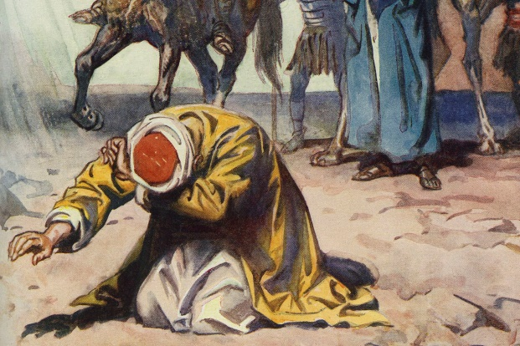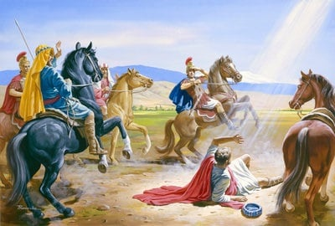  Saul on the road to Damascus H. M. Brock
 | Express a preference on the gifts you can best use to be a follower of Jesus (I can use all these, but my best one is … because…) and make simple links to the prayer of St. Teresa of Avila or the life of St. Dominic Savio or St. Gemma | This expectation links to the two sections in the old PB p. 84-85 ‘You are unique’ and p. 86-87 ‘God’s gifts to us’ and pp. 1oo-103 in the new PB. Alongside the activities in the new PB pupils should explore the gifts and qualities of Dominic Savio and St. Gemma from hearing about them. Pupils can then reflect on the gifts they have and describe how they can use their best gift to be a follower of Jesus or the best that they can be.  Pupils using the old PB can be encouraged to read the Prayer of St Teresa of Avila below and make a link between this prayer and the work on the 5 senses on pp. 84-85 (‘You are unique’) saying how they can use their senses to serve God or to follow Jesus. They can identify their best sense. This activity lends itself to writing and illustrating a ‘senses poem’.  Christ has no body but yours,  No hands, no feet on earth but yours,  Yours are the eyes with which he looks  Compassion on this world,  Yours are the feet with which he walks to do good,  Yours are the hands, with which he blesses all the world.  Yours are the hands, yours are the feet,  Yours are the eyes, you are his body.  Christ has no body now but yours,  No hands, no feet on earth but yours,  Yours are the eyes with which he looks  compassion on this world.  Christ has no body now on earth but yours.
 | Give examples of how you can create a better world (old book) | This expectation links to the end of the unit and the section ‘I have a dream’. Alongside the activities in the old PB, pupils can be encouraged to give some examples of what they would do to create a better world.
 | Describe some different ways of praying (new book) | This expectation follows the sequence of the new PB that focuses on the friendship both Dominic Savio and St. Gemma had with Jesus and then links this with how prayer is the way we can grow close (keeping in touch) to Jesus too.  The PB gives a good example of praying using a gospel (or bible) text. It gives the example of the story of the Ten Lepers and uses a version a bit like guided visualisation – particularly if pupils are encouraged to perform the ‘Preparation for Prayer’ (p. 104).  Perhaps a way for pupils to give some different examples of ways to pray is to be asked to illustrate these different ways – that can be artefacts, body postures or through use of particular senses (especially listening and sight).  Provide a set of artefacts that Catholics and other Christians typically use to help them pray: bible (could use the Ten Lepers), (rosary) beads, candles, images or statues, music. Let pupils explore them. Provide thought bubbles or question cards that pupils use to record how a particular artefact can be used when they pray.  To make a link with the Ten Leper story pupils can be asked which of the senses was used to help them pray when listening to the Ten Lepers – how can listening help us pray?  To make a link with the Lord’s Prayer (‘Our Father’) pupils can be asked how is speaking aloud helpful when they pray.  If teachers want to explore body posture with pupils, you can focus on 1. Joining hands (praying hands), kneeling, sitting and how they can help us pray.  [For the teacher: see Section 486 of the You Cat https://www.cdowcym.org/documents/resources/YOUCAT.pdf  Standing in the presence of God expresses reverence (you stand up when a superior enters) and also vigilance and readiness (you are ready to set out on a journey immediately). If at the same time the hands are outstretched in praise of God, the person praying assumes the original gesture of praise.  Sitting in God’s presence, the Christian listens to what is happening interiorly; he ponders the Word in his heart (Lk 2:51) and meditates on it.  Kneeling, a person makes himself small in the presence of God’s greatness. He recognizes his dependence on God’s grace.  Folding the hands, a person overcomes distraction, “recollects himself” (gathers his thoughts) and unites himself to God. Folded hands are also the original gesture of petition.]

