INTERPRETATION OF PRIMARY RELIGIOUS EDUCATION EXPECTATIONS
SUMMER FIRST HALF TERM
YEAR 1
UNIT | EXPECTATION | OUR UNDERSTANDING
1.5 Resurrection | Talk, wonder and ask questions about whether the story of Easter has anything to say to them about joy, hope, new life  Recognise some symbols of Easter, e.g. cross (rather than crucifix), new life (spring, flowers) Easter eggs, Easter garden  Talk and ask questions about the feelings of the disciples on meeting Jesus | The new TB contains additional material for this unit of work. It adds the story of the empty tomb and Mary Magdala and the story of Jesus’ return to heaven called the Ascension. Both the Ascension of Jesus (Thursday 13th May) and Pentecost (23rd May) occur during this half term.  Teachers can therefore include the story of the Ascension and Pentecost in their religious education lessons (see resources).  Both TBs begin the unit by reflecting on how Easter – the resurrection of Jesus – is celebrated. There should be opportunities for pupils to talk about how they celebrated Easter at home. This can focus on the symbols of Easter.  Begin with a circle time: place objects and pictures associated with Easter on the floor (Easter egg, flowering plant, Easter bonnet, Easter card, Easter bunny, chicks, Easter cross [not crucifix]). Ask individual pupils to pick one of the objects or pictures and say what it is and what it is connected to.  Draw out from the pupils how they celebrated Easter (coincided with the easing of the latest lockdown) probably by eating chocolate eggs and may be an Easter egg hunt – a Sunday dinner, meeting up with some family, some may even have gone to Mass. The focus of Easter –Jesus is alive, he rose from the dead – is on new life and that the new life of Jesus is, after we die, given to us too. So draw out from pupils how the new life of Easter turns sadness into happiness and brings us hope.  Use the story of Water Bugs and Dragonflies and talk about where the dragonfly went and how he feels. Ask pupils to say whether this is a happy or sad tale. Can they spot any links to the story of Easter? What’s different about the dragonfly and Jesus? – Jesus comes back to his friends!  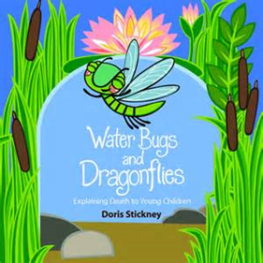  https://slideplayer.com/slide/15422712/  Read the story in the old TB p. 67 and new TB p. 92 and ask the questions about the story.  Complete Activity 1 old TB p. 67 and new TB p. 92 – Make an Easter Cross.  Next, in preparation for reading the story of Mary Magdala to pupils from the new TB p. 94-96 (see resources), focus on who was sad and why were they sad?  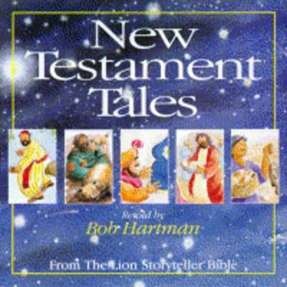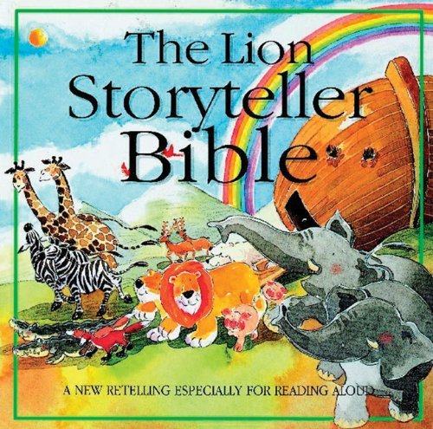  If you have got New Testament Tales or Lion Storyteller Bible by Bob Hartman use the pictures of ‘A Happy Day’ for this next activity (see resources).  Using the picture which shows the 3 women feeling sad, talk about how Mary (in red with the yellow scarf) is feeling. Ask pupils how the picture shows the sadness – the colours, tears, holding each other etc.  Now show the picture that shows Mary later in the day. Talk about how Mary is feeling and how the picture shows this.  Pupils act out how little scenes using body language to show sadness turning into happiness. Take it in turns to freeze frame the action and talk about how they feel.  Look at the picture of Mary again when she is feeling happy. Use thought bubbles around the picture to express how Mary is feeling.  Read the story of Mary Magdala’s visit to the tomb and meeting with Jesus. Watch the BBC Religion animation on the story of Easter at this point. It focuses on Mary of Magdala and there are some activities on the animation (see resources) [You could watch this animation at the start of the unit as well]  https://www.bbc.co.uk/teach/class-clips-video/religious-studies-ks1-the-christian-story-of-easter/zhgv47h  If not already done so, complete Activity 1 ‘Make a class Easter garden’ or one per table group Easter garden and answer the questions.
 | Give an answer to a question like, ‘What makes you joyful?’ ‘What do you hope for?’ | During work contrasting sadness and happiness, focus this question on the discussion about the joy and happiness that Easter brings. For the question about hope, this could be a follow on from discussion prompted by reflecting on the message of Water Bugs and Dragonflies and its link with the story of Jesus rising from the dead.
 | Recognise some symbols of Easter, e.g. cross (rather than crucifix), new life (spring, flowers or flowering plant) Easter eggs, Easter garden | Alongside the circle time activity, give pupils the objects or pictures of objects as a small group activity (see resources). Ask pupils to match the title of the object to its picture. If teachers want some pupils to go beyond this, pupils can match the title with a simple description of what it is used for e.g.  Cross – is put in church it has cloths on it to show Jesus is risen [Jesus no longer needs his burial clothes because he is risen from the dead. See John 20:3-10].  Spring flowers: in spring flowers come alive again, just like Jesus at Easter.  Easter eggs: out of eggs come chicks – new life - just like Jesus came out of his tomb.  Easter garden: Jesus tomb was in a garden. Like the spring flowers in a garden, Jesus came alive again. [See John 19:41-42 ‘There was a garden in the place where Jesus had been put to death, and in it there was a new tomb where no one had ever been laid. Since it was the day before the Sabbath and because the tomb was close by, they placed Jesus’ body there.’]
 | Recognise some stories of Easter and know they are from the Bible  Talk and ask questions about the feelings of the disciple on meeting Jesus | Recognition of stories can be visual – from being shown a picture – but is principally from hearing stories read and working with a story. In order to recognise the stories pupils will have heard the story during the lessons and be able to identify it. Pupils are not required to retell the story, but should be able to go beyond knowing the story title and are able to give a detail from the story. This can be from questions to pupils about what a character did in the story etc.  If pupils are able to explore a bible and told that the stories about Jesus are found in the Bible and the teacher points out the stories in a bible this should help pupils know the stories come from the Bible.  [All the stories of Easter presented in the TBs are there to enable the pupils to see that Jesus appeared to his friends to show that he was alive – the physical focus on eating and Thomas touching Jesus’ body – but also alive in a new way (Jesus can just appear and disappear and he is not at first recognised by his friends) Jesus’ new life now does not move towards death, but is everlasting – he came out on the other side of death as the TB says.]  There are plenty of opportunities for pupils to recognise the story of Mary Magdala from the new TB. The BBC animation and New Testament Tales (Storyteller Bible) provide opportunities alongside the new TB.  The story of the disciples in the Upper Room gives opportunities for talk about nice surprises and the Activity 1 of a ‘lift-the-flap’ surprise picture is a lovely idea.  A good story to also focus on is Doubting Thomas old TB pp. 73-76 and new TB pp. 103-106.  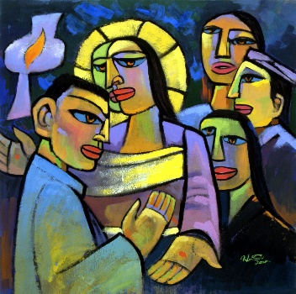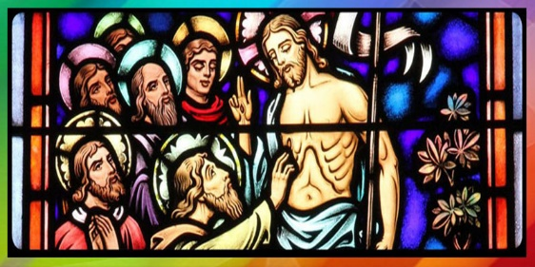  He Qi ‘Doubting Thomas’ Stained glass ‘Doubting Thomas’  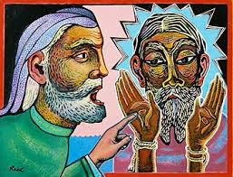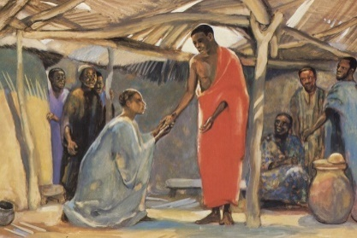  William James Reed, ‘Doubting Thomas’ Mafa Jesus ‘Doubting Thomas  Following the introductory activity about seeing and believing - play some games that bring out that we do believe things that we cannot see or understand - read the story of Doubting Thomas from the TB or from a bible story book. Focus on the parts of the story – its sequence.  Now give pupils some artwork about the story. Some is suggested above. Ask pupils to take a picture and ask them if they can spot the point in the story that the picture shows.  Ask pupils to say what is their favourite picture and can they say why? Take that picture and give a thought bubble and a speech bubble and ask pupils to fill in these (e.g. what was thought by Thomas and said by Jesus) and display round their favourite picture.
 | Recognise the story of the Ascension and Pentecost  Talk about the feelings of the characters in the stories | Use artwork to aid pupils’ recognition of the stories of the Ascension and Pentecost.  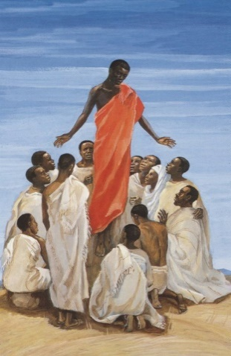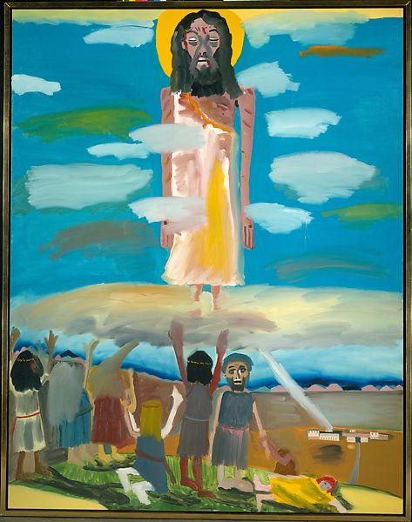  Mafa Jesus ‘The Ascension’ Frederick J. Brown ‘The Ascension’  Ask pupils compose their own picture of the Ascension of Jesus (it is celebrated on Thursday 13th May).  How do you think the disciples felt when Jesus left them? Why?  How would you have felt? Why?  Ask pupils to imagine saying ‘goodbye to their best friend’ and make into a little role play. Talk about what someone might promise to do when they have gone – ring, text, face time, write a postcard or letter. Talk about what Jesus promised – to send the Holy Spirit as a helper  Pentecost (celebrated Sunday 23rd May)  Prepare pupils for the story of Pentecost by having a story box with objects associated with the story from Acts 2:1-6, 22-23. In the sack put a fan (strong enough to create the noise of air blowing), a candle with flame (electric or a candle that you light), an energy bar or battery, a world map or globe. Tell pupils they are all connected to the day the followers of Jesus grew from the friends of Jesus to 3000 people. Photographs of these objects could be placed on a table and each small group is asked what these things might be for (see resources).  Give pupils sight of some artwork (suggested below) and ask what the picture shows. Can they spot a link with the objects they were asked about (fan, candle/light, battery or energy bar, world map or globe - telling the good news about Jesus to people all over the world – [this image also includes Jesus’ hands keeping the promise to send the Holy Spirit.  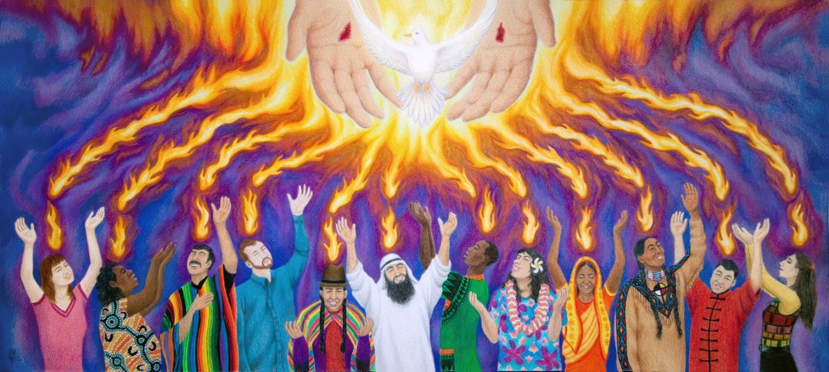  Tell the story of Pentecost from a bible story book or ask Year 2 for a copy of the story in the Year 2 old PB pp. 72-73 or new PB pp. 80-81.

