INTERPRETATION OF PRIMARY RELIGIOUS EDUCATION EXPECTATIONS
SUMMER FIRST HALF TERM
YEAR 5
UNIT | EXPECTATION | OUR UNDERSTANDING | PROMPT QUESTIONS
5.5 Life in the Risen Lord | Compare their own and others’ ideas about the resurrection | It is important that the RE display is changed from an emphasis on Good Friday to Easter Sunday, using signs and symbols of Easter that celebrate new life and the resurrection of Jesus. There are some good guiding questions in the old TB pp. 40-41 that provide some good starting points.  A useful starting point is provided in Opening Up Easter by RE Today https://shop.retoday.org.uk/9781905893461  The ‘For the teacher’ section gives a good context and Activity 1 ‘googling Easter’ in conjunction with a reading and analysis of Paul Cookson’s poem ‘I don’t believe in Easter’ will bring pupils to the place where they are then ready to tackle the resurrection accounts.  It would be useful for teachers to probe and gather pupils’ knowledge about the resurrection in a question and answer session using a stimulus of an Easter picture.  Show pupils the 11 minute clip on the (death and) Resurrection of Jesus from The Miracle Maker film see https://vimeo.com/404287245 (1:11-1:22)  Read pupils one of the stories of Jesus’ resurrection (perhaps John 20:1-18) and allow pupils to read other stories (see Jesus’ Resurrection worksheet for the texts) so that they build up their knowledge of the stories and can contrast the emotions of the disciples of Jesus on Good Friday and on the first Easter Sunday. These differing emotions can be plotted on a line graph using different emojis with sadness and fear as low points and joy as a high point. Ask questions about the reasons for the different emotions. These questions will enable pupils to demonstrate how the emotions are linked to beliefs about Jesus.  There is an example of a newspaper template in the old TB p. 77 that is useful for the questions it has as prompts. There are better templates e.g. at twinkl see: https://www.twinkl.co.uk/resource/t-he-019-newspaper-editable-template  For a further activity show pupils a selection of the excellent “Stations of the Resurrection” by Simon Smith. These are 19 modern interpretations of the different appearances of Jesus set in and around Leeds. See https://proost.co.uk/downloads/stations-of-the-resurrection-by-si-smith For example, the image to the right is set on Harrogate Road in Moortown. I have overlaid the text of the story on to the second image. The download costs £5 and is well worth it. Pupils could reinterpret a particular image from Simon and create their own using a scene from their own neighbourhood or a favourite place they know.  THE NEW PB p. 86 Activity 1 lends itself to the Conscience Alley or Pros and Cons Tunnel activity:  The aim of this activity is to create a balanced argument, considering how and when, not just what, we say. It develops a range of perspectives, encouraging decision-making and challenging attitudes.  Pupils are split into 2 groups. Each half will explore one side of an issue.  E.g. should the guard take the money and conceal the truth or should he not take the money and tell the truth? One side gives reasons to say yes, he should take the money, the other side disagree and give reasons to tell the truth.  - Each individual should have a separate point to make  - Each half agrees the order in which the individuals are going to present their argument and lines up  - The 2 lines face each other, forming a tunnel and a volunteer walks down, listening to the points which alternate between each side of the argument  - It is important to consider how each point is delivered and where in the line it will come  - At the end the volunteer decides which way he/she has been swayed and why  - This leads to a discussion of the strength and influence of certain points  The expectation is focused on the group work that is offered in the Activities in the PBs. It is question 3 in the old PB p. 67 and question 2 in the new PB pp. 87-88. Through the exercise pupils will learn one story of the resurrection very well as well as hear other resurrection accounts from the other groups. They will be able to compare ideas and using the Judge’s Summary will be able to appreciate how believers in the resurrection make sense of the evidence. (You can’t prove the Resurrection happened by looking at the evidence, you believe it or you don’t). Judge’s Summary from the new PB p. 88:  Consider the following:  - Were the disciples truthful or not?  - What did you find most convincing about their reports?  - Would you say they imagined seeing Jesus? Give reasons.  - Do you think they were bribed to spin these sensational stories? Why?  - What do you think should happen now?  - If you believe that Jesus rose from the dead at Easter, how does the evidence help you make sense of that belief? | How did the disciples of Jesus feel on Good Friday?  How had they all behaved?  What do you know about the resurrection of Jesus?  Did the disciples of Jesus expect Jesus to rise from the dead?  Who did Jesus appear to?  What different emotions did the friends of Jesus show?  How is Jesus’ resurrection a different kind of event from the resurrection of his friend Lazarus? (see John 11:1-44) – Jesus’ life is everlasting, Lazarus would die again!  What do you think happened to the body of Jesus?  Was it stolen?  Who would be likely to steal it?  Why?  What evidence is there that Jesus is not a ghost?  What are the different stories of the resurrection telling us about Jesus and about the importance of hope?  What does Jesus’ resurrection mean for us?  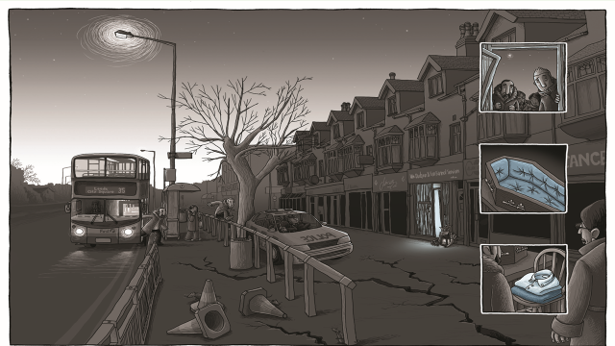  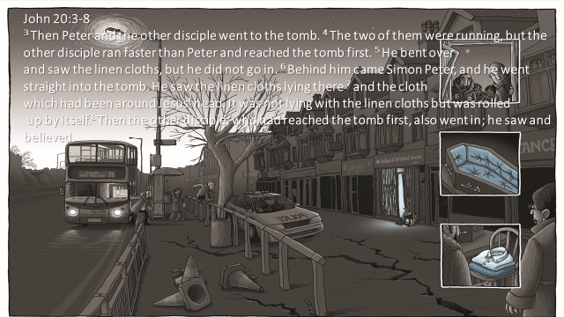
 | Show knowledge and some understanding of the meaning of the Resurrection for Christians | This expectation is most directly linked to the new PB and the learning objective ‘Understand the meaning of the Resurrection. Reflect on the importance of the Resurrection for us.’ See new PB p. 89-90 and activities on p. 91.  The old PB picks up a key idea of the Resurrection of Jesus as Jesus always being with us see PB pp. 68-69 which is then the lead in to a focus on prayer however, the meaning of Easter is required learning so it will need to be covered (if using the old PB see resources).  Ask pupils to look carefully at the stained glass image of Jesus’ resurrection on p. 89 of the new PB (see resources). Ask them to compare to the Resurrection window from the church in Lisburn in Northern Ireland. If purchased Picturing Jesus from RE Today answer the questions about the Lisburn church window – Picture 22.  Use the following questions with the WTL window:  - What colours have been used?  - Why is there so much red?  - How does the window show that it is Jesus who has been raised?  - How is the link with the appearance of new life shown by the figure of Jesus? (rising from the tomb looks like the growth of a new plant or tree [or a birth through labour])  A useful starting point would be to complete more activities from Opening Up Easter from RE Today pp. 27-29 in conjunction with reading p. 89 and reflecting on the ‘Pause to discuss’ questions and the section on p. 90 entitled ‘What does the Risen Jesus do for us?  Activity 2 ‘Engaging with poetry’ in Opening Up Easter is an excellent activity and this could be followed by completing (1) write a poem from Activity 3.  Following this, remind pupils of the difference in meaning between a crucifix and a cross for Christians. The crucifix emphasises the suffering and death of Jesus while the cross (with no figure of Jesus on it – see images on the right) emphasises the resurrection – the victory of Jesus over death itself and therefore the promise of eternal life for all believers.  Present pupils with different crucifixes and crosses (physical and/or photographs) for pupils to reflect on and respond and relate the emotions and beliefs that are expressed in the different artefacts. It is the emotions and beliefs that are key (crucifixes can express sadness, suffering, pain, horror, fear, sorrow, sacrifice, love etc.) crosses can express, peace (as in it is over, rest in peace), forgiveness, faith, hope, love, happiness, joy, new life, victory over death etc.  For the different emotions and beliefs pupils match up to a colour (while colours can be informed by the liturgical colours of the church’s year allow pupils to suggest colours) and then using images and words from magazines and newspapers pupils in trios or groups create a large RESURRECTION (or Easter) CROSS in that colour with images and words cut out that reflect that belief and associated emotions that are represented in Jesus’ resurrection (see resources for ideas). | What does the resurrection mean for Jesus?  What does Jesus resurrection mean for you and me?  What does the resurrection do for me and you?  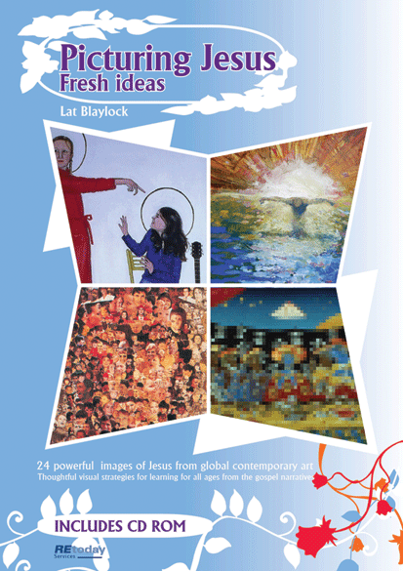  https://shop.retoday.org.uk/find/picturing+jesus/1  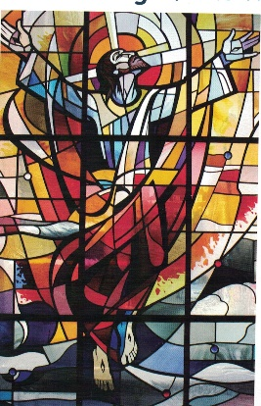  WTL Resurrection window  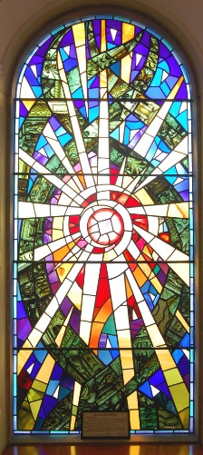  Resurrection Window, Lisburn N. Ireland  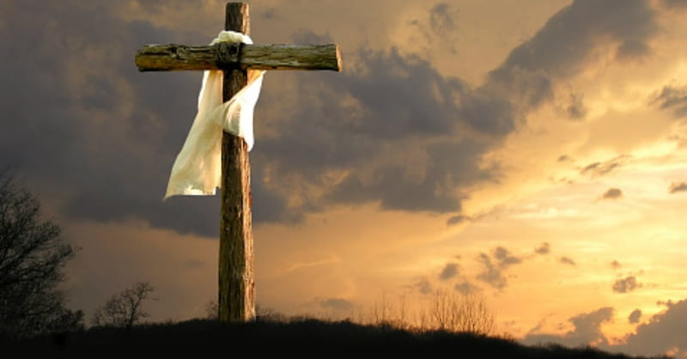  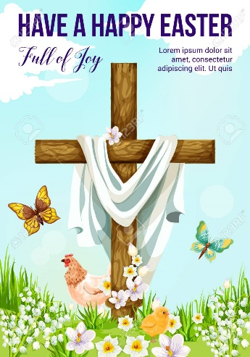  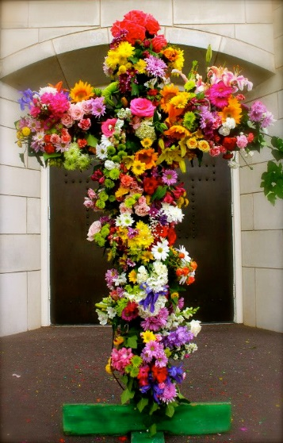  While we may be more excited about Christmas, why is Easter the most important event for Christians?  What beliefs do Christians have about Easter and what different symbols are used to show these beliefs?
 | Show some understanding of Jesus’ teaching on prayer | This expectation focuses on Jesus and prayer and is prepared for in the old PB in the section ‘Jesus is with us’ pp. 68-69 and in the new PB pp. 94-95.  It will be important to teach that prayer is about developing a friendship with Jesus/God in the same way pupils grow closer to a friend, hence the subtitle in the PB ‘Prayer is being with Jesus’. Friendships grow when we spend time together, listening and speaking and sharing our life with our friend, the same is true of our friendship with Jesus/God.  Give pupils bible texts about:  - What Jesus said about prayer: Luke 11:5-13; Matthew 6:5-13 and Luke 18:9-14  - What Jesus did: Luke 6:12-13; Luke 9:15-16; Luke 5:15-16 and Luke 9:28  Ask pupils in pairs or trios to read the texts and produce a first draft of ‘Jesus’ Guide to Prayer’ picking out, through Jesus’ word and example, what Jesus actually taught us about prayer. The different guides can be fed back or compared and things added to each trios versions.  Introduce the types of prayer, focusing on these 4: giving thanks, praise, asking, and sorry, see old PB pp. 70-71 and new PB p, 97. You could give each type of prayer a name like ‘Andy Ask’ and ‘Peter Praise’ etc. see RE Ideas: Jesus pp. 24-25 from RE Today and how some fun with jelly baby sweets!  Alongside the activities on pp. 72-73 in the old PB and pp. 97-98 of the new PB, give pupils the text of the Lord’s Prayer – the prayer Jesus recited when his disciples asked him “teach us to pray”. Pupils can see the source of the prayer in Matthew’s Gospel 6:9-13 and Luke’s Gospel 11:1-4  Ask pupils to identify where the 4 types of prayer are found in the Lord’s Prayer.  Now go back to the examples of what Jesus said and did and ask pupils to find the 4 types of prayer there too.  Finally get out their draft of ‘Jesus’ Guide to Prayer’ and improve them. After feedback from other trios and groups compose the Class’s agreed Guide to Prayer. | 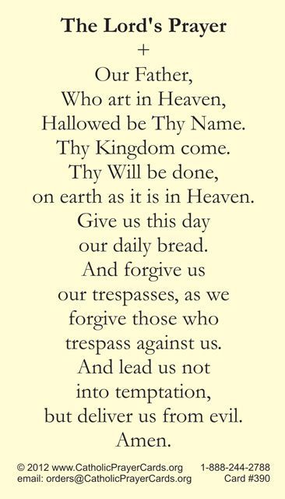
 | Show some understanding of the religious beliefs within the Lord’s Prayer and the Rosary | The Lord’s Prayer old PB, p. 76-77 and new PB, p. 100.  Pupils will be able to show some understanding of the Lord’s Prayer that Jesus gave us. The prayer is in 7 parts, the first 3 parts are about God the Father and the last 4 parts ask God the Father to meet our needs. Pupils can annotate the first part of the prayer unpacking the meaning of:  Father (why is the image of a loving Father important? What does it say about us and about God?)  Hallowed (hallowed is an old word meaning holy – God is so great (set apart from us – this is what holy means) we wonder and are in awe of him (‘Our God is a great big God’). He is so great even His name is holy so we remember to use it appropriately, with absolute respect. God is holy also in the sense that He is perfect and because He is perfect he lacks nothing (God is all good, all loving and almighty) and so we can be sure that what we ask of God He can give.  Thy kingdom come. Thy will be done, on earth as it is in heaven. (God’s kingdom is not in one place on the map, but is anywhere where God is listened to and people live out God’s message - this is where “God Rules” - Jesus’ message about God’s Kingdom is really about learning that God wants us to love one another, to practise forgiveness and to never exclude anyone but to include them and to make these three aspects of the Kingdom more and more present here and now.  4 petitions – asking prayers. We pray because we need to, unlike God, we are not perfect, we have needs for our body and soul/spirit and we are not always good nor always loving. But more than this, Jesus’ prayer teaches us that we are not complete without God – this is why prayer is such a precious gift because through it we can grow closer to God!  Ask pupils to look at the lyrics of ‘How we need you’ a song based on Psalm 42 by Fischy Music. If you don’t have the song, pupils can pick the tune up by listening to the 45 second clip on the Fischy music webpage. It is a song in the Collective Worship package if your school subscribes:  https://www.fischy.com/songs/how-we-need-you-2/  Pupils can compare the lyrics to psalm 42 (in the Good News version see https://www.biblegateway.com/passage/?search=Psalm+42&version=GNT  If school has purchased Big, Big Questions from RE Today there are some excellent activities based on this song on pages 24-29  The Rosary: have a selection of rosary beads in different colours, full necklaces and finger rosaries (ask pupils to bring in a set)  Talk about how they are used and how using beads helps Catholics pray.  Catholics pray the rosary to show the special place Mary has in Christianity. Mary is so special because when God chose Mary to be the mother of His Son Mary said “Yes!” – Mary agreed to become the mother of Jesus, God’s Son.  Catholics say a prayer about Mary’s role in bringing God’s Son into the world to bring forgiveness and salvation. It is called the ‘Hail Mary’ and is about the role Mary played in God’s plan and through it we give honour and thanks to Mary.  The first section: ‘Hail Mary, full of grace, the Lord is with you’ comes from the angel Gabriel’s greeting to Mary at the Annunciation in Luke 1:28  ‘Hail Mary’ – the angel Gabriel’s greeting (in the bible ‘Rejoice’)  ‘Full of grace, the Lord is with you’ – These are more difficult to understand: God gave to Mary the gift of himself so in Mary’s “Yes” Mary plays her part in bringing God, not only to herself, but to the world. This is the meaning of Emmanuel used at Christmas meaning “God is with us”.  The next words, ‘Blessed art thou among women, and blessed is the fruit of thy womb, Jesus’ come from the greeting of Elizabeth, Mary’s cousin and mother of John the Baptist, in the story of the Visitation in Luke 1:42. Mary is honoured because, of all women, God chose her to be the mother of His son.  The Church added the next part of the Hail Mary prayer:  Holy Mary – to be holy is to be set apart for God. It is to be called and chosen for a special task. Mary is holy because she has been set apart from all other human beings to be the mother of God’s son.  Mother of God – Mary is the mother of God because she gives birth to Jesus, God’s Son, the second person of the Trinity.  Pray for us sinners now, and at the hour of our death.  We ask Mary to prayer for us now and when we die so that Mary can lead us to Jesus her Son in heaven.  Mary is honoured in Christianity because of her central role in God’s plan and this is shown by having a prayer dedicated to her but also through having two months dedicated to her October and May. It is in October that Catholics make a special effort to pray the rosary.  Rosary beads are composed of 5 sets of 10 beads with each set of 10 – a decade – separated by a single bead to prayer the Lord’s Prayer or the ‘Glory Be to the Father’ prayer.  By praying the rosary Catholics can reflect on the full story of God’s plan of salvation beginning with the Annunciation and ending with the Crowning of Mary as Queen of Heaven in 4 sets of Mysteries:  1 The Joyful  2 The Luminous (Light)  3 The Sorrowful  4 The Glorious  The activities in the PBs provide opportunities for pupils to show the beliefs associated with the Rosary alongside the beliefs in the Hail Mary and Lord’s Prayer. | 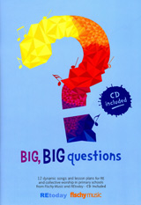  https://www.osv.com/wp-content/uploads/2021/02/howtorosary.pdf
 | Show some knowledge and some understanding of religious signs, symbols and actions used in prayer | This expectation can be focused on the use of Rosary beads, but can also include other artefacts (objects) that are aids to prayer. Teachers can build up a display with some of the following:  candle light,  an icon or religious picture  statues  bible  prayer cards  Music: choose something appropriate  Silence  Physical gestures:  Sign of the Cross  Praying Hands  Kneeling  Signing at the Gospel  The learning outcomes of using an artefact should be that pupils understand:  - What it is;  - The value & importance it has for those who use it,  - How it is used within the Catholic community;  - What it tells us about Catholic beliefs.  Ask pupils to choose two or three from each and produce a guide to their use, the meaning of the artefact or sign and why they a good aid to prayer.

