INTERPRETATION OF PRIMARY RELIGIOUS EDUCATION EXPECTATIONS
SUMMER FIRST HALF TERM
YEAR 2
UNIT | EXPECTATION | OUR UNDERSTANDING
2.5 Eastertide | Ask and answer questions about the feelings and experiences of characters in the stories of Easter | In order for pupils to understand the importance of Easter it will be necessary to explore in more detail – particularly if it wasn’t done before the Easter holiday – the basic events of Holy Week and Good Friday – the suffering and death of Jesus. Both PBs (old PB p. 64 and new PB p. 68) begin the unit by mentioning how sad the disciples were when Jesus died on the Friday and was placed in the tomb.  Establish and consolidate the pupil’s knowledge of Holy Week, including Palm Sunday, Cleansing of the Temple, The Last Supper, Peter’s Denial, the Trial before Pilate telling the stories using child-friendly version e.g. Teacher Book 1 (for Palm Sunday old TB 1 p. 60-61 or new TB 1 p. 83; Good Friday old TB 1 p. 63 or new TB 1 pp. 86-87) or God’s Story 2, The Lion First Bible etc.  Using pictures of Holy Week (see resources) ask pupils in trios to put them in the order they happened – they could place each on a Holy Week timeline.  There are some good activities to complete with pupils in Opening Up Easter pp. 8-11 by RE Today.  Ask pupils to freeze frame different events during Holy Week ensuring that they are asked to say how the different characters are feeling. Pupils complete a ‘Feelings Graph’ (see resources) to show how the disciples and Jesus must have felt. The graph will go from ‘feeling better’ to ‘feeling worse’ and the story title or picture could be placed on it (or the story can be numbered) and pupils plot how the disciples felt. Pupils could use two colours one for Jesus and one for the disciples on the same graph or compose two graphs  Pupils watch the short animation on the story of Easter from the BBC see link below:  https://www.bbc.co.uk/teach/class-clips-video/religious-studies-ks1-the-christian-story-of-easter/zhgv47h  Complete some of the activities that accompany the animation (see resources).  Ask pupils to think of music they like to hear when they are happy and sad. Listen to ‘Woah, He is Alive’ by Fischy Music.  https://www.youtube.com/watch?v=QJMnSgKvYk0  Ask pupils: what parts of the story is the song about? How does the music show the change from sadness to joy? This activity can link to activity 3 in the old PB p. 66 and activity 2 in the new PB p. 73.
 | Retell, in any form, at least one Easter story | This expectation is closely connected to the first expectation and will most likely be completed at the same time.  To retell does not mean learning to write down the story exactly as it appears in the Bible, but means to retell the story in their own words. To retell means to have correct details from the actual story in their own account: the correct sequence, characters and setting. However, the words ‘in any form’ means that a pupil’s retelling does not need to be a written account alone, but could be an oral retelling based on an account of the story presented in different media or from memory. Or a pupil could write a sentence for each part of a sequence created in different media.  Use different storytelling techniques like drama or godly play etc. There is a fishbone diagram in the resources if teachers want to focus on the story of Jesus’ appearance to the disciples and Peter at the shore. Pupils could compose a senses poem of the story from this activity.
 | Give simple descriptions of what the stories of Easter tell us about Jesus | The old PB (pp. 64-66) begins with Jesus appearance to his disciples on the shore. The story of the appearance at the shore is the second story in the new PB which begins with the appearance to Mary of Magdala, see pp. 68-70. This expectation links to the last question in the ‘Pause to talk’ section on page 70 of the new PB.  What do these two stories tell us about Jesus:  - He is alive – he rose from the dead  - Death isn’t the end of the story - like Jesus, Christians believe that after they die, they can have a new life with Jesus in heaven.  The expectation is really about why Easter is so important to Christians, why it matters so much? Teachers can link the story of the appearance of Jesus on the shore to Peter’s three denials on the morning of Good Friday if you want to focus on the importance of forgiveness as well as new life. After the disciples had shared a meal with Jesus, Jesus took Peter aside (John 21:15-19) and asked Peter 3 times whether he loved Jesus. In this way Jesus forgives Peter for his denial of Jesus three days earlier.  Using a story like Let’s Be Friends Again (see https://childrensbooksforever.com/Childrenpics/LETS%20BE%20FRIENDS%20AGAIN.pdf)  Discuss the story with pupils, who needed to forgive and how the big brother felt before and after forgiving. Make a link with Jesus’ forgiveness of Peter and discuss with pupils why they think it is important to forgive.  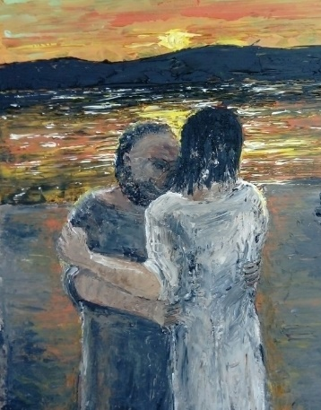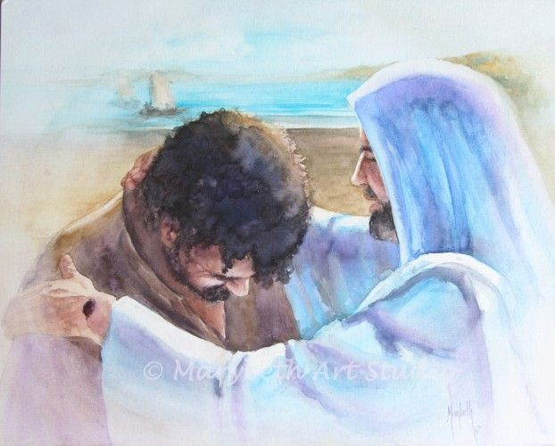
 | Suggest answers to questions like, ‘What matters most at Easter?’ | This activity could be done at the start of the unit and repeated towards the end to show any gain in understanding  This question is a question of meaning and purpose. A limited number of things can be given out or shown by the teacher that the pupils then sort. Pupils will respond to the question: “what matters most at Easter?” through sorting the various things and coming up with two or three important things. The teacher can elicit from pupils why they think these things matter most.  Teachers can use some of the images of different Easter cards and Easter (secular and religious) symbols. Give pupils the images and ask them to sort them with the question ‘Which of these show what Easter is really about?’ (Teachers can ask pupils ‘Is Easter really about: cuddly bunny rabbits, fluffy chicks, chocolate eggs, flowers?) If teachers have talked about forgiveness, then a picture of Jesus with Peter can be included. The exercise should help pupils articulate the importance of Jesus as bringer of new life, hope, joy, forgiveness etc.
 | Ask and answer questions about the feelings and experiences of characters in the story of Ascension | The ‘Pause to talk’ section of the new PB p. 78 supports this expectation with 2 of its questions:  - How do you think the disciples felt when Jesus left them? Why?  - How would you have felt? Why?  There is also support in the old PB p. 71 where pupils are asked to imagine saying ‘goodbye to a good friend’ with accompanying role play. (See activity 1 (a) and (b) p. 71)  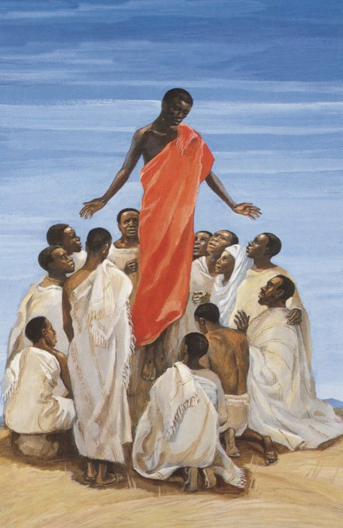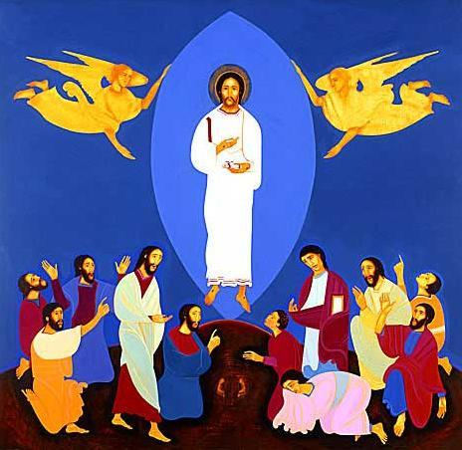  Mafa Jesus ‘The Ascension of Jesus’ Michael O’Brien ‘The Ascension’  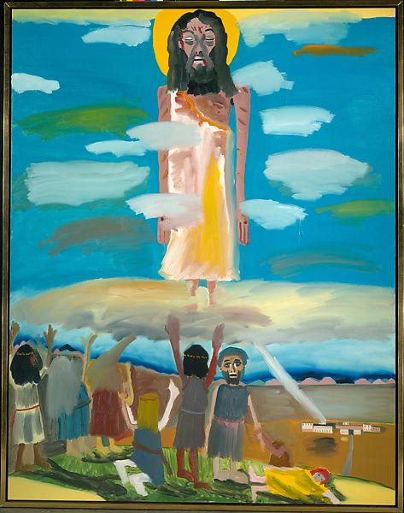  Frederick J. Brown ‘The Ascension’  The point of the ‘Bad News – Good News’ section (see old PB pp. 67-68 and new PB pp.74-76) is to show the rollercoaster of emotion that Jesus’ disciples went through in their life with Jesus. Jesus is someone given to them, then taken away (Jesus is killed), who then returns (the Resurrection) but who then leaves them again (the Ascension). But before he ascends, Jesus promises that the Holy Spirit will come and will give them its power and energy and be a Helper to them. The Bad News – Good News section is important as a source of knowledge that Jesus promises to send the Holy Spirit (a new friend) to the disciples – a new invisible friend as the PB has it.
 | Ask and answer questions about the feelings and experiences of characters in the stories of Pentecost | The key ideas from the text in the PB on the story of Pentecost is that the Holy Spirit will be a Helper to the disciples (friends of Jesus). The Holy Spirit will  - give the friends of Jesus the courage to tell all people about Jesus  - help the friends of Jesus remember and understand all that Jesus said.  [For the teacher: for context read John 14:25 and John 15:7, 12-13)  So the theme of this section on Pentecost is ‘The Holy Spirit is our Helper’  Prepare pupils for the story of Pentecost by having a story box with objects associated with the story from Acts 2:1-6, 22-23 in addition to the retelling in the PB. In the sack put a fan (strong enough to create the noise of air blowing), a candle with flame (electric or a candle that you light), foreign language phrase books, a sign saying courage, an image for ‘understanding’, an energy bar or battery, a world map or globe. Tell pupils they are all connected to the day the followers of Jesus grew from the friends of Jesus to 3000 people. Photographs of these objects could be placed on each group’s table and each group is asked what these things stand for – noting ideas for the objects (see resources).  Now tell the story of Pentecost from Acts 2:1-6, 22-23 (Good News version or a good bible story book). Review the pupils’ responses, their questions and puzzles etc. This story is ripe for creative retelling using the objects or photographs from the story box.  There is support to meet this expectation by using the hot seat activity on p. 83 of the new PB: what happened to you when the Holy Spirit came?  - How did you feel?  - What did you do?  - What will you do next?  And the ‘Before and After’ activity on p.74 of the old PB  Activities engaged with for this expectation will also lend themselves to meeting the expectation:  Retell, in any form, the story of Pentecost.
 | Give simple descriptions how the Holy Spirit helped the disciples and relate this to their own lives giving examples | This expectation is closely linked to the one above and can be easily linked to work on the feelings of the disciples and how the Holy Spirit helped them.  Alternatively, if pupils were introduced to the trinity kenning in the Mysteries unit (2.2) revisit the six last lines about the Holy Spirit:  Promise keeper  Hand holder  Heart warmer  Cheerer upper  Energy booster  Life giver  Give pupils the WTL textbook story of Pentecost or a suitable version of Pentecost and ask them to identify if any of these ideas are shown by the story: the following appear: promise keeper, Cheerer upper, energy booster – the pupils may also see the other two aspects in the story.  Ask pupils to give a couple of examples how the Holy Spirit helps them in their lives. This can focus on promise keeping, energy booster – focusing this on feeling brave and determined. This can and should focus on living one’s faith with courage (or acting with courage) how we are helped by the spirit to understand how we should put our faith in action.
 | Describe the symbols of the Holy Spirit | The focus should be wind and fire.  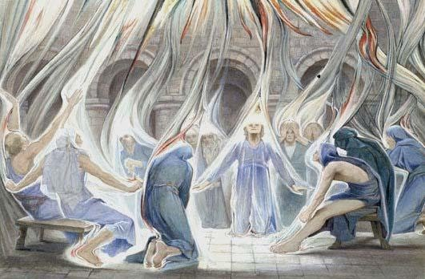  Estella Louisa M. Canziana, Pentecost Day Elizabeth Wang, Pentecost Day  Wind: Estella’s painting is really good at depicting the symbol of wind. The wind shows the power of the Holy Spirit, the text of Acts 2:2 says ‘sounded like a strong wind blowing’. The Holy Spirit is an invisible force (like wind) that we cannot control. It is also a sign of life that the Holy Spirit brings: air that moves is full of vitality, full of life [For the teacher: in the first story of creation (the 7 days, the spirit of God ‘hovered over the waters’ and in the second creation story (the creation of the man and woman) God breathed into the man’s nose and he came alive – that breath of God was the Holy Spirit – living giving Spirit]  Fire: Elizabeth’s painting is good at depicting the symbol of fire. The painting shows fire as the power of God that boosts our energy enabling us to live life with courage, confidence and understanding. Fire symbolises the presence of God. In the Old Testament Book of Exodus God appears to Moses in the burning bush. Fire shows that God is present with the disciples. God’s spirit may be invisible like the wind but God is-with-us.  If teachers want to focus on the tongues of fire – on the fact that the fire was in the shape of tongues – then they can make a link for the children with the story of Pentecost and how the Spirit gave the disciples the gift of languages so that they could tell many people about Jesus. A good image to use for this is He Qi’s painting of Pentecost with its tongue shaped fire (it’s also ‘dove’ shaped too!).  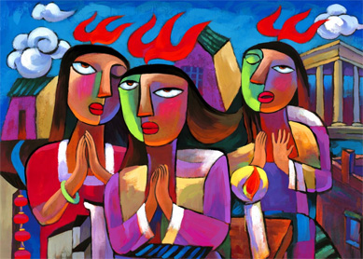  If teachers ask pupils to complete the activity on the ‘gentle side of the Holy Spirit’ (see old PB activity 3 p. 75 and new PB activity 3 p. 83) then pupils can also describe the symbol of the dove for the Holy Spirit.

