INTERPRETATION OF PRIMARY RELIGIOUS EDUCATION EXPECTATIONS
SUMMER FIRST HALF TERM
YEAR 4
UNIT | EXPECTATION | OUR UNDERSTANDING | PROMPT QUESTIONS
4.5 Mission of the Church / The Early Christians | Ask and respond to questions about how the disciples felt before and after Easter  Make links between Peter’s three denials that he knew Jesus and Jn. 21: 15-17, using the source to express a point of view | Context: this unit of work continues the story of Holy Week. Jesus has died but he then appears to his friends, the disciples, on the shore of the Sea of Galilee (called Tiberias in John’s gospel). Jesus then ascends to heaven and tells the disciples to wait in Jerusalem for the Holy Spirit to come. When they receive the Holy Spirit at Pentecost it gives the disciples its power enabling them to go out into the world and tell people about Jesus (preach the gospel). Pentecost is considered the Church’s birthday (you could bring in cake to celebrate, though there won’t be room for nearly 2000 candles!). The book Acts of the Apostles (written by Luke) tells the story of Pentecost and recounts the work and journeys of the early Christians. The first part of Acts focuses on Peter and the second half on Paul and his journeys.  This expectation draws out that there is much scope to focus on the emotional ups and downs of the disciples as they come to grips with the reality of Jesus as someone given to them (their lives with Jesus), then taken away (Jesus is killed), who then returns (the Resurrection) but who then leaves them again (the Ascension). But before he ascends, Jesus promises that the Holy Spirit will come and will give them its power and energy and be a Helper (Advocate) to them.  Review the events of Good Friday using the death of Jesus from Luke 23:44-49 (Good News version) focusing on the scene and the emotions it expresses. Teachers should help pupils remember what the disciples did after Jesus was arrested - they all ran away and particularly Peter who said he never knew Jesus when asked 3 times. They also kept their distance from Jesus when he was dying on the cross (see Luke 23:49). Pupils could watch the clip on the death of Jesus from The Miracle Maker https://vimeo.com/404287245  (108.27 – 114) to remind them of the event and its emotional impact.  Ask pupils to fill in the Emotions chart (see resources – could enlarge to A3) for ‘Jesus dies’ plotting the emotions of the disciples on the graph.  Next focus again on the resurrection from John 20:1-18, the appearance of Jesus to Mary Magdala that the previous unit ended with. Again discuss the emotions of Mary (her ups and downs) and reflect on what the other disciples must have felt when Mary said she had seen Jesus! Pupils fill in the next part of the Emotions chart of Jesus’ resurrection.  This brings the work to the first learning objectives in the old PB pp. 62-65 ‘Know that Jesus appeared to the disciples after his resurrection’ and ‘Know that Peter was chosen to be the leader of the Church’ and in the new PB pp. 74-75 ‘Know that Jesus made Peter the head of the Church. Think about what this means for all Christians.’  The focus for the WTL is to establish that Peter was chosen by Jesus to be the first Pope, the first leader of the Church. In order to reflect on what that means for Christians there is scope for pupils to reflect on the character of Peter, the fact that Jesus called him ‘the Rock’ (Peter) – see Matthew 16:18 - someone to build on and rely upon; but also it is key that Peter often failed to follow Jesus and lacked courage (e.g. when he tries to walk on water and began to sink – Matthew 14:22-31, when he denied that he even knew his best friend! – Luke 22:54-62). This provides pupils with evidence that to be a follower of Jesus you don’t have to be perfect but with the help of Jesus and the Holy Spirit you can become reliable, someone who can be trusted and someone who is very brave.  Rather than simply answering the questions on p. 65 of the old PB or p. 75 of the new PB, pupils could complete the resource sheet ‘Peter first leader of the Church’ which gives opportunities for pupils to get a more rounded picture of the character of Peter and lots of opportunities for discussion to deepen understanding. Teachers can differentiate (give less references or give the texts rather than references) to suit different pupils and there is a teacher’s support sheet that gives suggested answers. Pupils can use the ‘Peter Character Map’ (enlarge to A3 or make a similar map on a large sheet of paper) to note down different aspects of Peter’s character (see resources).  Teachers who want to use the story of Jesus appearing to the disciples at the beginning of the unit in a more reflective and creative way can use it to focus on Peter and the central role of forgiveness and ‘friendship restored’. Just as Peter denies he knows Jesus 3 times, so at the appearance of Jesus by the lake, Jesus asks Peter 3 times if he loves him ending with Jesus saying to Peter “Follow me”. (See power point ‘Peter’ in resources).  In a circle time, ask pupils to think about something that they wished they hadn’t thought, said or done. Tell them that sometimes we can do something that we come to regret (and it can distract us and play on our minds, and at times we think about it and it makes us restless).  Now focus on Peter: read Luke 22:54-62 (Good News version) to the pupils. Ask the pupils how many times Peter said he didn’t know Jesus. Ask them why they think Peter denied knowing Jesus. Ask them what Peter must have been feeling at that time. Ask the pupils what Jesus must have felt like too.  Now show the pupils the painting of Peter’s denial by Frank Wesley. Ask pupils what emotions Peter is showing?  Ask pupils to think why Peter is bent over and covering his face  [For the teacher: the cockerel feet on Peter’s bent back remind us of the denials. The bent back – Peter is weighed down by his denial, his sin. He covers his face because he is ashamed. There is a hand on Peter’s shoulder – an image for Jesus or God who is still with (showing love and support, accompanying) Peter. The bright colours which at one level signify the dawn when the cock crowed on another level enwrap Peter in a divine (God’s) embrace – there is still hope! The bright colours echo the colours used for the Holy Spirit in other works of art!]  Ask pupils to think how the colours used show the emotions.  [To heighten the emotional impact perhaps play the aria from St. Matthew’s Passion by J. S. Bach Part 2 track 39 entitled “Erbarme dich, mein Gott” (“Have mercy, my God,  for the sake of my tears! See here, before you heart and eyes weep bitterly. Have mercy, my God.”) Peter’s song of sorrow after disowning Jesus]:  https://www.youtube.com/watch?v=hQjN_pTjpXc  [For the teacher: the story of John 21:1-19: Jesus hadn’t as yet had a chance to speak personally to Peter and restore him to friendship. So although Peter knows Jesus has been raised from the dead and has seen him once (see John 20:19-23) he will probably be anxious about Jesus’ reaction because of what he did (denied knowing Jesus) a few days earlier. We can pick this anxiety up in the story of Jesus’ appearance at John 21:1-3. Peter is restless, something is playing on his mind, and he impulsively says "I’m going fishing.” Peter recognises his earlier disloyalty and cowardice and can’t rest in it. When Jesus takes Peter aside he takes Peter’s burden away by his 3 fold question: ‘Do you love me?’ and then by saying “Follow me” at verse 19.]  Focus now on Peter being taken to one side by Jesus: how will Peter be feeling about what he did a few days before? What might Peter think Jesus is going to say on seeing Peter?  Did Peter need to be brave?  Was it hard for him to be honest about what had happened?  The focus on hands on shoulders will lead into talk of showing love by embracing, by giving hugs – these are signs that things are made right again. There is scope for talking with pupils about the importance of restoring friendship not only because of how it makes us feel, but because we can move on, it frees us for living!  See power point ‘Peter’ for the sequence of work | What’s the name given to the Friday before Easter Sunday?  What happened on that Friday?  Why do you think it is called Good Friday?  How do you think the disciples were feeling?  Why were none of his friends with Jesus when he died?  Why might Peter be feeling worst of all Jesus’ friends?  What different emotions did Mary feel on Easter Sunday morning?  What do you think Jesus’ friends thought when Mary said she’d seen Jesus?  What sort of person was Peter?  What were Peter’s personal strengths (or good points)?  What were Peter’s personal weaknesses (or bad points)?  Why did Jesus choose him as the first leader of Christians?  Read the Parable of the Two House builders in Matthew 7:24-27: Which things about Peter are like the first house builder and which things about Peter are the like the second house builder?  Apart from listening to Jesus and acting on his words, what else helped Peter follow Jesus really well (the Holy Spirit – the ‘Helper’.)  Why is the ‘Rock’ a good image for Simon Peter?  What would your best friend (in class) say was a good name for you? Why?  https://www.twinkl.co.uk/resource/t2-e-012-adjective-word-mat  For the teacher: some good points made about Peter on the following webpage:  https://studyandobey.com/character-studies/peter-character-study/  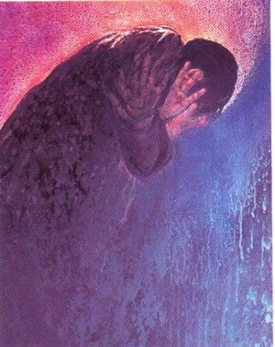  Frank Wesley, Peter’s Denial  https://globalworship.tumblr.com/post/141506637745/holy-week-art-from-india-frank-wesley  How many times did Peter say he didn’t know Jesus?  Why do you think Peter says he does not know Jesus?  How was Peter feeling?  How do you think Jesus must have felt?  In the painting: why is Peter bent over?  Why does Peter cover his face?  Is there anything unusual about the painting?  How do the colours used in the painting express emotions?  What might the bright colours be a sign of?  Show pupils Rembrandt’s painting, The Return of the Prodigal (Parable of the Lost Son) to bring out the idea how we show our love and support (and forgiveness) by placing our hand on a person’s shoulders. The next two paintings of the restoration of Peter by Jesus are from google images.  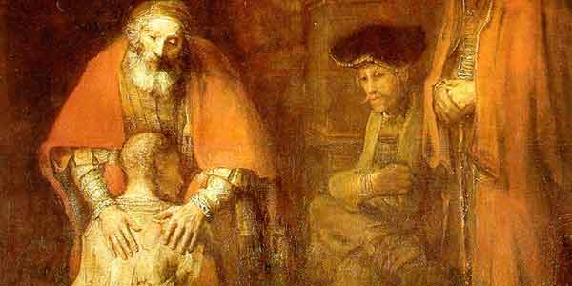  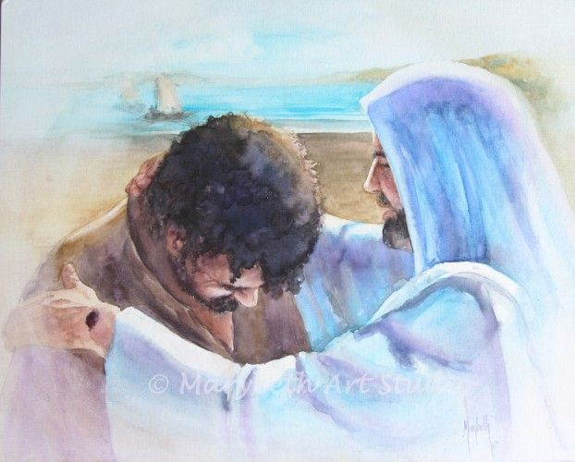  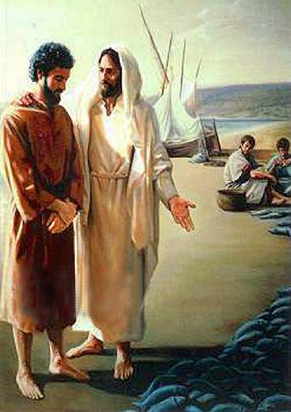
 | Ask and respond to questions about how the disciples felt before and after Pentecost | Ask pupils to complete C and D on the emotions chart by studying two texts Acts 1:6-9 (the Ascension) and Acts 1:10-26 (Disciples waiting). Ask pupils to decide and explain when the disciples were feeling lonely, scared/frightened, fearful, confused, mystified/in awe etc.  Prepare pupils for the story of Pentecost by having a story box/sack with objects associated with the story from Acts 2:1-24, 37-41. In the sack put a fan (strong enough to create the noise of air blowing), a candle with flame (electric or a candle that you light), foreign language phrase books or dictionaries, a bottle of wine, a sign saying courage, a sign saying ‘understanding’ or an image for it, a speech bubble, a world map or globe, a bottle of water and large scallop shell (or cut out of one). Tell pupils they are all connected to the day the followers of Jesus grew from 12 to 3000. Photographs of these objects could be placed on each group’s table and each group is asked what these things stand for – noting ideas for the objects.  [For the teacher: the sign or image for ‘Understanding’ is included because it is the gift of the Holy Spirit that helps the disciples (and Peter in this story) understand God’s plan for the first time: that Jesus who was killed was raised by God the Father and so destroyed the power of sin and death opening the way to heaven for us.]  Now tell the story of Pentecost from Acts 2:1-24, 37-41 (Good News version). Review the pupils’ responses, their questions and puzzles etc. This story is ripe for drama or creative retelling.  Pupils complete the Emotions Chart ‘E’ for Pentecost.
 | Describe, with increasing detail and accuracy, how the disciples changed after the coming of the Holy Spirit and the beliefs that enabled them to change? | Following the group work activity (1) on p.78 of the new PB and p. 69 of the old PB provide an opportunity for pupils to describe accurately and in detail the change in the disciples and the beliefs that enabled them to change.  Ask pupils to make a list of emotions that show the change before and after Pentecost – this can be a list of opposites i.e. sadness – joy / fearful - confident / trembling – courageous / afraid to go out – telling everyone about Jesus etc. Pupils can review their learning from the Emotions chart and describe using the texts on the chart and the opposites list of emotions how the disciples changed.  Various paintings are included to the right so that pupils can make links between emotions and the symbols of the Holy Spirit (wind, fire and dove, as well as other beliefs associated with the Holy Spirit like ‘providing energy and confidence’, giving understanding, instilling courage).  Place the different paintings of Pentecost Day on tables. Either place them in the centre of large sheets of paper or place large think bubbles, question bubbles, blank charts to add symbols with a box for its meaning. Ask groups of pupils to visit the tables in turn recording thoughts, writing questions, noting down symbols found and their meaning and beliefs expressed. Give some time for feedback to deepen understanding.  [For the beliefs that enabled the disciples to change, pupils will need to see that the Holy Spirit is our ‘Helper’ who gives us the gift of ‘Courage’ so that we can face our fears and tell everyone we meet about Jesus and who gives us the gift of ‘Understanding’.]  Give pupils the text (Good News version) of John 16: 5-7. Here the Holy Spirit is called the Helper. Ask pupils, ‘Why did Pentecost need to happen?’ ‘What if it hadn’t?’ Pupils can think about the state the disciples were in before Pentecost.  Prompt pupils to think about how the Holy Spirit helped the disciples: remind pupils of the change in the disciples and give them the text of Acts 2:14-24 (Peter’s Message) and John 16: 12-13.  [The Holy Spirit helps the disciples by giving them two gifts: 1. the gift of courage – to go out and tell the world about Jesus, and 2. the gift of understanding – to understand for the first time what God’s plan was – to give His only Son as saviour of the world. This plan is what Peter speaks about in Act 2:14-24]  Ask pupils to write a diary entry for a disciple who experienced Pentecost. Ensure they include emotions, the change that took place, what the Holy Spirit did to them or for them and what the disciples’ message was to the people they spoke to – what did they invite people to do? | 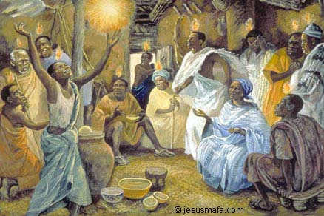  Jesus Mafa, Pentecost Day  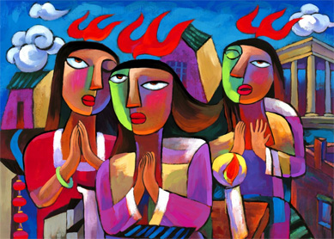  He Qi Pentecost Day  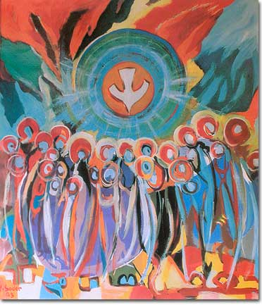  Jean Sader, Pentecost  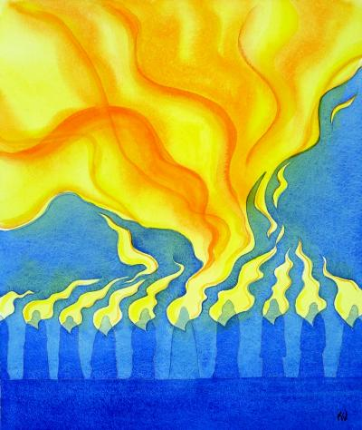  Elizabeth Wang, Pentecost Day  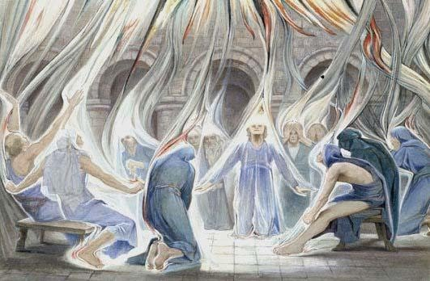  Estella Louisa M. Canziana, Pentecost Day
 | Suggest ways they live out the good news making links with beliefs | This expectation is linked to the new PB p. 78 and is based on the work in question 3 on the fruits of the Spirit. Pupils following the old PB can also meet this expectation using the fruits of the Spirit as well as completing the activities on p. 75 of the old PB on the Mission of the Church.  The Holy Spirit brings good things into Christian’s lives. Just like a healthy tree that produces lots of good fruit so those who are filled with the Holy Spirit show these good qualities in their lives.  Read Galatians 5:22-23. Ask pupils ‘What does the Holy Spirit bring?’ List the nine fruits of the spirit. Have a discussion about the meaning of each fruit. Ask pupils to give examples of when they have seen people (and themselves) showing these fruits, at home, school and in the wider world. There is scope for pupils to express these fruits in short dramas. Ask pupils to think how we (or Christians) can keep growing in these fruits? (The fruits are virtues that we grow – get better at and become – by practising them with the help of the Holy Spirit.) You could make a link with John 15: 16 (the idea of mission is here) and the Parable of the Two House Builders (Matthew 7:24-27) i.e. ‘listen to the words of Jesus and act on them’, as well as ideas like, pray, read the Bible, go to Church, take part in some Christian action that helps others etc. | John 15:16 “You did not choose me; I chose you and appointed you to go and bear much fruit, fruit that will last.”
 | Describe, with increasing detail and accuracy, the life and work of key figures in the history of the People of God – e.g. Stephen and/or the conversion of Saul to St Paul. | There are plenty of questions in the PBs that provide an opportunity for pupils to gain knowledge and some understanding of Stephen, the first Christian martyr (feast day 26th December) and Saul who became known as Paul. The new PB has a better section on Stephen and has much more detail on the life of St. Paul.  It is probably best to focus on the life of St. Paul in order to complete this expectation. Pupils will need to know that Saul and Paul are the same person.  [For the teacher: Paul was not one of the original 12 disciples; he did not know Jesus before his death and resurrection. He was known as Saul and was a very devout Jew and Pharisee. He became an apostle after the Resurrection and after persecuting the first Christians, believing their teaching was heretical and dangerous, because they professed belief that Jesus was the Messiah and they did not follow the Jewish law strictly. Paul was present at the stoning to death of Stephen and approved of the killing. Once he converted, Paul had to fight for his status as an apostle. As is often the case in such a situation, he proves his love of Christ and fellow Christians by working ‘harder than all the other apostles’ (see 1 Corinthians 15:10). After his conversion experience on the road to Damascus, he was feared at first. However, he was accepted and it was agreed by the original disciples and Paul that he would preach the gospel to the gentiles – non Jews - which accounts for his missionary journeys. Where ever Paul founded a Christian community (a church) he kept in touch with them by writing letters – many of these letters are now part of the New Testament.  The name Saul (used for Paul in the first 13 chapters of Acts of the Apostles) is Hebrew, the language of his original faith. Paul is simply the Latin translation of Saul (Paulos in Greek). So it wasn’t that Paul was given or took a new name when he became a Christian – like Jesus named Simon ‘Peter’ - rather he went by his Latin (he was a Roman citizen) name when he went travelling around the Roman empire. This is understandable because he was the apostle to the gentiles – the non-Jews. Using his Roman name (a name similar in Greek) he would put people at ease (a good missionary tactic) and is one of the ways Paul became, as he says, “all things to all people” (see 1 Corinthians 9:19-23). Luke, who wrote Acts of the Apostles and who was a sometime companion of Saul, uses the name Saul until Acts 13 verse 9 where he says “Then Saul – also known as Paul…” showing that Paul isn’t a name taken after his conversion because his conversion happened back in Chapter 9 of Acts. After this verse, Luke then uses the Roman name Paul for Saul in Acts of the Apostles. Paul is also the name that Paul uses in his own letters to the Christian churches he founded.]  Simon Smith has a resource called ‘Raised in Leeds’ available for £5 from Proost, a hosting website. See https://proost.co.uk/downloads/stations-of-the-resurrection-by-si-smith  One of the 19 ‘stations of the resurrection’ is Paul’s Damascus Road conversion experience. It is situated under the A64 flyover in Leeds city centre. Pupils could situate their own artwork in their locality or in a favourite place.  There is a good activity in RE Ideas: Journey pp. 20-25 from RE Today. The activity looks at the lives of 3 Christian figures, but only the material on Paul needs covering. Activity 1, 2 and 3 is suitable for Year 4.

