INTERPRETATION OF PRIMARY RELIGIOUS EDUCATION EXPECTATIONS
SPRING SECOND HALF TERM
YEAR 3
UNIT | EXPECTATION | OUR UNDERSTANDING | PROMPT QUESTIONS
3.4 Called to Change / Reconciliation | Retell one of Jesus’ stories of forgiveness, ensuring it is accurate in its sequence and detail. | The retelling is based on hearing and reading the story from a Bible or more detailed bible story book. Pupils can be presented with the stories using different creative strategies before they give their own retell which should display the correct sequence of events and include details of characters and context.  The old PB presents stories all from Luke’s gospel:  Zacchaeus (Luke 19:1-10),  Parable of the Lost Sheep (Luke 15:1-7)  Parable of the Lost Son (Luke 15:11-32)  The new PB presents the story of Zacchaeus and the Parable of the Lost Sheep. | Can you write down, in a flow diagram, the key events in the correct order?  What key details do you need to include?  What dialogue (direct speech) must be included?
 | Make simple links between stories and Jesus’ teaching about forgiveness. | The introduction in the old PB to the story of Jesus meeting with Zacchaeus gives as context that Jesus calls people to change by turning away from sin. The new PB p. 42 gives a good definition of sin for this age group: “when we fail to love God and others. It is when we choose to do something hurtful to another person. It is when we deliberately choose to do something that we know is wrong. For example, it is when we tell a lie.”  The key message of all three stories is that people others reject are welcome to God. Each story shows the approach of God (by Jesus with Zacchaeus) as someone who is seeking out the lost to welcome them into friendship (Jesus sees Zacchaeus and eats with him – a sign of hospitality and welcome, the shepherd’s only thought is the lost sheep and off he goes in search of it, the Father sees his young son from far off and runs to greet him), he is gentle and compassionate, but determined to bring back those who are lost  [For the teacher: Zacchaeus was typical of tax collectors at the time of Jesus. The Romans were an occupying army and to pay for their occupation they taxed the population. As was usual, the Romans sought people from the community to carry out this work. Typically these people – tax collectors – collected the Roman tax but also overcharged and kept the extra for themselves – they became both rich creating hardship for their own community and despised by their own people. They were sinners in the eyes of ordinary Jews and traitors because they worked for the occupying army. For Jesus to cross that line and reach out to Zacchaeus with generosity and the invitation to forgiveness was scandalous – no good Jew associates with sinners!]  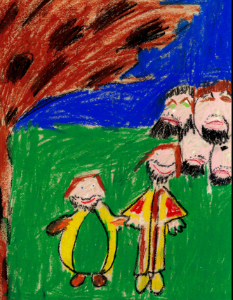  This wax crayon picture of the story of Zacchaeus created by an 8 year old is from the RE Today collection.  It captures how Jesus has persuaded Zacchaeus to repent of his greed and the disdain of the onlookers for Jesus (and Zacchaeus) who dares to associate with tax collectors (traitors because they work for the Romans) like Zacchaeus.  Show this to the pupils after they have worked through the questions on the 4 pictures in the old PB pp. 34-35. Pupils then create their own A5 size picture – using media of their own choice – Pupils (if possible) mount their picture in the middle of an A4 sheet, give it a title and annotate their picture writing around it the part of the story shown, why they have chosen the colours they have, the expressions shown on the faces and finally what it tells us about Jesus’ teaching about forgiveness.  Another strategy is to show pupils the 3 pictures of the story of Zacchaeus asking them what they like about each one and maybe which they think is best and why. Then if they are able, ask them to fill in the ‘Similarities and Differences’ chart.  The Parable of the Lost Sheep (Luke 15:1-7)  Listen to this prayerful meditation (up to 3.28 minutes) on the parable using Edward Usher Soord’s painting (1900) before teaching about the parable.  https://www.pathwaystogod.org/resources/lost-sheep-alfred-usher-soord  Question 1(a) and (b) in the old PB p. 37 is key to bringing out the different approach Jesus/God has to those who have done wrong – he is merciful, kind, gentle and compassionate – unlike those who only see the “sinner”.  The questions in the old PB p. 37 and new PB p, 47 will enable pupils to bring out their understanding.  The Parable of the Lost Son (Luke 15:11-32) – the old PB alone.  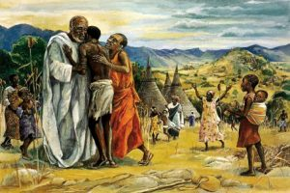  The Mafa painting of the Lost Son, unusual because it perhaps also shows the young son’s mother welcoming him home, but may also be picking up on the way the lost young son is treated by God in a motherly and fatherly way, something Rembrandt’s painting also shows.  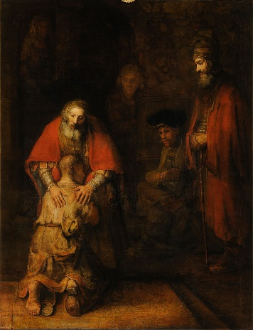  [For the teacher: This famous painting by Rembrandt also has the older brother in the picture, standing to the right in judgement of his younger brother who he has already disowned “this son of yours” (v.30) he tells his father. However, it is not true to the parable because in the parable the older son refuses to go into the house and so the Father comes outside to him (again seeking out). The older son, by his refusal – understandable no doubt – separates himself from his Father which is another idea about sin – when we are selfish it is like putting distance between ourselves and God and others like the younger son did at the beginning of the story by going to ‘a distant country’. In other words, we cannot in the older son’s case, reason our way to forgive someone, to forgive as God does we need God’s help – forgiveness is always a gift given. The beginning of the Wikipedia entry is well worth a read, particularly about the hands – one motherly, one fatherly of the Father, linking to the way God treats sinners, see] https://en.wikipedia.org/wiki/The_Return_of_the_Prodigal_Son_(Rembrandt)  The activities on p. 41 of the old PB are useful and in (d) pupils should be encouraged to say what the parable teaches us about sin and forgiveness.  The Mafa painting could be used in conjunction with questions 3 and 4 on p. 47 of the new PB and questions 3(a) and (b) of the old PB p. 37. | How do the people treat Zacchaeus?  Why do they treat him like this?  What was different about the way Jesus treated him? What words can you use to describe this?  What words would you use to describe the expressions on the faces in this picture?  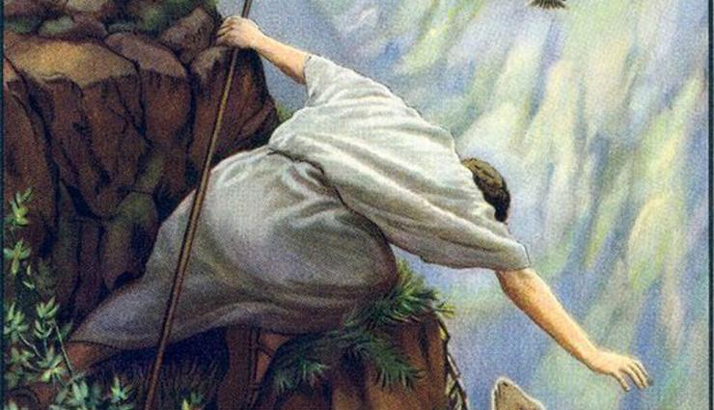  This painting by Soord captures the lengths that God goes to to bring back the lost. The painting dramatises verse 4 of the parable “Suppose one of you has a hundred sheep and loses one of them. Doesn’t he leave the ninety-nine in the open country and go after the lost sheep until he finds it? with the reality of the risks the shepherd takes  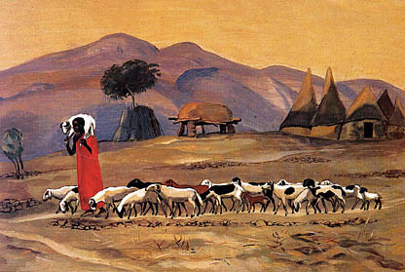  This Mafa Jesus painting of the Lost Sheep focuses on the end of the parable and the image of Jesus or God as the Good Shepherd bringing home the lost sheep – a sheep more prized than the rest because what was lost is now found! (Luke 15:7 “I tell you that in the same way there will be more rejoicing in heaven over one sinner who repents than over ninety-nine respectable people who do not need to repent.”)  Why would God be happiest about one who repents than 99 good people?
 | Make simple links between our choices and their consequences | The new PB begins the unit of work by reflecting on wrong choices and how they affect us and other people. This same work is on pp. 38-40 0f the old PB. The activities give opportunities for pupils to show a link between a wrong choice and its consequence – we see this in the diary entries of Joe. However, teachers may want to ensure this is something the pupils make a link to. The link between action and its consequence can also be done at the beginning of this activity using the new PB p. 38 when asking pupils ‘What are the rules in school?’ get them to note down the consequences of not following the rules by giving an example.
 | Ask and respond to questions about the feelings and experiences of characters in the stories, as well as their own | This expectation can be met across the whole unit by exploring the feelings of characters in the various stories and asking pupils about their feelings too. As an example:  Zacchaeus – split the story into 3 or 4 parts and ask children to explore through drama each part separately focusing on the feelings of the different characters.  Or use one painting or image of the story of Zacchaeus and ask about the feelings of the characters shown.  Or track the feelings of characters:  1. which are always the same – those who do not like Zacchaeus and think Jesus is wrong to befriend him and perhaps Jesus’ feelings too  2. those that change: Zacchaeus, how did he feel at different stages in the story?  It is always good to give space for pupils to ask their own question and for pupils to be asked what they would feel like too if they were there.  The work on choices and their consequences through the diary work will also give opportunities for pupils to give their own view of feelings and experiences. | Which people never change their feelings? (those who do not like Zacchaeus and think Jesus is wrong to befriend him  What do you think Jesus is feeling knowing everyone does not like Zacchaeus?  Is Jesus showing courage, why or why not?  How does Zacchaeus feel at different parts of the story? How can you show this?
 | Express a point of view about whether forgiving is easy or hard to do | This is asked as a question on p. 40 of the old PB and p. 41 of the new PB. An answer to this would suffice to meet this expectation.  In the previous unit ‘Jesus the Teacher’ there was an activity on forgiveness scenarios. See ‘Six forgiveness scenarios: When is it hard to forgive? (RE Ideas Jesus p. 9 and 12, RE Today). This will enable pupils to consider why forgiving is important even though it is hard to do. If this wasn’t used there it can be used here. See the 3.3 Interpretation document. | Can you give an example of a time when you could easily forgive someone for what they did?  Why was it easy?  Can you give an example of a time when it was really hard to forgive?  Why was it hard?
 | Describe with increasing detail and accuracy the steps involved in the Sacrament of Reconciliation | This expectation can be met by the section on receiving the Sacrament of Reconciliation on pp. 44-45 of the old PB and pp. 51-53 of the new PB. In particular the expectation is met if pupils can design and create their own guide to ‘How to go to Confession’. The worksheets in the new TB will be useful for pupils. See TB pp. 56-58  It is important however that pupils understand that reconciliation is a sacrament but also a process which is shown in the sacrament:  - We recognise we have done wrong (Examination of Conscience)  - We seek forgiveness  - We tell (confess) our sins  - We say we are really sorry (Act of Contrition)  - We make up for doing wrong (Penance)  [For the teacher: the elements of this process are shown in the parable of the Lost Son.] | Making your guide to the Sacrament of Reconciliation:  What should you include before Confession?  What should you include during Confession?  What should you include after Confession?
 | Give at least two reasons why reconciliation is necessary | This expectation is about reconciliation of relationships generally as well as the Sacrament of Reconciliation. So pupils can meet it by saying why it is good to be reconciled with a friend after work on the diary entries of Joe about his friendship with Steve. It can also be met by considering the material about ‘Making things right with God’ on pp. 42-43 of the old PB and ‘The Sacrament of Reconciliation’ on pp. 48-50 in the new PB, particularly question 1(c) p. 43 in the old PB and questions 1(c) on p. 50 and 4 on p. 53 of the new PB. | Why is it good to be forgiven?  What does it feel like?  Why is it good to forgive?  What does it feel like?  Why do we sometimes need God’s forgiveness?  How can we receive God’s forgiveness?
 | Make a simple link between the beliefs Christians hold about Lent (Lenten promise, three Christian duties -prayer, fasting, and almsgiving) and how it affects their behaviour. | The new PB has no material on the season of Lent. The old PB has a short, but useful section at the end of this unit on pp. 46-47.  The old PB focuses on the Lenten Promise and there is enough material to support pupils being able to show how thinking about, making and trying to keep a Lenten promise affects their behaviour during Lent so that they become closer to Jesus/God.  Teachers will also need to have a focus on CAFOD’s Lent Family Fast Day on 26th February see https://cafod.org.uk/Fundraise/Family-Fast-Day  CAFOD are encouraging Catholics to ‘Walk for Water’.  Adults and children over 14 are encouraged to go without some food – to fast - on Family Fast Day to come to understand what it is like to live without much food, or to struggle to get food, (which is becoming an increasing reality in the UK) all the time. The money saved by going without that food is then given (almsgiving – charity) to CAFOD to support their work with people in different countries less fortunate than ourselves. Pupils should be able to make a link between thinking about people less fortunate than them and how that affects their behaviour in going without something on Family Fast Day or going without (or even doing something extra) something during Lent (could be a part of a Lenten Promise) and it  Schools will be thinking of ways to support CAFOD and other charities during Lent and encouraging children who the school is teaching at home to get involved.  The first Christian duty of Lent is to make special efforts to pray. The booklet RE Ideas Jesus by RE Today pp. 20-24 has some good ideas for exploring prayer with the pupils. Prayer is important for Christians and all people of faith, because through it we grow closer to Jesus/God and trust in Jesus/God more and more.

