INTERPRETATION OF PRIMARY RELIGIOUS EDUCATION EXPECTATIONS
SPRING FIRST HALF TERM
YEAR 2
UNIT | EXPECTATION | OUR UNDERSTANDING | PROMPT QUESTIONS
2.3 The Good News | Retell, in any form, at least two religious stories on the theme of the Good News | To retell does not mean learning to write down the story exactly as it appears in the Bible, but means to retell the story in their own words. To retell means to have correct details from the actual story in their own account: the correct sequence, characters and setting. However, the words ‘in any form’ means that a pupil’s retelling does not need to be a written account alone, but could be an oral retelling based on an account of the story presented in different media or from memory. Or a pupil could write a sentence for each part of a sequence created in different media. | Stories common to the old and new PB are, The Ten Lepers (Luke 17:11-19) and the Feeding of the 5000 (Matthew 14:13-21).  The story unique to the old PB is the Healing of Jairus’ Daughter (Mark 5: 21–24, 35–43).  The Miracle Maker film has a clip (5.16) of the Healing of Jairus’ Daughter. The whole film is seen through Jairus’ daughter’s eyes: https://www.youtube.com/watch?v=_I1bG-s44Cw  The stories unique to the new PB are the Finding in the Temple (Luke 2:41-50), the Call of the First Disciples Luke 5:1-11) and the Cure of the Paralysed Man (Luke 5:18-26)  There is a clip (1.51) of the Cure of the Paralysed Man from the Miracle Maker https://www.youtube.com/watch?v=7l5yFH64QhQ  Tell me the story of …  What happened in the story of …  Who are the characters in the story?  What do they do?  Who was Jairus?  What did the Jesus say? What did the disciples do?  Can you sequence this story and tell me what happened?
 | Give clear, simple descriptions of what these stories tell us about Jesus / God | Teachers can focus on either God or Jesus to help pupils meet this expectation. This expectation can be focused on the story of Jairus in the old book, together with the Ten Lepers and the Feeding of the 5000.  Pupils will need to know the meaning of ‘miracle’. Something that is impossible for us to do so it is something God does (that requires our faith in God /Jesus).  What does this story tell us about God?  Teachers should focus on at least two stories. If it is a story of a healing, then pupils will describe God as a loving God or loving Father who cares for us and is compassionate or kind. If it is the Feeding of the 5000 this tells us that God will provide for us, for our needs, if we are hungry or in need of anything. Any miracle story also tells us that God is powerful. He uses His power to do good things.  What does this story tell us about Jesus?  The old PB begins with the story of the Healing of Jairus’ Daughter. This story tells us that Jesus brought good news to us: the Good News that God is a loving God who wants to bring us joy and happiness. Jesus has God’s power, because he healed Jairus’ daughter. He also turns sadness into joy. The story of Jairus’ daughter also tells us that with Jesus there is always hope – we must trust in Him, e.g. while Jesus was on the way to Jairus’ house ‘some messengers came from Jairus’ house and told him, “Your daughter has died. Why bother the teacher any longer?” Jesus paid no attention to what they said, but told him, “Do not be afraid, only believe.” (Mark 5:35-36)  The Ten Lepers is in both the old (pp. 38-40) and new (pp. 43-45) PB.  Pupils will need to know something about leprosy as it was understood at the time of Jesus: a contagious disease that couldn’t be cured and caused disfigurement of the body so to avoid infection of other people lepers were homeless, isolated from their families and community and had to live outside the village, town or city.  [For the teacher: the contagious nature of the disease and the disfigurement of the body led to lepers being understood as ‘unclean’. This means lepers needed to be ritually (through a religious rite) purified to be accepted back into normal society. One of the means of this was to get a ‘clean bill of health’ from a priest. However, leprosy was incurable so lepers were considered outcasts beyond the help of religious purification and therefore the common view came to be that the leper was beyond the help of God in this life. Jewish society treated lepers as if they were already dead.]  On the human level, lepers were unloved, desperately lonely, homeless and poor. Jesus shows that he is a friend to the friendless and has the power to heal the ten of leprosy. | How could you show your love for someone who was sick? Give some examples.  How could God show love to someone who is sick?  Can you give an example of God doing this (showing this love)?  Look at the pictures (Feeding 5000 and the Cure of the Ten Lepers).  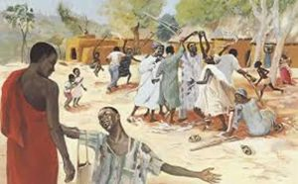  Cure of the Ten Lepers Mafa (Cameroon) 1973  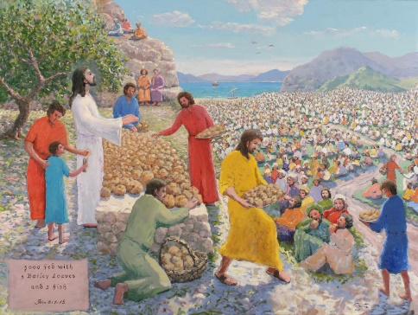  Feeding of the 5000 Pierre Bittar (France) 2011.  What does this story tell us about God? (God is really powerful and uses his power to show his love and care for us by healing those who are sick and providing us with what we need to live.)  What does this story tell us about Jesus?
 | Ask and answer questions about their own feelings and experiences and of characters in the stories | This expectation can be met across the whole unit by exploring the feelings of characters in the various stories and asking pupils about their feelings too. As an example:  Tell the story of the Ten Lepers (Luke 17:11-19)  After telling pupils about the life of a leper at the time of Jesus, particularly that they are unloved and friendless, ask pupils about what Jesus’ cure of the Ten Lepers tells us about Jesus (he has the power to heal, he is a friend to the lepers, he shows God’s love to the lepers).  Give pupils some emoji’s on cards. Ask them if one of the characters in the story has that feeling. Ask them to hold up that card.  Ask pupils to act out each emoji. Pupils could also act out the story of the Ten Lepers.  Ask pupils about how Jesus felt about the leper who came back and the nine who didn’t.  Ask pupils what they think and feel about the story.  Ask pupils if they would have been the one who came back or one of the other nine who didn’t?  Ask them if they think Jesus wants us to say ‘thank you?’  ‘Is it important to say thank you?’  Ask pupils to draw 3 things they are thankful for: ‘I am thankful for…. Describe what it is and say why they are thankful for it.  Make ‘Thank you bags’  Being thankful is not something you can keep to yourself – ask pupils why not.  Ask pupils:  - To think of someone they really want to say thank you to  - Design (using a net template) and make their own thank you bag.  - Draw or write on paper something they want to thank that person for  - Put into the bag  - Take it to that person  Have a larger thank you bag displayed and a sentence starter ‘I am thankful to …for… ‘put their ideas in each week. Read them out at the end of the week. This can contribute to exploring the virtue of gratitude.  The story of the Feeding of the 5000.  The old and new PB has suitable activities to teach the importance of the Feeding of the 5000. The key points in the PB are that ‘People loved listening to Jesus’ Jesus was a really good story teller, but they loved listening to Him not just because of his stories but because he brought them good news, he made them happy.  Ask pupils how we listen to Jesus today? (by listening to stories from His life in the Bible, by praying – listening and speaking to Jesus)  Repeat the meaning of the word ‘miracle’. No ordinary person could make that amount of food from 5 loaves of bread and 2 fish. Bring in a satsuma or an apple and show how a little food cannot feed everyone in the class so that they are filled and had enough – so it is something God does (that requires our faith in God /Jesus).  Ask pupils what this tells us about Jesus? | The Feeding of the 5000. There is a film clip (2.23) https://www.youtube.com/watch?v=bFggyj_9Rqo and a cartoon version (2.10): https://www.youtube.com/watch?v=S6rj9cAJrWE
 | Give examples of how to follow the teachings about bringing good news to the friendless / sick. | Pupils will know that Jesus cares for people, showing love to the lonely, being a friend to the friendless, and healing of the sick.  Pupils can give the example of the ‘Thank you bag’ but also by sharing some photographs of how your school has supported those in need: the homeless, the poor etc. at Christmas and at other times. These can be photos of food collections, back packs collected, wash bags collected etc. Ask pupils to think about how they can bring good news to others through being a friend to the friendless and comfort to those who are sick.  Give pupils the worksheet: ‘Bringing Good News’ and ask them to draw or write in the boxes examples of how they can bring good news to others. | 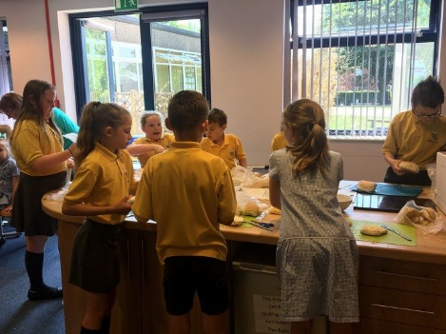  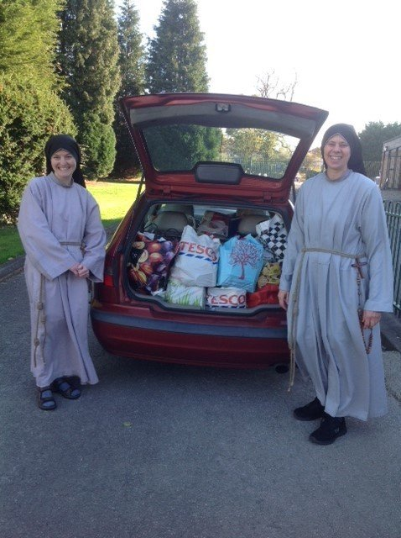
 | Answer questions like, ‘Are our actions more important than our words?’ ‘Why?’ (GD) | Begin with an activity that shows the importance of words:  Using a ‘blindfold walking game’ get one pupil to walk across the classroom blindfolded while another gives directions. In pairs and taking turns all pupils do the same. Ask pupils to complete the sentence  - ‘If you can’t see, then it’s good to trust…’  Relate the answers to the fact that words are important because they can guide us.  This could then be related to some signs that have words to guide us.  Ask pupils what could happen if you didn’t follow what the words said.  Next help the pupils to consider the importance of action by using an activity about making and keeping promises this will:  - Help pupils think about promises they make  - Understand the importance of keeping promises  - Reflect on what it feels like when a promise is broken  Using RE Today’s booklet Exploring a Theme: Codes for Living pp. 3-4  Now introduce and tell pupils the Parable of the Two Sons (Matthew 21:28-31)  ‘Now, what do you think? There was once a man who had two sons. He went to the older one and said, ‘Son, go and work in the vineyard today.’ ‘I don't want to,’ he answered, but later he changed his mind and went. Then the father went to the other son and said the same thing. ‘Yes, sir,’ he answered, but he did not go. Which one of the two did what his father wanted? “The older one,” they answered.  Reminding pupils of the ways in which they and their school have brought good news to others (could use photographs again and bringing Good News ideas) ask pupils to answer the question:  Are our actions more important than our words?’ ‘Why?’
 | Stories that only appear in the new PB: Finding in the Temple Luke 2:41-51 (pp. 37-39) and Jesus Calls the Disciples based on Luke 5:1-10 (pp. 40-42) | 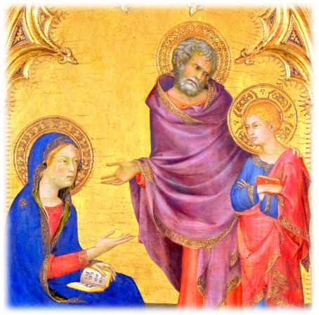  Simone Martini (1342)  The new PB begins with the early life of Jesus to make a chronological link between Christmas when Jesus birth is celebrated and this next unit of work. This is to lessen the confusion some pupils have that before the holidays Jesus was a baby and now – two weeks later - he is a grown up!  Alongside some of the activities in the new PB p. 39, The Finding in the Temple lends itself to the Ask and answer questions expectation. This is particularly the case if the painting by Simone is used of the finding of Jesus and with it the pupils are asked:  -how do you think Mary was feeling?  -How do you think Joseph was feeling?  -How do you think Jesus was feeling?  Pupils could be encouraged to highlight some of the uncomfortable feelings adjective words (Twinkl) (KS1) in this activity.  Using the picture on p. 38 of the new PB ask pupils to think of the feelings of Mary and Joseph, e.g. surprised, confused, happy, joyful  A good teaching point is that in the Temple Jesus was finding out more about God (the Father) by asking big questions and so teachers should encourage pupils to be like Jesus and also ask questions.  See RE Today booklet RE Ideas Jesus pp. 8-10 for a good activity on the Finding in the Temple and asking big questions.  The Call of the Disciples (Luke 5:1-11)  The key idea in the new PB is that Jesus needed some people to help him tell everyone the good news that God loves everyone.  The Miracle Maker film clip (4.00) is an excellent introduction to the story.  Alongside the ‘Pause to talk’ and the activities on p.42, teachers could expand this activity by exploring with the pupils the kind of people Jesus choose as his disciples.  This could begin by thinking about the theme:  Jesus chooses 12 people to change the world.  Pupils in a small group or pairs use KS1 Character description words (Twinkl) to describe the qualities needed in their team of 12 world changers. If using a word mat, (https://www.twinkl.co.uk/resource/t-l-5250-character-adjective-word-mat) pupils simply need to circle the qualities they think most important.  Then pupils list some reasons why these are good qualities.  The teacher highlights some of the qualities pupils have chosen and some of the reasons given.  The teacher then introduces and reads the story of the Call of the Disciples from Luke 5:1-11 and the pupils watch the clip of it from the Miracle Maker film.  The teacher now focuses on two things: the qualities that these fisherman had and that they weren’t perfect (i.e. Peter says he’s a sinful man). The qualities pupils will be prompted to think about are that fisherman are: hardworking (work long hours out at sea), brave (the sea is dangerous, go out in all weathers and there are storms), and patient (wait out at sea a long time until they catch the fish).  The teacher asks pupils whether they think Jesus has made a good choice in choosing these people. Why?  The teacher then suggests to the pupils well, what about Peter – he’s a sinful man – he says he’s done lots wrong and shouldn’t be Jesus disciple? But why does Jesus still choose him?  Have you heard of another person Jesus choose as one of his 12 friends – Matthew the tax collector? (Miracle Maker full movie scene at 28.10 to 29.52) https://vimeo.com/404287245  The teacher reads the story and every time Matthew’s name is mentioned pupils say in chorus ‘Oh no, Jesus, not him!’  Pupils role play the story of the Call of Matthew from Matthew 9:9-13 in a group of no more than six and when Jesus calls Matthew, 4 in chorus say ‘Oh no, Jesus, not him!’ and at the end of the role play all say ‘Good News: Jesus welcomed everyone.’  Ask pupils what they think of Jesus’ choice of 12 world changing disciples. Why is this good news? (Jesus brought Good News because he was a friend to those left out and disliked by other people. This will then link well to the story of the Ten Lepers.) | Where were Mary, Joseph and Jesus going?  Why were they going there?  How old was Jesus?  Did Jesus get lost?  What did Jesus do?  After a while what did Mary and Joseph do?  Where did Mary and Joseph find Jesus?  What was Jesus doing?  What did Mary say to Jesus?  How was Mary and Joseph feeling?  What did Jesus say to Mary and Joseph?  What does Jesus call the Temple?  There is a clip (3.33) of the Finding in the Temple from the film Jesus of Nazareth https://www.youtube.com/watch?v=9f2qZqOZ-y0  There is a clip of the Call of the First Disciples (4.00) in the Miracle Maker film: https://www.youtube.com/watch?v=poNuGusSX5c  You are choosing 12 people to change the world: what sort of people are yours going to be?  Why have you chosen those qualities or adjectives?

