INTERPRETATION OF PRIMARY RELIGIOUS EDUCATION EXPECTATIONS
SPRING FIRST HALF TERM
YEAR 3
UNIT | EXPECTATION | OUR UNDERSTANDING | PROMPT QUESTIONS
3.3  Jesus the Teacher | Retell the story of the Presentation and recognise the link with its central belief | The retelling is based on hearing and reading the text of the story from a Bible (Luke 2:22-38) or more detailed bible story book. The retell should display the correct sequence of events and include details of characters (Simeon and Anna) and context.  Pupils can recognise that Simeon says that Jesus is “A light to the nations [some translations say ‘gentiles’]” (verse 32) in the story. What Simeon says is the origin of the Christian saying that Jesus is the ‘Light of the World’ (see John 8:12).  Using a bible in pairs pupils look up John 8:12 and Matthew 5:16.  John 8:12: “I am the light of the world … Whoever follows me will have the light of life and will never walk in darkness.”  Ask pupils questions to draw out the link with Simeon saying that Jesus is “A light to the nations”  Jesus is the light of our [Christians] life – ask pupils what this means, or ask how Jesus is like a light for us?  Matthew 5:16 “your light must shine before people, so that they will see the good you do and praise your Father in heaven.”  Give pupils the lyrics of the song ‘This little light of mine’ and concentrate either on ‘Ev'rywhere I go,  I'm gonna let it shine ‘ or the third verse of the alternative version ‘All around the neighbourhood I'm going to let it shine’. Ask pupils to note down how they can be shining lights either everywhere they go or in their neighbourhood and towards their neighbour.  In a circle time activity, ask pupils to say how they can be shining lights to one another. Pupils can write their ideas in a light bulb shape or candle shape and these can be stuck in books or a display can be made. | Why did Mary and Joseph take Jesus to Jerusalem?  What does it mean to dedicate or to be dedicated to something?  Where did they go in Jerusalem?  What did Mary and Joseph offer?  What does the word sacrifice mean?  Who was Simeon?  What did he do when he saw the baby Jesus?  Why was Simeon so happy?  What did he say about Jesus?  What did Mary and Joseph think about this?  Who was Anna?  Where did she spend all of her time?  What did she tell everyone about Jesus?
 | Ask and respond to questions about their own and others experiences of following Jesus | This expectation can be met by the activity above: circle time or in pairs, pupils can respond to the question ‘how can you be a shining light to others, what could you do?’  This expectation can also be met by applying the teachings of Jesus to their lives and answering the questions in old PB pp. 38-39 and new PB pp. 50-52  This expectation can also be met by answering the questions in the new PB p. 55 Activity 3:  3. The Parable of the Sower has a meaning for us today.  a) Think of things that would stop God’s message taking root in your life?  b) What might get in the way or distract us from living as Jesus asked us?  c) What can we do to help God’s message grow in our lives? | What’s the connection between being a light and what we do?  So, how can you be a shining light?  Give some examples.
 | Make a simple link between the chosen parables and Jesus’ message about how we should live  Suggest answers to questions like, ‘How can God’s Word grow in you?’ in relation to the parable of the Sower (GD) | Using the Parable of the Sower, pupils will be able to make a link between a type of ground and a corresponding behaviour or action (see old PB p. 41 and new PB p. 55). Teachers could give pupils the Parable of the Two Housebuilders (Matthew 7:24-27) – there is a power point of this on Twinkl - to help make the point that the good soil is like those people who build their lives on the words of Jesus by living them out. The Miracle Maker clip of the Two Housebuilders (1.32) has a good understanding that  https://www.youtube.com/watch?v=GByss2oqDHw  links this parable to the sower’s good soil – “let my words go deep” – and the importance of listening and acting on God’s Word. Teachers could give or ask pupils to draw a field scene with a tree or large flower with leaves or petals in the centre and pupils write in the petals or leaves examples of what those who listen to God’s Word and live by it do.  Teachers who want to be very creative could use the examples of the Virtues to Live By logo:  or the detail from the Haitian Hunger Cloth of Jacques-Richard Chery (1982)  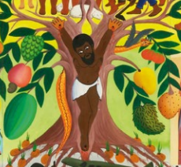  And ask pupils to design their own writing their ideas within abstract leaves or the different fruits.  Using the above activity as a basis, some pupils can be asked to complete the greater depth (GD) question: ‘How can God’s Word grow in you?’ in relation to the parable of the Sower.  Using 2 Timothy 3:16-17 “God’s Word is useful for teaching the truth … and giving instruction for right living, so that the person who serves God may be able to do every kind of good deed.”  Teachers could ask pupils questions to draw out the implications of 2 Timothy so that pupils could add to ideas on their trees /flowers by giving examples e.g.  - Get to know the Bible or the teaching of Jesus better  - Listen to Jesus’ words and act on them  - Pray, because Jesus tells us to pray to God for all that we need  - Be more like Jesus: forgiving and loving  Using the Parable of the Unforgiving Servant, pupils will be able to make a link between the parable and the importance of forgiveness.  Teachers could use Fetti’s painting – which freeze frames the scene when the servant shows no mercy towards his fellow servant by throttling him –  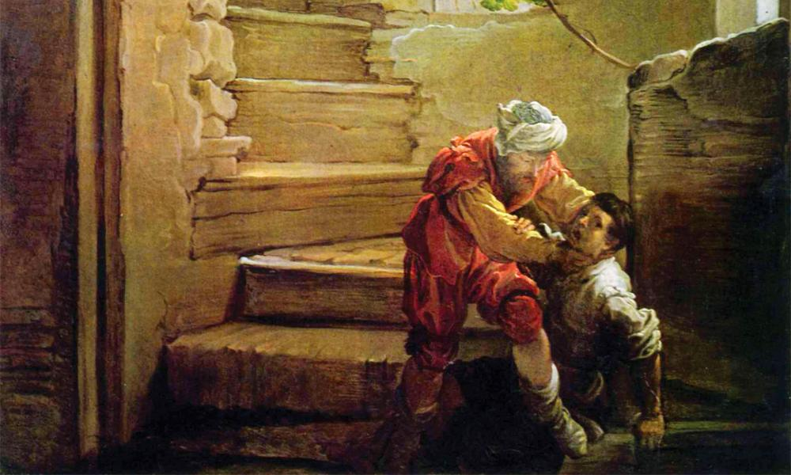  and ask pupils questions about the behaviour of the servant:  - Was this fair?  - What just happened to him?  - What should he have done when he saw the other servant?  - So, what should we do? | Where does the seed fall?  What happens to the seed in the … ground?  Give an example of something that might stop someone acting on God’s word?  What sort of people are like the good soil?  Give examples of how they might live.
 | Retell one of Jesus’ parables, ensuring it is accurate in its sequence and detail | The retelling is based on hearing and reading the text of the story from a Bible. The retell should display the correct sequence of the parable and include the significant details. The two main parables to retell is either the Parable of the Sower or the Parable of the Unforgiving Servant (Activity 2 from new PB p. 57 – the DVD cover [in the old PB Activity 2 p. 43] – could be incorporated into this expectation. | Can you write down, in a flow diagram, the key events in the correct order?  What key details do you need to include?  What dialogue (direct speech) must be included?
 | Express a preference (e.g. ‘which is, what is, which parable … ‘what do you like / not like about…’ etc. on an aspect of learning from this unit. | After reading the Parable of the Sower and/or the Parable of the Unforgiving Servant, ask pupils to express what they like or don’t like about it under a heading ‘Positive +’ / ‘Negative –‘  Or use the same strategy but with a painting of the story:  Added to positive / negative could be preference based on:  - Colours used and why pupils like them  - It’s imaginative – in what ways?  - The feelings / emotions the painting brings out?  Pupils could choose from the following: the first painting of the Parable of the Sower is from Mafa (Cameroon, 1973). The second painting is from Thomas Bertram Poole (USA) and the third from Vincent Van Gogh (born Netherlands, but painted near Arles, southern France, 1888)  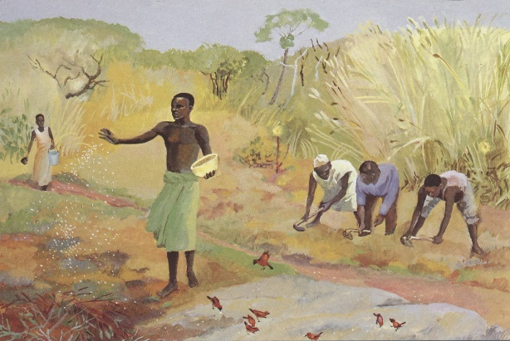  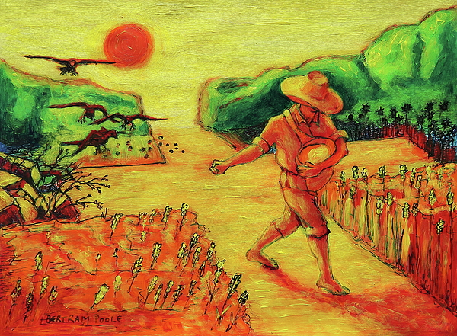  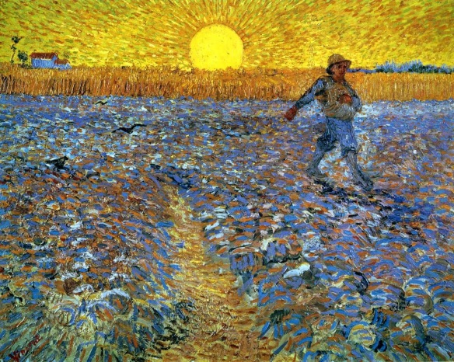  The first painting of the Unforgiving Servant is by Claude Vignon (France, 1629) shows the beginning when the servant is forgiven his enormous debt by the compassionate king. The second by Domenico Fetti (Italy, 1620) shows the second part of the story when the same servant throttles a fellow servant he sees on his way out because he owes him a small amount.  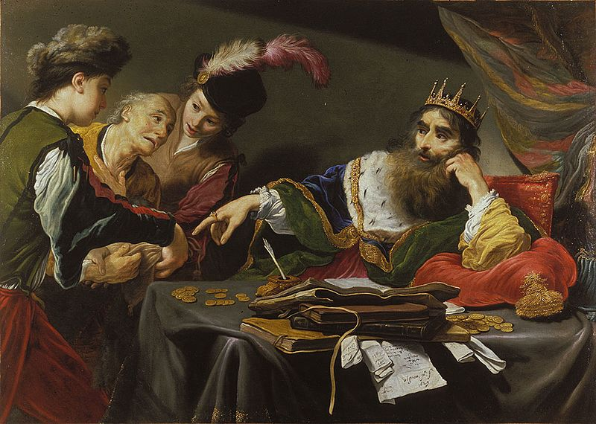 | What do you like about the parable of …?  What don’t you like about …?  What’s your favourite of the two you have read? Why is that your favourite?  Which is your favourite painting? Why is it your favourite?  What colours are used?  Why do you think these colours are used?  How does the painting make you feel?  How does it show those emotions?
 | Describe, with increasing detail and accuracy, the role of John the Baptist in the life of Jesus (new book) | Pupils will be able to describe the role of John the Baptist in life of Jesus. The description will take the information from p. 45 of the new PB, including activity 1 that uses Luke 3:10-14, and information on the Baptism of Jesus from pp. 46-47 of the new PB that is based on Matthew 3:13-17.  The information in the new PB comes from four different bible passages:  1. Luke 1:76-79  2. Luke 3:3-6  3. Luke 3:10-14  4. Matthew 3: 13-17  In the new PB the last sentence of the second paragraph on p. 44 says “So, before sending His Son, God chose John, who became known as John the Baptist, to prepare the way for Jesus.”  If teachers want pupils to know what Zechariah, John the Baptist’s father, said of John in his prophecy. They can read it in Luke 1:76-79, Zechariah says that his son John will:  - Be a prophet of God (a prophet is someone who tells others God’s messages)  - Prepare the people for the coming of Jesus  - By getting their sins forgiven (sins – going against what God wants by our actions, words and thoughts)  If teachers want pupils to have a more detailed knowledge of what John asked the people to do they can read it from Luke 3:3-6 and Luke 3:10-14. When John the Baptist had grown up he tells people to  - “Turn away from your sins and be baptised, and God will forgive your sins.”  - “Get the road ready for the Lord; make a straight path for him to travel.”  And in Luke 3:10-14 John teaches different groups:  ‘Then the people asked him, “What are we to do, then? He answered, “Whoever has two shirts must give one to the person who has none, and whoever has food must share it.”  To tax collectors John said “Don’t collect more than is legal.”  To soldiers John said, “Don’t take money from anyone by force.”  In Matthew’s version of the Baptism of Jesus, John at first didn’t want to baptise Jesus because he did not feel worthy enough to baptise someone as important as Jesus. In Matthew 3 verse 11 John says “He [Jesus] is much greater than I am; and I am not good enough even to carry his sandals.” And again in verse 14 when Jesus asked John to baptise him the text says that “John tried to change his [Jesus’] mind. I ought to be baptised by you, and yet you come to me.” Jesus answered that John should baptise him “for in this way we shall do all that God requires. So John agreed” (verse 15). The new PB says that by this Jesus meant ‘that he wanted to live with the people and do what they did’ (p. 46)  John the Baptist has a really important role in the life of Jesus. John gets people ready to meet Jesus and through John’s baptism of Jesus we see that Jesus is not just an ordinary person but the Son of God (i.e. the second person of the Trinity). The PB also asks in ‘Pause to discuss’ on p. 47 how do we know the three persons of the Trinity were present at Jesus’ baptism? This provides opportunities for creative activities using art of the baptism of Jesus showing the Trinity.  To introduce the story of the baptism of Jesus pupils could watch the clip of it (2.04) from the Miracle Maker film https://www.youtube.com/watch?v=JZ5jm5Ix5bY  Q&A with the pupils:  What does John think about Jesus?  What does Jesus hear when he comes out of the water?  What does it say?  Whose voice is it?  Do they see a glimpse of a bird?  What bird could it be?  What is the bird there for?  Can anyone spot a link from this and what I am doing - making the sign of the cross i.e. Father, Son, Holy Spirit.  Pupils could also complete in pairs a Time Line or Continuum Line (see thinking skills examples on website) of the story to https://www.dioceseofleeds.org.uk/education/re-catholic-life/religious-education/primary-re/re-subject-leader-primary/  gain a good knowledge of the story and its sequence.  Revisiting the work in Year 2 on God as Trinity, ask pupils how the three persons in one God is shown in the Baptism of Jesus by using He Qi’s (China, 2005) painting of it.  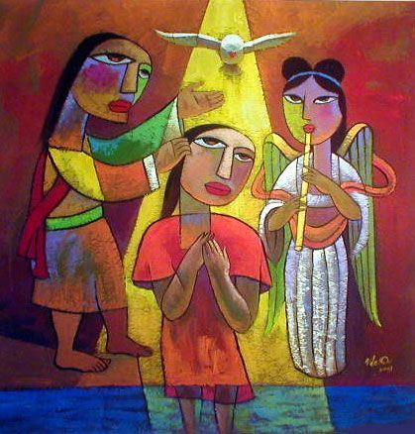  Questions:  What part of the story is shown by the painting?  What has the artist added that is not in the story?  Why might it (angel) be added? (The angel is playing a [vertical] flute – music can represent the joy in heaven at the Baptism of Jesus)  Where is the yellow light coming from?  What does Jesus hear when he is inside the yellow light? (God the Father’s voice ‘You are my beloved Son’)  What mathematical shape can you see inside the painting? (Particularly in the yellow shaft of light)  Why do you think the artist has used this shape? (Triangle for Trinity – 3 persons in 1 God)  Another activity:  Using the stained glass window picture of the Baptism of Jesus (see RE Ideas: Jesus from RE Today pp. 15-17), ask pupils to complete some of the following sentence starters (adapt as necessary):  - The artist has told the story well by …  - The artist has shown an important part of the story where … by…  - The message of this story is/is not shown well because…  - I like/don’t like … because …  - I think the artist should have … because …  The point of all the questions about the art of the Baptism of Jesus is for pupils to make a link between the painting and the belief that Jesus is the Son of God.  Multi-sensory observation. Pupils choose a painting of the Baptism of Jesus. See Paintings of the Baptism of Jesus sheet. Ask pupils to imagine being at the Baptism of Jesus and complete a fishbone thinking skill pictogram for it, noting down what the character might see, hear, touch, taste, smell, think and feel?  Pupils asked to write a senses poem about the Baptism of Jesus including as many of the senses as possible. | Q&A with the pupils:  What does John think about Jesus?  What does Jesus hear when he comes out of the water?  What does it say?  Whose voice is it?  Do they see a glimpse of a bird?  What bird could it be?  What is the bird there for?  Can anyone spot a link from this and what I am doing - making the sign of the cross i.e. Father, Son, Holy Spirit.  What part of the story is shown by the painting?  What has the artist added that is not in the story?  Why might it (angel) be added? (The angel is playing a [vertical] flute – music can represent the joy in heaven at the Baptism of Jesus)  Where is the yellow light coming from?  What does Jesus hear when he is inside the yellow light? (God the Father’s voice ‘You are my beloved Son’)  What mathematical shape can you see inside the painting? (Particularly in the yellow shaft of light)  Why do you think the artist has used this shape? (Triangle for Trinity – 3 persons in 1 God)
 | ‘Why is it important to forgive?’ in relation to the parable of the Unforgiving Servant (GD) | Following the different activities on the Parable of the Unforgiving Servant teachers could introduce the worksheet: ‘Six forgiveness scenarios: When is it hard to forgive? (RE Ideas Jesus p. 9 and 12, RE Today). This will enable pupils to consider why forgiving is important even though it is hard to do.  Following this activity, teachers can give the worksheet ‘What was the message of the Parable of the Unforgiving Servant’, to some pupils. It will be a good idea for these pupils to read the parable again. First pupils (in pairs) will identify those statements they agree with and get rid of those they don’t by crossing them out (faintly) or cutting them out and putting them on one side. Pupils will then try and put the ones they agree with in order from least to most important. They could do this by taking two at a time and deciding which one is more important until they decide on the most important of all.  Once this task is done the teacher asks pupils to make a heading: “Why is it important to forgive?” Pupils are then asked to note down what are their TWO most important suggestions and say what they tell us about forgiveness.  Teachers could then ask pupils to pick TWO things they disagree with and ask pupils to write why each is not a good idea or not what forgiveness is about.

