Catholic Primary School

**RE Newsletter 6**

SUMMER TERM 2

The month of June is dedicated to the Sacred Heart of Jesus. The devotion to the Sacred Heart of Jesus reminds us of the never ending and merciful love that Jesus has for us.

The Church’s prayer cycle for the summer includes the following:

* *A Deeper Understanding between Christians and Jews*.
* *Those Who Suffer Persecution, Oppression and Denial of Human Rights,* especially on St John Fisher and St Thomas More (22 June)
* *Europe*, especially of the feasts of St Benedict (11 July), St Bridget of Sweden (23 July) who are Patrons of Europe
* *Human Life*, especially on Day for Life (3rd Sunday in June)
* *Seafarers*, especially on Sea Sunday (2nd Sunday in July)

We hope, as always, you find this newsletter interesting and informative. Please keep us in your prayers as we keep you in our prayers, especially at this time.

Dates from the Church’s calendar:

1st June Mary, Mother of the Church

5th June St. Boniface

7th June **Trinity Sunday**

9th June St. Columba

11th June St. Barnabas

13th June St. Anthony

14th June **Corpus Christi**

19th June **Sacred Heart of Jesus**

20th June Immaculate Heart of Mary

22nd June Ss John Fisher & Thomas More

24th June **Nativity of John the Baptist**

28th June **Ss Peter & Paul, Apostles**

3rd July St. Thomas, Apostle

11th July St. Benedict, patron of Europe

22nd July St. Mary Magdalene

23rd July St. Bridget, patron of Europe

**Nursery and Reception— The Church**

**“The Church is the family of God, the people that God gathers in the whole world”**

*Religious Education Curriculum Directory*

This half term, the children in the Nursery and the Reception classes will be learning about the Church. The children will begin to understand that we call the Church the family of God. They will learn that a church building is a holy place where we can all pray and are welcome. The children will learn that Jesus is present in a special way in the Blessed Sacrament and he invites us to be with him. They will learn to be thankful that lots of people help to look after the church and know why Sunday is a special day.

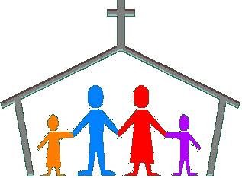

At home you could help your child by:

• visiting church, either for Mass or another time, to talk about the church

reminding them what a special place a Church is and reasons why

• talking to your child about their Baptism, explaining how this was the day

that they became part of God’s family.

**_________________________**

**Year 1—Miracles**

**“The signs worked by Jesus attest that the Father has sent him. They invite belief in him. To those who turn to him in faith, he grants what they ask. So miracles strengthen faith in the One who does his Father’s works; they bear witness that he is the Son of God.”**

*Catechism of the Catholic Church*

The children will hear some stories from the gospels which tell of Jesus using his God-given power to show his love and compassion. They will hear the story of the Calming of the Storm and know that we can ask Jesus to help us when we are afraid. They will learn that Jesus showed his love for sick people when he cured a man who was paralysed and know that Jesus has great love for people who are sick today. They will learn that Jesus responded to the faith of the blind man with compassion

and think of ways that we can trust Jesus in situations of need.



**At home**

You could help your child by:

•reading the story of the Calming of the Storm or other miracle stories from

the New Testament

**▪**talking to them about how we can ask Jesus, through our prayers, to help us

**Year 2—The Birth of the Church**

**“The Church is the family of God, the People that God gathers in the whole world. This Church is the communion of Christ’s disciples brought together in Christ its Head by the Holy Spirit. It is the Body of Christ, the Temple of the Spirit. As the People of God, the Church is drawn into Christ’s praise of the Father and Christ’s mission in the world.** *Religious Education Curriculum Directory*

The children in Year 2 will learn that when the apostles received the Holy Spirit they spread the Good News. They will reflect on how they can spread the Good News. They will learn about the early Christian community and understand that the Christian community continues today to live by Baptism, the Eucharist and its mission to love God by loving our neighbour.

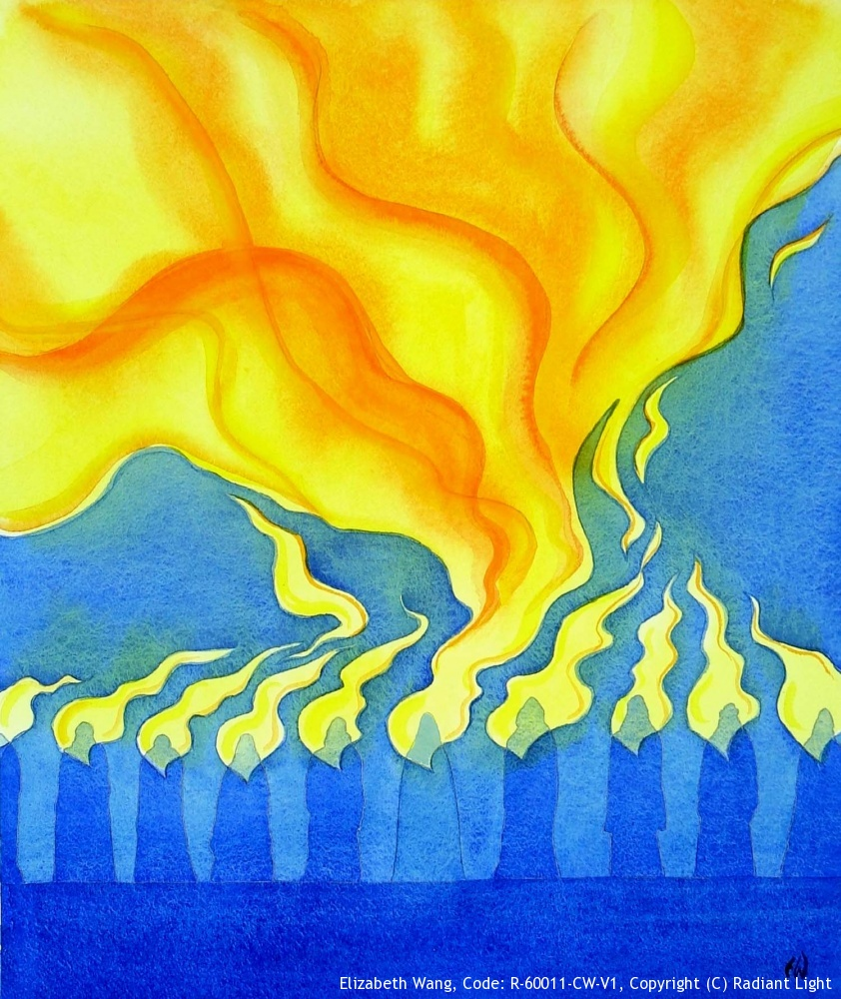

At Home

You could help your child by:

• talking about the symbols of the Holy Spirit and how the Spirit helps us

**Year 3—Being a Christian**

**“The greatest commandment of all: “Listen Israel, the Lord your God is the one Lord, and you must love the Lord your God with all your heart, and with all your soul, with all your mind and with all your strength. The second is this: you must love your neighbour as yourself.”** Mark 12: 29-30

**“The truth of our union with Jesus Christ in the Eucharist is tested by whether or not we really love our fellow men and women.”** Pope John Paul II, 1979

Year 3 will develop their understanding of what being a Christian involves. They will reflect on the joy and challenges involved in following Jesus and learn about these through the lives of Ss. Peter and Paul. The children will reflect on their gifts and talents and the gifts the Church calls Sacraments, especially the Eucharist. They will reflect on how to use the gifts God has given to us to be a

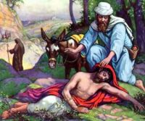

Christian .

At Home

You could help your child by:

• encouraging them to recognise and praise the gifts and talents o

• talk about their experience of receiving Holy Communion and help them to

make the link between receiving the gift of Jesus and becoming more like Jesus

**Year 4—Belonging to the Church / The Church**

**“The Church is the family of God, the People that God gathers in the whole world. This Church is the communion of Christ’s disciples brought together in Christ its Head by the Holy Spirit. It is the Body of Christ, the Temple of the Spirit. As the People of God, the Church is drawn into Christ’s praise of the Father and Christ’s mission in the world.”** *Religious Education Curriculum Directory*

Year 4 will learn that we all belong to a community. They will learn about different types of community and know what it means to belong to a community. They will develop their understanding of what it means to belong to community of the Church and know that people become a member of the Church through Baptism. The children will be introduced to the Creed – a



statement of the Catholic faith and learn about the structure of the Church’s

liturgical year.

**At Home:**

You could help your child by:

• helping them with their parish project

**Year 5—The Transforming Spirit**

**God’s self-revelation is made perfect in us by the Holy Spirit, the Spirit of truth. This truth was promised by Jesus and revealed at Pentecost. Through the Holy Spirit people are formed and guided to become God’s people through knowing God.** *Religious Education Curriculum Directory*

Year 5 will learn about and reflect upon the Ascension and the transformation produced by the Holy Spirit at Pentecost. They will learn about and reflect on the lives of St. Peter and St. Paul and learn that the Pope is the successor of Peter.

**At Home:**

You could help your child by:

• reading the stories of the Ascension and Pentecost with your child

• reading about St. Peter and St. Paul and exploring together why they are so important to Christians

**Year 5—People of Other Faiths**

**“The Church therefore urges her sons and daughters to enter with prudence and charity into discussion and collaboration with members of other religions. Let Christians, while witnessing to their own faith and way of life, acknowledge, preserve and encourage the spiritual and moral truths found among non-Christians, also their social life and culture** *Nostrae Aetate*

Year 5 will learn that we live in a country where people have different beliefs and different cultures. They will learn that Christianity comes from Judaism and learn something about Islam, Hinduism and Sikhism. The children will learn what Christianity shares in common with other faiths and learn some of the differences between the faiths.

**At Home**

You could help your child by:

• finding out about different places of worship

**Year 6—Called to Serve**

**“The gifts of the Holy Spirit enable us to share the mission of the Church.”**

*Religious Education Curriculum Directory*

The children will learn about Jesus’ teaching and example of service of others. They will develop their ability to recognise that God has given us all gifts and talents to use in the service of him and his people. They will learn about the gifts of the Holy Spirit and understand that we receive these gifts in a special way through the Sacrament of Confirmation. The children will have an

opportunity to reflect on a life of service through the role of the priest,



religious and married life.

**At Home**

You could help your child by:

• discussing the importance of the gifts of the Holy Spirit

•discussing the many ways in which we can be called to serve God and our

neighbour

**▪** chatting about their gifts and talents, both obvious ones and hidden ones

__________________________________________________________________________________

**Year 6—Love in Action**

**Jesus says: “As you did it to one of the least of these my brethren, you did it to me.” Many saints were shaken to the core by this passage from the Bible. On account of it, St. Francis of Assisi changed his whole life. Mother Teresa converted because of this saying… When I reflect that these words come from the mouth of Jesus … then I see that I am called to seek and to love Jesus above all in these little ones, in the least.”** *Pope Francis, DoCat*

The children will learn and reflect on some of the principles of Catholic Social Teaching. They will reflect on the implications of our belief that we are made in the image of God and explore the importance of family and community. The children will explore St. Paul’s image of the Church as the ‘Body of Christ’ and draw out the implications of this image for Christian action in the world, particularly through an exploration of the corporeal works of mercy.

**At Home:**

You could help your child by:

• discussing with them the importance of family and family time

• reflecting on the corporeal works of mercy. See <https://drive.google.com/file/d/0B5ETRkL51fhMazByR21ZeEU3VUk/view>