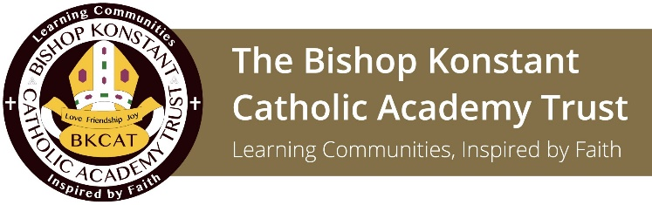

BISHOP KONSTANT CATHOLIC ACADEMY TRUST

INTERIM HEADTEACHER VACANCY

The Trustees of the Bishop Konstant Catholic Academy Trust wish to appoint an Interim Headteacher to commence 01 September 2019

St Wilfrid’s Catholic High School and Sixth Form
NOR: 1529
Age range: 11-18
Salary dependent on current salary and experience

The Bishop Konstant Catholic Academy Trust is a well-established Trust entering its 7th year of operation. Within our academies are communities where our children and young people are given a clear vision for life, a vision which is rooted in the person and teachings of Jesus Christ and which is faithful to the mission of the Catholic Church.

We are looking for an inspirational, enthusiastic and forward thinking individual with high standards and vision to lead St Wilfrid’s through a period of continual change and development until a permanent appointment is made.

St Wilfrid’s Catholic High School and Sixth Form offers a Catholic Education to both baptised Catholics and other families who value the inclusive ethos, excellent pastoral care and high academic standards. Our families choose St Wilfrid’s knowing that all students are encouraged and supported in developing their skills and talents in order to achieve their full potential.

A practising Catholic, or committed to our Catholic ethos, you will also be a natural leader of people. Adept at recognising talent within the staff team and developing effective teams you will be a highly proficient communicator, capable of engaging with and motivating students, staff and parents to ensure the best possible outcomes.

You will possess a rigorous approach to monitoring and have personal qualities such as drive, resilience and compassion to deliver effective school improvement.

Additionally you will have a commitment to developing and celebrating the Catholic life of the school as well as a proven track record of:
- Successful school leadership at Deputy Headteacher/ Headteacher level
- Raising standards in teaching and learning, leading to measurable whole school improvements within a consistent, caring, accountable ethos
- Clear understanding of strategic and financial management
- Making the most of innovative educational development

The Academy Council, Trust and Diocese will work closely with you to ensure support and development. You will enjoy a talented and supportive body of teaching and support staff.

Application forms are available on the Trust website www.bkcat.co.uk and school website www.st-wilfrids.bkcat.co.uk . Informal visits to the school are encouraged. To arrange a visit please contact Sue Heptinstall, Trust Head of HR, Bishop Konstant Catholic Academy Trust, email: sheptinstall@bkcat.co.uk telephone 01924 802288, to whom applications should be returned.

We are committed to safeguarding and promoting the welfare of children, young people and vulnerable adults and expect staff and volunteers to share this commitment. The post is subject to a satisfactory enhanced disclosure from the Disclosure and Barring Service (DBS) and Section 128 check.

Closing Date: Monday 1 July 2019 at 12 noon
Shortlisting: Week commencing 8 July 2019
Interviews: Monday 15 July 2019

