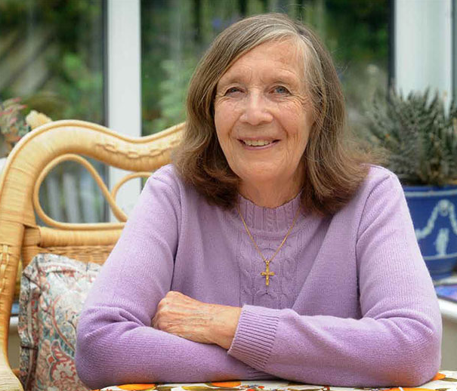
Sylvia Wright

- Sylvia Wright was a nurse from Leeds who sold her home and possessions in 1982 to move to India and work relentlessly and courageously among the sick and disabled in this very poor area of India.
- Over the years, Sylvia has set up The Sylvia Wright Trust which is a registered charity in the Indian State of Tamil Nadu.
- During her time in India, Sylvia has built and established a 180 bed charity hospital, a residential school for 200 profoundly deaf children, two day centres for 80 severely disabled children, a Nursing College for 60 students as well as running many community health projects.
- In 2017, following improvements in state medical provision, the hospital was transferred to a group of Indian doctors. In the same year, the old day centres for disabled children were replaced by one, purpose built centre in the grounds of the school for the hearing impaired and the capacity of the Nursing College was increased to 120 students.
- The Sylvia Wright Trust, which I based in Leeds, has several committed volunteers who raise funds to support all projects above.

