St. Francis
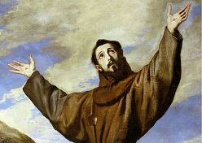
- Born in Assisi in Italy in 1181 as son of a wealthy cloth merchant
- is a Christian Saint
- In his early life, he served in the military and was captured and imprisoned for a year.
- During this time, it was reported he had a message from Christ calling him to leave his worldly life.
- So he gave up all his worldly goods, dressed in rough clothes and asked and begged for food to keep him alive
- His family disapproved and his father disinherited him
- He visited hospitals and cared for the sick
- He was the founder of the Franciscan order based on the simple statement by Jesus: “Leave all and follow me.”

