Mother Teresa
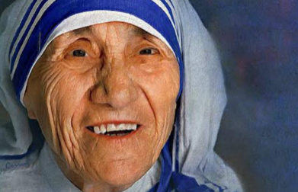
- Mother Teresa was a humanitarian. This means she did things to help out other people. Her entire life was fully devoted to helping the poor, the sick, the needy and the helpless.
- Mother Teresa grew up in the Roman Catholic Church and devoted her life at an early age to God.
- Once Mother Teresa had learnt English, she joined the Sisters of Loreto in their missionary work in India.
- In 1932, she took her vow as a nun and chose to take the name Teresa.
- Mother Teresa taught for many years and became a headmistress in a school in Calcutta.
- Whilst in India, she received basic medical training and then set out to help the sick and needy. She had very little support and whilst trying to feed and help the poorest of the poor, she was often left hungry whereby she even had to beg for food.
- In 1950, Mother Teresa formed a group within the Catholic Church called the Missionaries of Charity. She explained that this charity would take care of, “The hungry, the naked, the homeless, the crippled, the blind, the lepers, all those people who feel unwanted, unloved, uncared for throughout society, people that have become a burden to the society and are shunned by everyone".
- The missionaries started with only 13 members and today, have over 4,000 members who care for people around the world who are in need.
- Mother Teresa was awarded the Nobel Peace Prize in 1979 as well as a Presidential Medal of Freedom from Ronald Regan for her efforts linked to charity around the world.

