Made in God’s Image

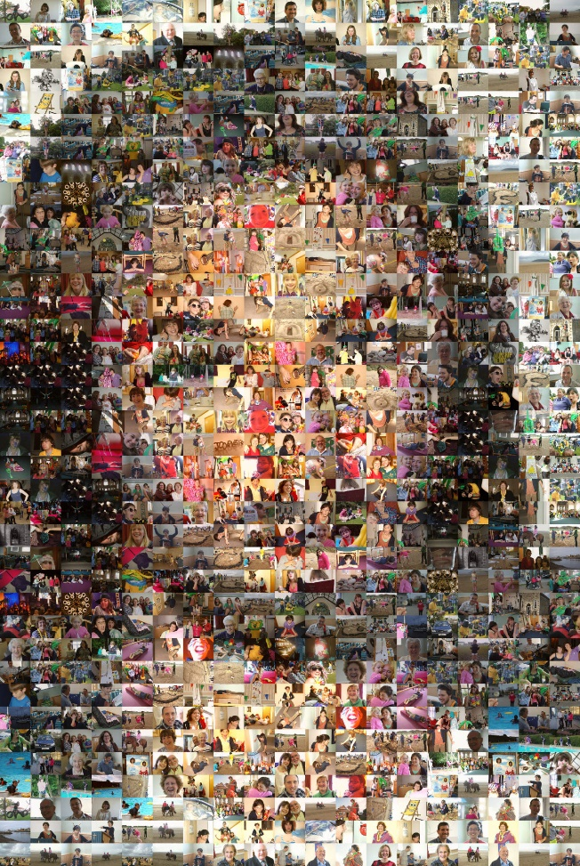

How do these people reflect God’s image?

