Dorothy Day
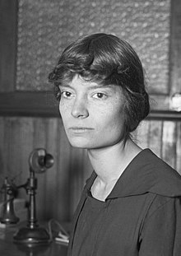
- Was a writer who wrote many articles, journals and letters
- Converted to Catholicism in late 1927
- She co-founded the Catholic newspaper ‘The Catholic Worker’ that promoted Catholic teachings
- This newspaper grew in popularity spreading the Word of God evangelising more people
- She co-founded the Catholic Worker Movement, which tackled issues of social justice.
- Fought for women’s suffrage (equality for women)
- She established special homes to help those in need
- Her faith continued to grow throughout her life attending Mass and confessions regularly as well as attending spiritual retreats.
- She carried her Bible and missal on long journeys reading it at a time when most Catholics didn’t.
- Was a pacifist and once fasted with others for 10 days in Rome wanting the Bishops to condemn all war.
- She was regarded as a friend of Bishops and cardinals

