Brother Damien
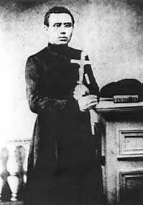
- Persevered and worked very hard to become a priest
- Was a missionary and went to Hawaii to share the word of God by preaching, talking to people and helping to build churches
- Volunteered to go to Molokai Island, where people suffered with leprosy (an infectious disease)
- Lived with the lepers and cared for them
- Encouraged them to care for one another
- Brought them together creating clubs like choirs
- Built a church and celebrated mass with them
- Taught the lepers that Jesus loved them and he was with them when they were suffering
- He dedicated his life to serve others and eventually died of leprosy on the island

