GOOD PRACTICE IN DEVELOPING A SCHOOL RELATIONSHIPS & SEX EDUCATION POLICY

GOOD PRACTICE IN DEVELOPING A SCHOOL RSE POLICY

Here are some suggested processes by which a school governing body might review and develop its policy on RSE. It is applicable to both primary and secondary schools and consists of eight successive steps. Schools may wish to consider whether to assign the first three or four steps to a small group of governors and staff, and to involve a wider group in the remaining steps.
This should be read alongside:
- the Secretary of State’s 2000 guidance on SRE to which schools must have regard when putting together an RSE policy and any relevant supplementary guidance;
- the guidance on statutory & Church requirements for RSE.

The policy will be used by:
- teachers who will look to it to guide their lesson planning
- parents, who will look to see both the RSE curriculum content and the values the school is promoting
- health professionals, visiting speakers and so on, who will want to know the aims, objectives and values the school’s SRE promotes, agreed teaching methodologies and boundaries for their work with young people
- partner schools, who will want to know the school’s approach to RSE so they can plan their curriculum in a way that ensures continuity of values and progression in learning.
- education staff involved in wider RSE provision.

Contents

GOOD PRACTICE IN DEVELOPING A SCHOOL RSE POLICY ....................................................2

STEP 1: REVIEWING EXISTING POLICY AND PRACTICE .............................................................4

STEP 2: IDENTIFYING THE PUPILS’ NEEDS ......................................................................................5

STEP 3: IDENTIFYING STAFF, PARENTAL AND WIDER COMMUNITY NEEDS ....................5

STEP 4: DRAFTING THE POLICY OR POLICY CHANGES .............................................................5

STEP 5: CONSULTATION ........................................................................................................................6

STEP 6: DISSEMINATION .......................................................................................................................6

STEP 7: IMPLEMENTATION ..................................................................................................................6

STEP 8: MONITORING AND EVALUATING THE IMPLEMENTATION OF THE POLICY......6

THE 8 STEP PROCESS ...............................................................................................................................7

FRAMEWORK FOR WRITING AN RSE POLICY .................................................................................8

STEP 1: REVIEWING EXISTING POLICY AND PRACTICE
- Consider whether existing RSE policy and practice conform to the latest legal requirements for RSE and is consistent with the Catholic mission and ethos statement of the school and in accordance with Catholic teaching.
- Review existing documentation and the effectiveness of present arrangements.
- Documentation might include:
      - statement of legal requirements
      - policy on RSE
      - roles and responsibilities
      - other school policies and relevant initiatives e.g. mission statement, confidentiality,
      - equal opportunities, SEND, pastoral care, PSHE, child protection/safeguarding teaching and learning, inclusion, differentiation, SIP
      - information regarding content
      - scheme of work for RSE
      - information regarding how, when, where and by whom RSE is taught, including use of outside speakers and agencies and materials
      - procedures for withdrawal and for advice to individual pupils
      - procedures for monitoring, review, evaluation and dissemination.

- Evidence of pupils’ learning which might include
    - reviewing a selection of pupils’ work
    - Ofsted and Section 48 reports
    - feedback from staff and pupil evaluations regarding the existing programme, including the delivery of RSE through RE, PSHE and other National Curriculum subjects
    - views of parents
    - comments from diocesan advisers.

- Evidence of staff confidence in the teaching of RSE which might include
    - feedback from staff
    - existing CPD programme
    - existing experience and expertise
    - staff awareness of policy and systems of support.

STEP 2: IDENTIFYING THE PUPILS’ NEEDS
- Consider feedback from pupils and parents, where appropriate, on their learning and emotional needs using ‘write and draw ‘techniques, questionnaires and holding discussions which will help to identify
    - pupils’ concerns
    - their existing skills and knowledge.
- Information from research studies may support/add to school findings or highlight where improvements could be made.
STEP 3: IDENTIFYING STAFF, PARENTAL AND WIDER COMMUNITY NEEDS

- Consider feedback from
  - school staff
  - governors
  - parents/carers

  - diocesan advisers
  - health and education professionals

using ‘write and draw ‘techniques, questionnaires and holding discussions which will help to identify
  - support for the existing programme
  - needs and concerns
  - those who could be involved in future development work.

- Information from research studies may support/add to school findings or highlight where improvements could be made.
STEP 4: DRAFTING THE POLICY OR POLICY CHANGES
- Decide who will write the first draft e.g. one individual or several individuals writing a section each - a working group
- Consider the format of the draft (see the model framework and model draft policy).
- Consider:
    - purpose, guiding principles, aims, objectives – including a moral framework of virtues
    - content and coverage of issues listed in Step 1
    - style, clarity, accessibility and readership
    - support and CPD implications for staff
    - what is achievable

STEP 5: CONSULTATION
- Decide upon methods and timescales for consultation regarding the policy with:
- parents
- diocesan advisers
- governors
- pupils.
- staff
- Redraft the policy in the light of consultation. Keep in mind that consultation is not the same as negotiation. It is virtually impossible to meet the values or viewpoints of everyone in the school community. The school’s governing body holds the final responsibility for the policy and RSE provision throughout the whole school.
STEP 6: DISSEMINATION
- Once agreed, inform all those affected about the content of the policy.
STEP 7: IMPLEMENTATION
- Decide who is responsible for the implementation of the policy.
- Consider the timescale – bearing in mind the need for staff CPD.
- Consider how implementation will take place e.g. starting with particular classes or throughout the school.
STEP 8: MONITORING AND EVALUATING THE IMPLEMENTATION OF THE POLICY
- Decide who is responsible for monitoring and evaluation.
- Consider how monitoring and evaluation will take place: e.g. through individual lessons, the programme as a whole, staff, feedback, pupil feedback etc.
- Decide to what extent the aims and objectives are being achieved.
- Decide to whom reports will be made: e.g. governors, parents. • Decide whether redrafting is necessary
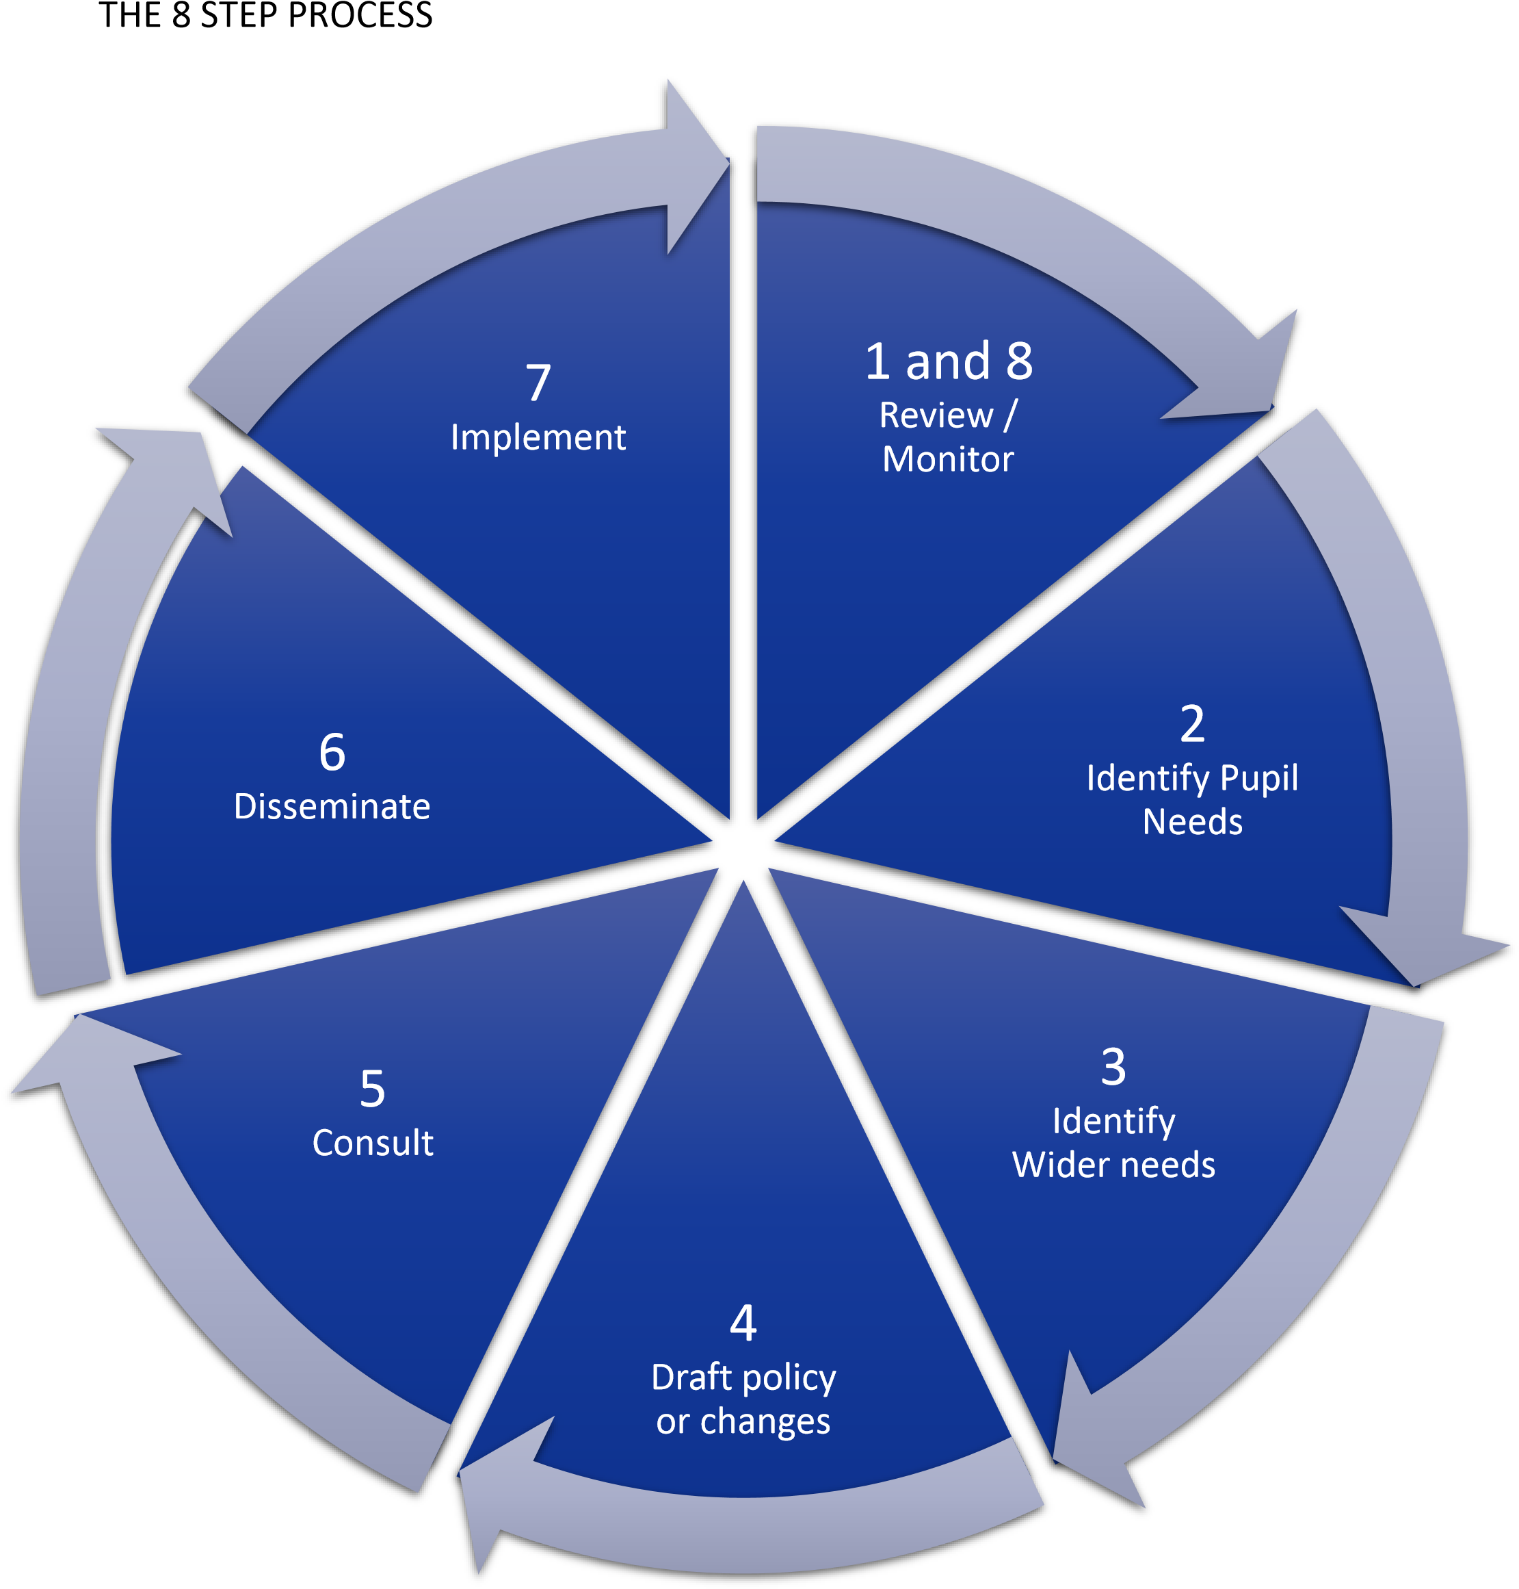

FRAMEWORK FOR WRITING AN RSE POLICY
In formulating a policy schools will need to refer to the earlier guidance in this document.
The school Mission Statement and the schools overall aims and objectives.
All policies should be informed by Church teachings and the school’s mission statement, overall aims and objectives. How will these inform the teaching of RSE?
The school's Mission Statement is...
The school's aims and objectives are...

Basic information:
Description of policy formation and consultation process.
What does this policy cover?
Who produced it?
Who was consulted and how?
When is the review date?
The intentions of this is policy are....
It was produced by....
Through consultation with...
It will be reviewed in....

Dissemination
How will governors, teachers, non-teaching members of staff and parents be informed about and have access to this policy?
The named stakeholders will be informed about this policy through....
The policy will be made available to them through.....
Rationale and Definition of RSE and why we are teaching it.
What is RSE?
How do we define it?
Why it is important to teach?
References should include appropriate directives from the Church, statements from the Bishops Conference (1987) and any diocesan guidelines regarding the educational and theological reasons for a Catholic school undertaking RSE as well as relevant DFE guidelines.
We define RSE as...
We consider that it includes....
We believe RSE needs to be addressed because....
What are we required to teach by law? (It is important for different audiences to understand that aspects of RSE are a statutory entitlement for young people at key stages 3 and 4). We are statutorily required to teach…
The centrality of virtue.
What virtues and values underpin our work in RSE and why? How do these link to our school’s overall values? Statutory guidance refers to schools teaching about ‘the importance of stable relationships’, ‘marriage’ and ‘family life’. What does this mean in the Catholic context of your school and your community? RSE in our school acknowledges the centrality of the following values and virtues…

The aims and objectives of RSE
What are we aiming to achieve through our RSE provision and how does this relate to our Mission Statement, school aims, wider PSHE education provision and the wider curriculum?
Our programme aims to…

It will develop the following:
attitudes and virtues
personal and social skills
knowledge and understanding

Ensuring inclusion and differentiate learning
We will ensure SRE is sensitive to the different needs of individual pupils in respect to pupils’ different abilities, levels of maturity and personal circumstances e.g. sexual orientation, faith and culture etc.
We will identify pupils’ different starting points by…
We will respect pupils’ unique starting points by providing learning that is…

Equalities Obligations
The governing body have wider responsibilities under the Equalities Act 2010 and will ensure that our school strives to do the best for all of the pupils, irrespective of disability, educational needs, race, nationality, ethnic or national origin, pregnancy, maternity, sex, gender identity, religion or sexual orientation or whether they are looked after children.
We will ensure equality by…
We will assess the needs of different pupils by…
We will review this policy every… or in light of…

Content headings
In broad terms what content will be covered and when?
Year groups are different and it is worth giving the school the flexibility to move aspects of this work to match the readiness of the pupils. You might want to include the resources you will use, but your policy will need to be amended whenever they are changed. Our programme will cover…… Resources used are….
Teaching strategies will include…

How will pupils’ learning in RSE be assessed
We will assess pupils’ learning through…

Parents and carers
The Church recognises that parents/carers are the primary educators of their children. How will the school seek to support them in this task? Parents/carers have the right to withdraw their children from RSE excepting those elements which are required by the National Curriculum science orders. How will the school provide support for parents/carers who withdraw their children to help the children with their learning?
We are committed to working with parents and carers. We will offer support by… (for example, offering material for parents or carers to explore with their children or offering workshops for interested parents and carers to find out more)
We will notify parents/carers when sensitive aspects of RSE will be taught, by…
We will communicate to parents/carers about their right to withdraw their children by…
If a parent requests that their child be removed from ‘sex education’, the school will provide support by….

Ensuring the curriculum is balanced
Whilst promoting Catholic values and virtues and teaching in accordance with Church teaching how will we will ensure that pupils are offered a balanced programme?

Providing a programme that offers a range of viewpoints, teaches clear scientific information and as well as covering the aspects of the law pertaining to RSE (in secondary schools/academies relating to forced-marriage, the recognition and reporting of sexual abuse female genital mutilation, abortion, the age of consent and legislation relating to equality) is not incompatible with the school’s promotion of Catholic teaching. Pupils need access to the learning they need to stay safe, healthy and understand their rights as individuals.

While promoting Catholic values and virtues, we will ensure that pupils are offered a balanced programme by providing….

Responsibility for teaching the programme
Will this be class teachers? Form tutors? PSHE education, RE, PE or science specialists? Will other professionals, for example school nurses, provide support? All staff will be involved in developing the attitudes and values aspect of the RSE programme
The programme will be led by…
It will be taught by…
It will be supported by…

Teaching Strategies
The programme will be taught through a range of teaching strategies, including…

Other roles and responsibilities
What are the roles and responsibilities of governors, the head teacher, PSHE/RSE Co-ordinator, all staff?

Relationship to other policies and other curriculum subjects
How does this policy link to the school’s bullying and safeguarding policies? SEND policy? How will you ensure that learning in ICT/Computing, Citizenship, RE and other relevant subjects complements learning about sex and relationships in PSHE lessons?
This policy supports/complements the following policies…
Learning about RSE in PSHE classes will link to/complement learning in…

Children’s questions
This needs careful thought…..Practical suggestions can be found in 4.5 ‘Dealing with questions’ in Sex and Relationship Education Guidance, 0116/2000, Department for Education and Employment, July 2000
Pupils’ questions will be answered by…

Supporting children and young people who are at risk
When teaching any sensitive issue, children and young people may give cause for concern, and a link needs to be made with the pastoral system and safeguarding arrangements.
Are children aware of confidentiality procedures?
If we have any reason to believe a pupil is at risk, we are required to… Our approach to confidentiality is….

Monitoring and evaluation
The programme will be monitored and evaluated by…

This framework is an adaptation of Guidance on producing your school’s SRE policy – PSHE Association 2013

