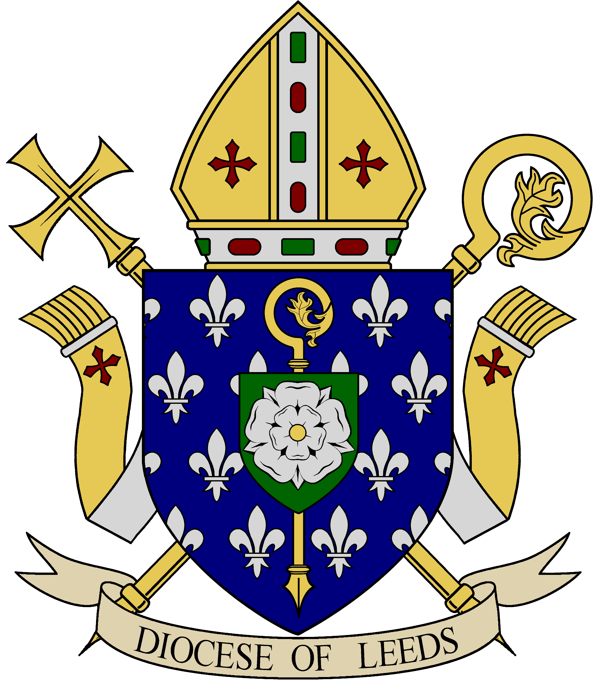
Diocese of Leeds – Preparation for First Eucharist
Recommended resources suitable for Family Catechesis
We Share in the Eucharist
Twenty Third Publications

Available from McCrimmons. www.mccrimmons.com

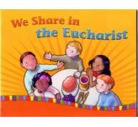
Leader’s Guide and Children’s Book

Each session ends with a “What have you Learned?” section with some interesting suggestions for activities.

- We Walk with Jesus
- A day to remember (the empty tomb); a meal to remember (the Last Supper); your parish church
- We Learn about the Mass (the parts of the Mass)
- Things we see at Mass (furnishings, books, vessels); we share greetings; we are a family (includes gestures); we ask forgiveness; we sing our praise (Gloria)
- We Share God’s Word
- We learn about the Bible (Abraham; Moses: David; psalms; prophets); we welcome Jesus (story of Jesus and apostles); The Liturgy of the Word; we hear the Gospel; we profess our faith; we pray for others (Prayers of the Faithful)
- We Give Thanks
- We offer bread and wine; we lift our hearts; we begin the “Great Prayer”; we can pray always (technique for praying)
- We Remember and Celebrate (the Consecration)
- We “see” with faith (the mystery of faith); we imitate Jesus (sacrifice); Alex makes a sacrifice; we pray together (for others); we offer ourselves (“Amen”)
- We Share the Bread of Life
- We celebrate sacraments; Jesus is the Real Bread; we prepare for Communion (prayer and making peace); we ask for mercy; we are one with Jesus

Section called “Family Guide” for whole family in the centre of the book; section called and instructions to make “My Prayer Book” at the end of the resource.

With You Always: a Family Catechesis Resource for Sacramental Preparation

(Archdiocese of Liverpool 2016)
[Also includes preparation for Reconciliation]
http://www.withyoualways.org.uk/


Each session is divided sections e.g. gathering, sharing, responding, celebrating, taking out.

- Come to the Water (family/Baptism)
- Church ‘Treasure Hunt’; the baptismal font; welcome (Sacraments of Initiation)
- Called by Name (names/saints)
- Matthew 16: 13-18 (naming of Peter); Mark 1:14-18 (calling of followers)
- Come Back to Me (choices/Reconciliation)
- Matthew 18:21-22 (forgiveness 77x); Sacrament of Reconciliation; Sign of Peace
- Following Jesus (a new way of living)
- Matthew 5:1-12 (the Beatitudes); how to live as Jesus taught us (strengthened by the Mass); Matthew 28:16-20 (the Great Commission); Philippians 4:8-9 (“with you always”)
- Teach us to pray (growth/Lord’s Prayer)
- Luke 11:1-4 (Lord’s Prayer); the sacrifice of the Mass/the Great Prayer; growing faith; using our bodies to pray
- Jesus Brings us Together (community/Eucharist)
- Luke 9:12-15 (loaves and fishes); the Last Supper/the Eucharist; the Triduum (what we see in Church)
- Jesus/Eucharist (Jesus calls us to follow Him)
- Isaiah 58; Last Supper narrative; receiving Holy Communion (illustrated p.5); a new way of living; Matthew 8:8 (heling of Centurion’s servant)

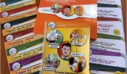
Called to His Supper
Jeannine Timko Leichner

Available from McCrimmons – www.mccrimmons.com

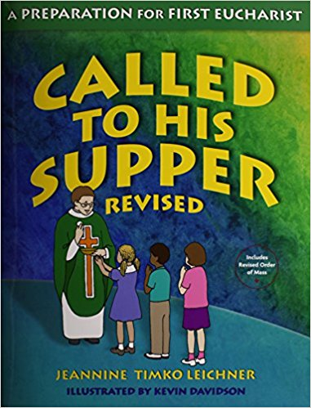
- Children’s Book: Called to His Supper
- Catechist/Parent Guide: Called to His Supper

Presentation
A comprehensive programme for preparation for primary aged children, consisting of a catechist’s guide (which includes a photocopiable parents/family sheet for each session) and a children’s workbook.

Structure & Content
The catechists guide begins with an overview and teaching tips. Each chapter then follows the same format: a page covering the background for the session, a scripture reflection, the aims and the preparation required for the session. It also highlights the key concepts. There is then a detailed plan for the session including an introduction, a group activity not in the workbook, a conclusion, dismissal and a ‘to do at home’ activity plus a list of 4/5 additional activities if there is time.

There are also detailed plans for 3 family faith celebrations
- A celebration of Baptism
- A celebration of God’s Word
- A celebration of Sharing

Children
The children’s workbook is a record of the main points covered during the session. The workbook uses easy language and simple explanations. The illustrations are simple line drawings which can be coloured in but the quality is not lost if a child does not want to and the points are covered by a selection of activities, including discussions, word searches, missing words, dot to dot and speech bubbles. There are also stories and prayers. ‘The children are enthusiastic about THEIR books’

Parents
The parent’s notes provide background information for adults on the same topics as the children’s sessions plus a family prayer, discussion idea and activity. Parents have commented that they find this useful.

Catechists
The main advantage of Called to his Supper is the quality and detail of the catechists guide. The guide provides comprehensive background and organisational detail which makes it ideal for those without teaching experience; also the breath of coverage means sessions can be geared to meet a variety of needs and circumstances.
The guide is written with a view to delivering 9 complete sessions lasting one to one and a half hours but one parish has successfully delivered it over 20 sessions of ½ an hour each.

The clarity of the workbooks means they are suitable for pupils with a variety of special needs without the need for differentiation and could even be used by children with severe learning difficulties with 1-1 support as a record of their involvement in the programme providing there had been some activities and resources at an appropriate level available during the sessions.
The workbooks are made of good quality materials and are reasonably priced.

I Belong, Redemptorist Publications
http://www.rpbooks.co.uk

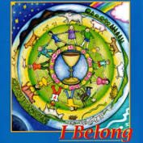
- Children’s Book
- ‘Special’ For Children with Learning Difficulties
- Parents’ Guide
- Leader’s Guide

This is an easy and well explained programme for children, parents and catechists. The notes for catechists and parents are wide-reaching and help adults to develop their own understanding. The programme can help to bring together the home, school and parish.

Presentation
The presentation has been described as colourful, appealing, attractive and beautiful. The pictures and photographs are up-to-date.

Structure & Content
I Belong is based on the framework of the celebration of the Eucharist. All the material is firmly grounded in the Bible and in the Catechism of the Catholic Church. There are 11 sessions, each one exploring a theme connected with the Eucharist. Each session begins with the children’s own experience of the theme and then goes on to think about the theme in Scripture and in the Church. Finally the children look again at everyday experience and ‘hopefully discover how the Eucharist is about real life.’
Each session is introduced by an example from Everyday Life as well as concluding with another Everyday Life section (often activities).

- In the Name of the Father (names)
- Old Testament: Adam names animals; New Testament: naming of Jesus (Annunciation and Baptism)
- Church: my Baptism; Everyday Life (being a beloved child)
- Lord have Mercy
- OT: snake in Eden/God’s promise; NT: Prodigal Son
- Church (penitential rite); Everyday Life (showing mercy)
[2 sessions on Reconciliation follow]
- Glory to God in the Highest
- OT: Moses & burning bush; NT: angelic host at Nativity
- Church: Gloria; Everyday Life (various activities)
- This is the Word of the Lord
- OT: call of Samuel; NT: Nativity
- Church: Liturgy of the Word; Everyday Life (activities)
- Bread to Offer
- OT: manna in desert; NT: miracle of loaves and fishes
- Church: includes definition of vessels; Everyday Life (activities)
- Fruit of the Vine
- OT: Isaiah’s song of the vineyard; NT: Wedding feast at Cana
- Church: Eucharist & past, present, future; Everyday Life (activities)
- Do this in Memory of Me
- OT: Passover; NT: Last Supper
- Church: Take and eat …; Everyday Life: fed and empowered
- Body of Christ
- NT (only): Mary & the ‘Gardener’; 2 friends & the ‘Stranger’
- Church: Consecration; Everyday Life (we are the Body of Christ)
- To Love and to Serve
- OT: Joshua and Promised Land; NT: the risen Jesus and the fishermen
- Church: Ite missa est; Everyday Life (activities)

Children
Catechists have commented that the programme is suitable for children aged 7-8, that it is child-friendly and that each theme starts from the children’s own experience. The children enjoy using their books, participating in the activities, especially the group discussions and completing the tasks. The children are able to write in their book, to draw and to stick in pictures to ‘make it their own’.

Parents
There has been positive feedback from parents who find the programme easy to follow and simple to use at home to help their children.

Catechists
Catechists have found this an easy and well explained programme. There is good guidance for leaders including extension ideas while the leader’s notes help adults to develop their own understanding.
Blessed: First Communion
(Dynamic Catholic 2017)
https://dynamiccatholic.com/blessed

- Sunday is Special
- Counting blessings; Your journey with God continues (7 sacraments); God loves to celebrate (special days/saints feast days/God’s “favourite” day); What makes Sundays special?; Listening to God at Mass
- Bible: Creation (also Baptism of Jesus; story of Joseph; the annunciation (and Flood); the Last Supper; the paralysed man; Zacchaeus
- The Greatest Event on Earth
- The ultimate prayer (Mass); God’s House; The 3rd Commandment (1 out of 168 hours in the week); Listening to God (Mass Journal); So many wonders (know what’s going on at Mass – it’s amazing)
- Bible: The Road to Emmaus (also Moses on Sinai; Jonah)
- The Word of God
- Overview of Mass (definition of ‘Rite’ and ‘Liturgy’); The Introductory Rites (We say sorry and Glory to God); The Liturgy of the Word; We Believe; Wear it out (the Bible)
- Bible: The Sower of Seeds
- The Eucharist
- Food for the soul; The Liturgy of the Eucharist (the Offertory; the Eucharistic Prayer; the Consecration; … Our Father); Holy Communion; the True Presence; Jesus is in you
- Bible: The Last Supper (also King David and the ark)
- Your First Communion
- This is a special day; You’re growing up (taking responsibility); Preparation matters (prayer; fasting); The Eucharist empowers us to do great things (example of saints); Your first but not your last …
- Bible: The Visitation
- God’s Family
- Made for mission; Your parish family; Go make a difference; The power of prayer; Trusting God
- Bible: I Will Always Be with You

Although this resource is not readily available in the UK there are some excellent ideas on the website www.dynamiccatholic.com/blessed. In particular Blessed includes some wonderful videos which could be made use of.

