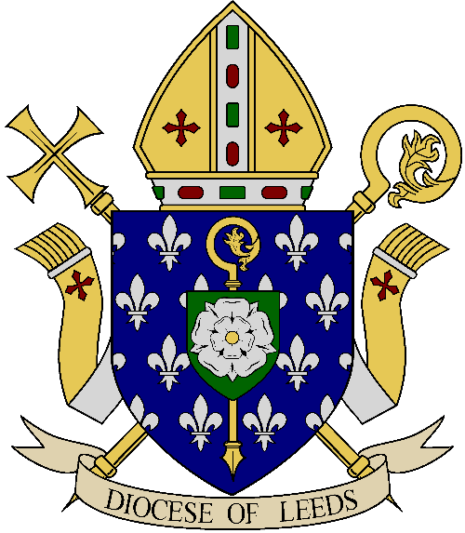
Diocese of Leeds

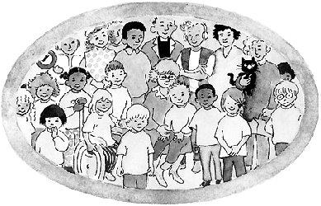
A Guide to Family Catechesis

FAMILY CATECHESIS

“The new evangelization is the opposite of a status quo mentality and an idea that pastoral programmes are simply to proceed as they did in the past. Today, a ‘business as usual’ attitude can no longer be the case.”
Lineamenta for the Synod of Bishops on the New Evangelization, No.10
“The role of parents in education is of such importance that it is almost impossible to provide an adequate substitute.
The right and duty of parents to educate their children are primordial and inalienable.”
Catechism of the Catholic Church (2221)

That role is named in the baptism ceremony . . .
“parents are the first and the best teachers of their children in the ways of faith”
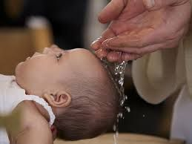
Fr James Mallon in Divine Renovation . . .

Child – centred catechesis presumes Catholic culture and active participation in the Church.
But this Catholic culture no longer exists in our society, and most families requesting sacraments are not active members of the parish.
The new reality means that no matter how good a program is, its value will be limited unless we work with the parents of the children.
After years of using various resources, I am now convinced that changing programs, books or resources is the equivalent of putting new tires on a broken-down car.
Our problem goes well beyond content, and is inherently a problem with the classroom-based, child-centred model used in most parishes.
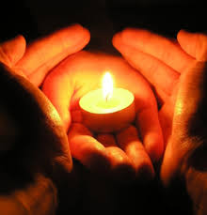
FAMILY CATECHESIS
- Brings the parents into the preparation process
- Supports them to be the ones who prepare their children
- Parents stay with their child throughout the prep sessions
- Parents sit with their child & work through a resource with their child
- Catechists support the parents
- Whole parish community supports the parents & family
- School works with parish to support parents & through RE to re-enforce what parents are teaching their children

Family Catechesis
- affirms the parents as the child’s first teachers in the faith
- parents talk to their own children
- Families pass on the faith

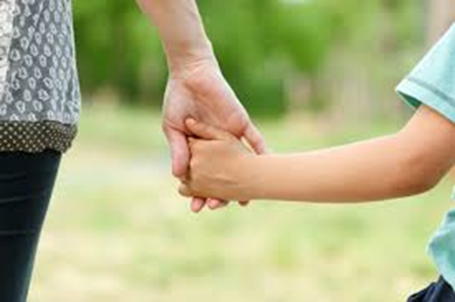

New role for the catechist
- Welcome families
- Set up the room
- Gather at the start of the session & send out at the end
- Catechists support parents
- Parents are your concern
- Children are parents’ concern
- The conversation about prayer, scripture, the sacraments begun in the parish during Family Catechesis continues at home in the domestic church…

A Parish Experience of Family Catechesis
- Small groups work best – for preparation and maybe celebration
- Establishing relationship with families makes the difference
- Having several preparation groups meeting at different times (and places) best supported parental participation
- Small number of key catechists with confidence to lead
- Not all catechists comfortable working with parents
- Some catechists struggle to support rather than teach
- Parents quickly adjust to expectation to be involved
- Some parents more nervous than others about being involved
- Sometimes other family members take the place of parents
- Courage required to let parents make a choice
- Works best with participation of whole parish community
- Different families need different resources – no one size fits
The New Confirmation Resource
Empowered by the Spirit – The Gift of Confirmation
A Possible Model for Family Catechesis

Autumn Parish planning meetings
January/February
- Invitation to Year 5 & 6 parents/carers to 45 minute meeting in all schools.
- For children who do not attend Catholic schools a parish meeting can be arranged
- Process of preparation & family catechesis approach for Sacrament of Confirmation explained
May
- Letter sent to Year 5 & 6 families
- Invitation to contact the Parish Office & book an appointment to enrol
- Each family comes to individual appointment (15 minutes) with a catechist
- Sign up to a preparation session group (maximum of 15 families per group)
- Recruitment & formation of new catechists
Early June
- First Preparation Session
- For parents only
- Led by the priests
- Introduce the resource
- Reflect on Sacrament of Confirmation
June
- First Confirmation Preparation Sessions –
- Parent (or other family member) comes with child to their Preparation Group
- A Lead Catechist welcomes the families and introduces the theme
- Parents talk with their children working through the session worksheets
- Catechists around to help and support
- Lead Catechist draws the session to a close with a prayer
Parishes or Deaneries November and/or January and February
- Celebrating the Sacrament of Confirmation

The contents of this booklet are based on material generously shared by colleagues from the Archdiocese of Liverpool.
We are most grateful for their help and support in this project.

