Pupil-led Collective Worship Planning Sheet
Class/Key Stage/Whole School/ Other Worship |  | Leaders
Date |  | Focus
PREPARATION/GETTING READY

 | What we will do: |  | What others will do:
Focal Point  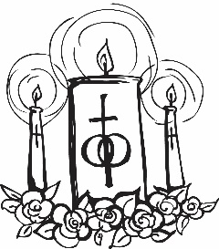 | What will your focal point look like?  (Describe or draw)  We will need:
Creating the mood | How will you create the right mood/ atmosphere as people gather to worship?  Music:  Lighting:  Seating: |  | How will you direct people as they gather and prepare them for worship?
THE ACT OF WORSHIP
Welcome | Who will welcome everyone and how?  How will we introduce the focus of the collective worship? How can we link it to people’s experience?
WORD | What Bible reading/s will you use?  Who will read/role play?  What prompts/props will you use, including ICT? Who will use them?
WORSHIP | How will you respond to the Bible reading in a prayerful way? What do you want to pray about? How will you do it?
WITNESS | What message/s do you want people to take as they leave? How will you help them to do this?  What prayer will you share?  What will the final message be?  Who will say it and how?

